Quick Links

General Formatting
CRM Terminology
Add Lead vs Edit Lead
Add Lead
Add Lead: Screen Header section
Add Lead: Company Information section
Add Lead: Contacts section
Add Lead: Subsidiary Companies section
Add Lead: Attachments section
Upload Attachment Window
Add Lead: Emails section
Upload Email Window
Add Lead: Activities section
Add Lead: Campaigns section
Add Lead: Contact Log section
Contact Log Add/View Window
Add Lead: Notes section
Add Lead: Log section
New Email Window
Email Lookup Window

General Formatting
Colors:
Blue:
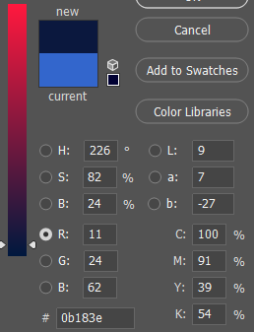

Gold:
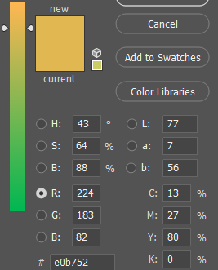

Table Lines
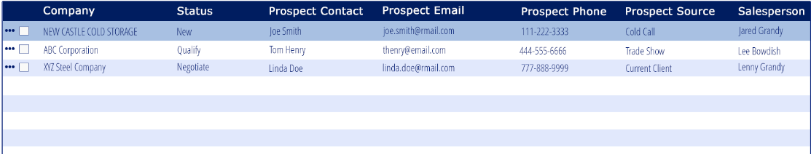
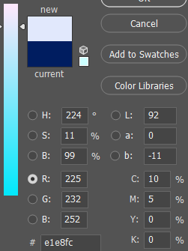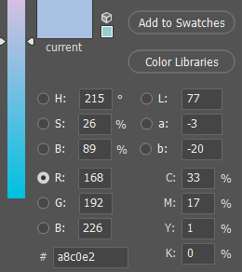

Fonts:

General text, field labels: Open Sans
-fallback: open sans, helvetica neue, helvetica, arial, sans-serif

Headers, title bars, buttons: Verdana
-fallback: Verdana, Geneva, sans-serif

Formatting
Text
text should automatically be converted to all-caps after the user is done typing

Phone/Fax
-all phone & fax fields should auto format the number to be in the formatting shown:
*United States & Canada - (xxx) xxx-xxxx
*Mexico, acceptable formats
- (xx) xx xxxx xxxx
- (xx xx) xxxx xxxx
- (xx) xxxx xxxx
- xx xxxx xxxx for cellphones from Greater Mexico City, Guadalajara and Monterrey
- xxx xxx xxxx for those based elsewhere.
*China
- (xxx) xxxx xxxx
*https://en.wikipedia.org/wiki/National_conventions_for_writing_telephone_numbers#China

Date
-date fields
-format: mm/dd/yyyy
– when manually entered by user rather than selected from the calendar option the format should convert the format
EX: 02/01/17 - 02/01/2017

Postal Code
-the system should recognize the postal code with or without spaces or dashes
-Ex: A0A1A0 can also be put in as A0A 1A0 – both should be recognized by the system
-see the link provided for various postal code formatting and needed character spacing
https://en.wikipedia.org/wiki/List_of_postal_codes
Time
-time format h:mm a
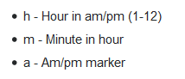
hour is numbers only
minutes is numbers only
AM/PM is selection based
If the user types A AM is selected if the user types P PM is selected
AM/PM should be display in all-caps

-user should be able to type the time in or click the clock icon to select a time

-before a time is entered there should be dashes where the data will be entered

-when the clock icon is clicked the time options should look like the image below
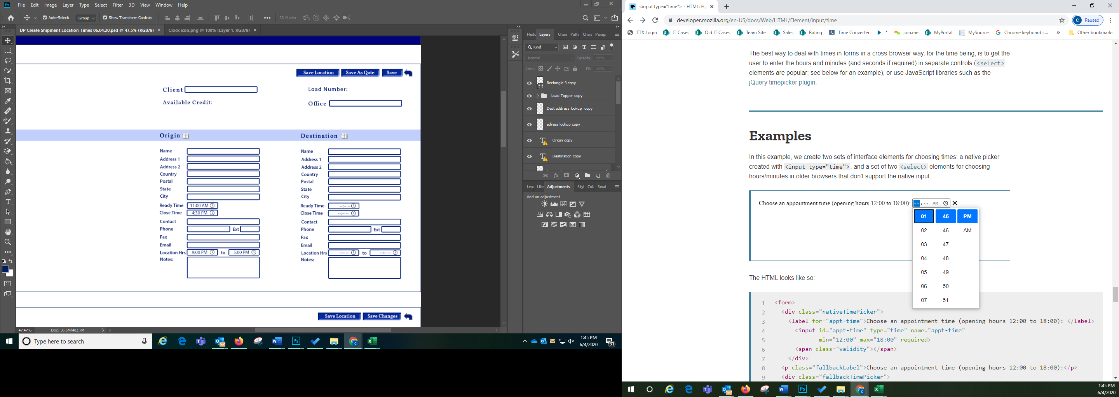

Calendars
– anywhere a calendar appears
-1st open the icon
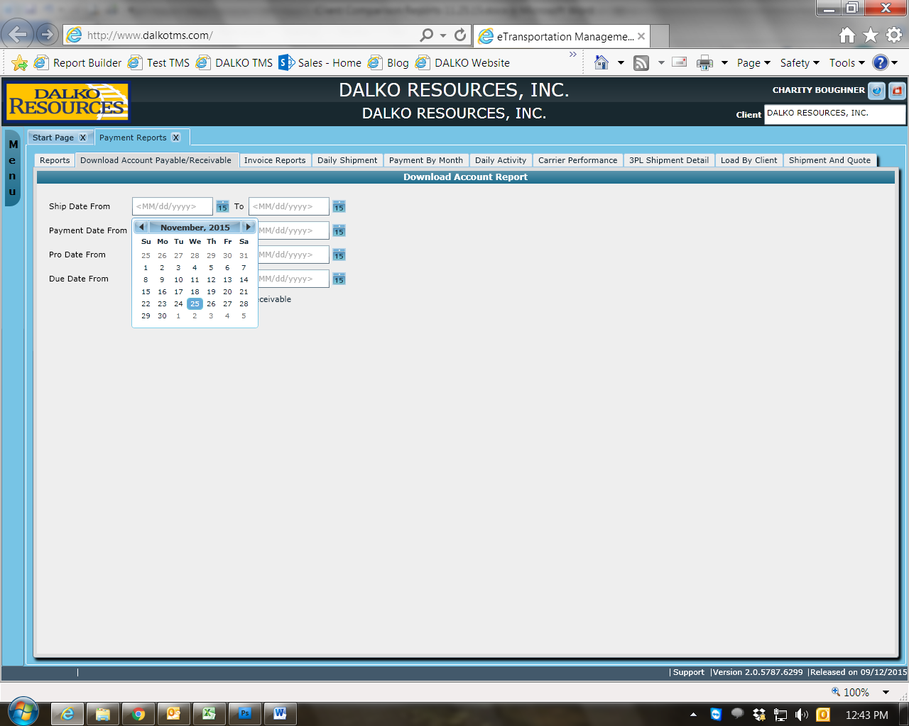
-when you click on the month it should convert the calendar to this view
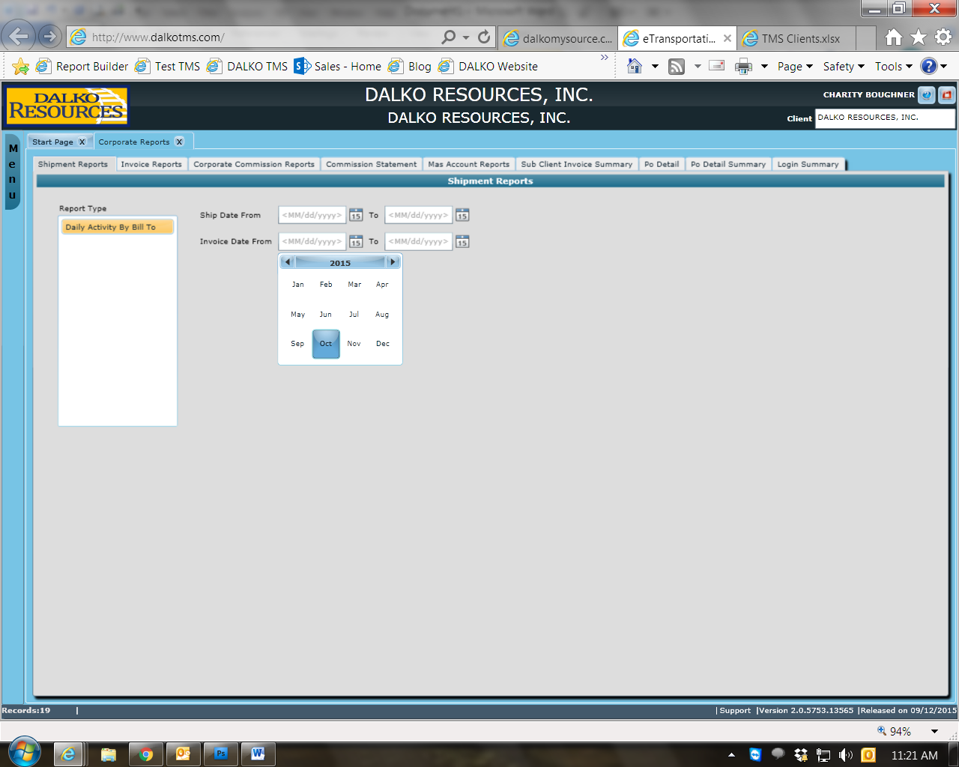

-when you click in the year is should convert this view
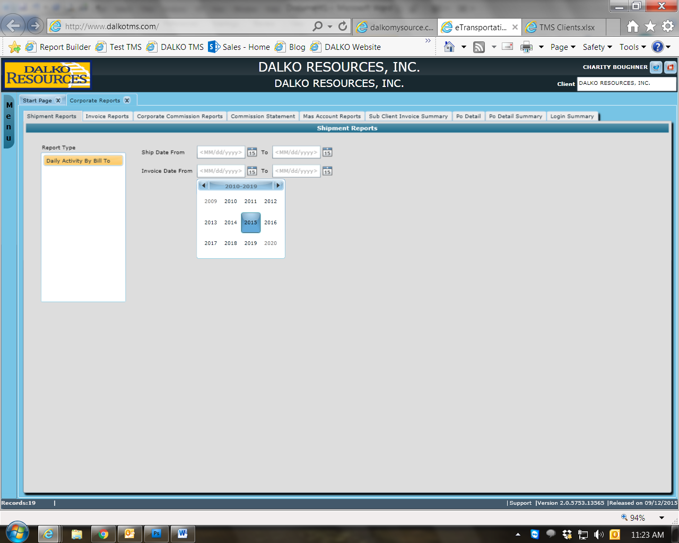
**the calendar views should work in reverse as the user select the information

Page Navigation
-Items Per Page – dropdown
- determines the number of vendors showed per page
-options: 10, 25, 50, 100
-Page Number
-displays the page number the user is currently on and how many pages there are in total
-if the user enters a page number it should jump to that page
-single arrow move forward or back one page
-arrow with line jumps to first or last page

Buttons/Fields
-Radial & checkbox buttons – use keystroke Space to select

-All other buttons – use keystroke Enter to select

-Dropdown –
- fields with dropdown lists should be blank by default unless otherwise stated in this document or setup with a default item through the system
-ex: fields such as Payment Terms & Product Class can be defaulted through Client Settings

- there should always be a blank option in the dropdown field unless it is a required field or stated otherwise for a particular field

- should always be in alphabetical or numerical order unless otherwise states
-shortcut within the dropdown list based on the first character
-ex: when E is typed the selection box should jump down to the first word in the list that starts with E

Required Fields
-the field should be flagged with a red vertical bar to indicate it is required

-if the user bypasses a required field without completing it the input box should turn red and there should be a message below the input field in red font
-Alert dependent on the missing required field

Message Examples:
Name is required
Effective Date is required
Expiration Date is required

General Validation
*all open input field should be spellchecked
*all open input field should auto capitalize except where noted

CRM Terminology
Lead – a company with the Status of New Lead, Contact or Qualify
Prospect – a company with the Status Present, Proposal, Pursuit, Negotiate, or On Board
Client – a company with the Status Client
-can be a Lead or Prospect that has been converted to a Client or a company could be created as a Client skipping the Lead/Prospect process

Add Lead vs Edit Lead
Add vs Edit is the same as the current.
The only difference between adding a new Lead and editing an existing Lead is:
New Lead
- the fields of a new Lead will be open and the user can tab through them and modify them without any extra step
-there is on Save button at the top of the screen that will save all changes at once
Edit Lead
- when editing an existing Lead the input fields will be locked until the user clicks the Edit button beside the field they wish to edit.
-There is no save button at the screen level. When the user edits a field there will be an approve/save option that saves the changes for that field only. There will also be an exit option which would exit the edit mode without saving changes to the field. The field would remain as it was before the edit button was clicked.
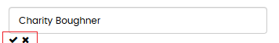

**add hover text to the Edit buttons
Edit hover text: “Edit”
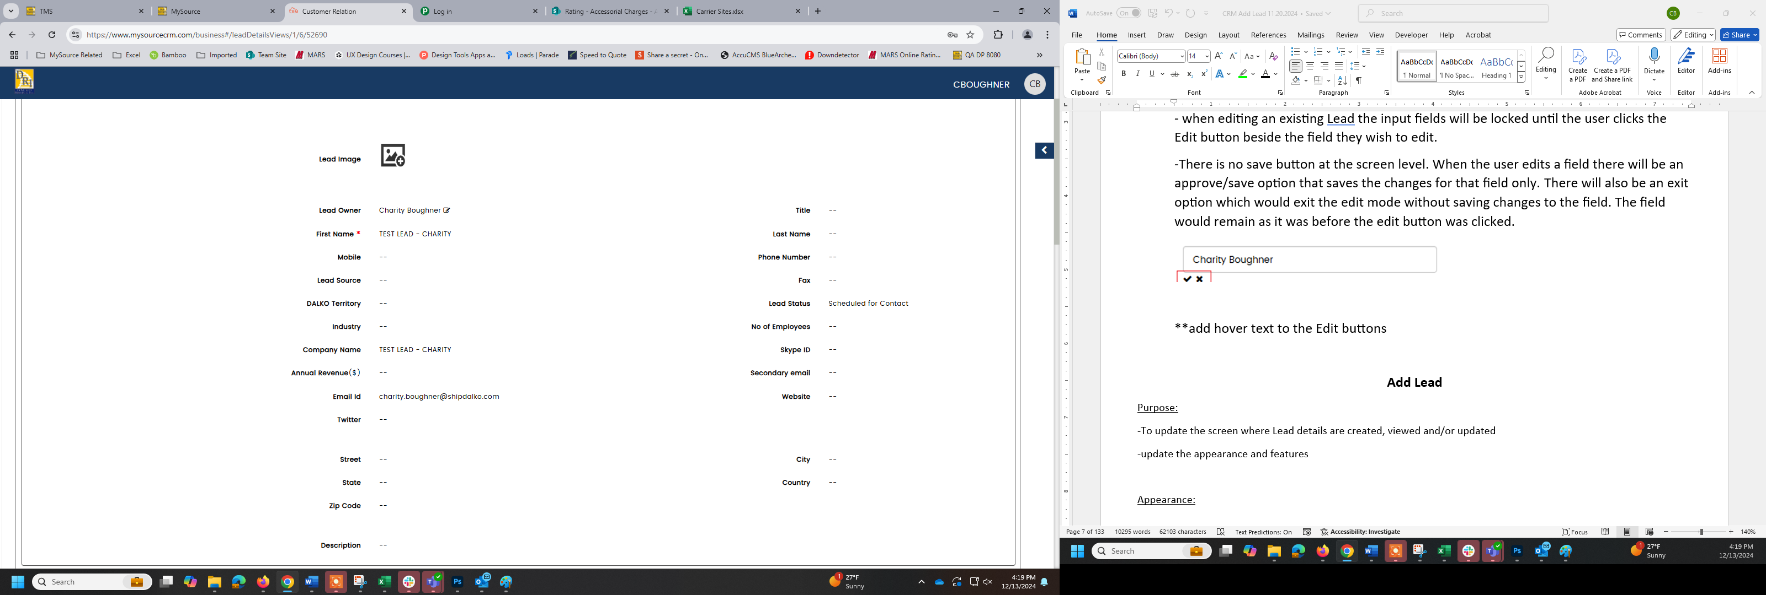
Save hover text: “Save Changes”
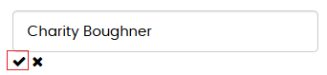
Exit hover text: “Cancel Edit”
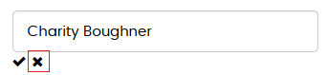

Add Lead
Purpose:
-To update the screen where Lead details are created, viewed and/or updated
-update the appearance and features

Appearance:
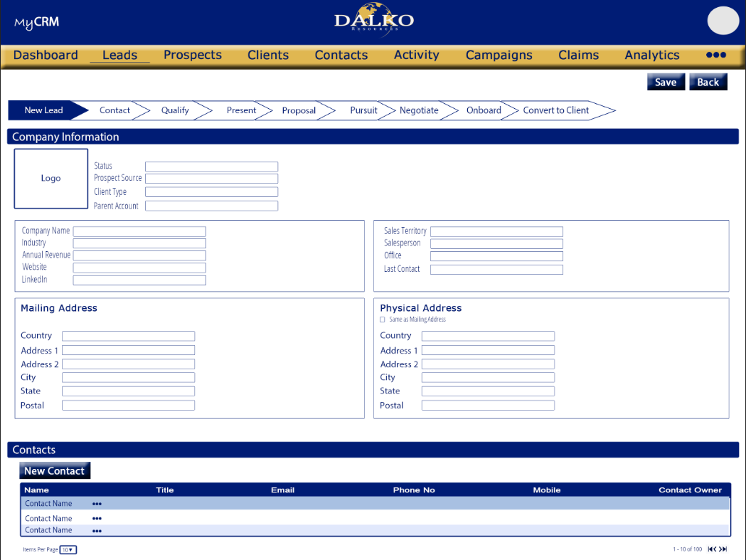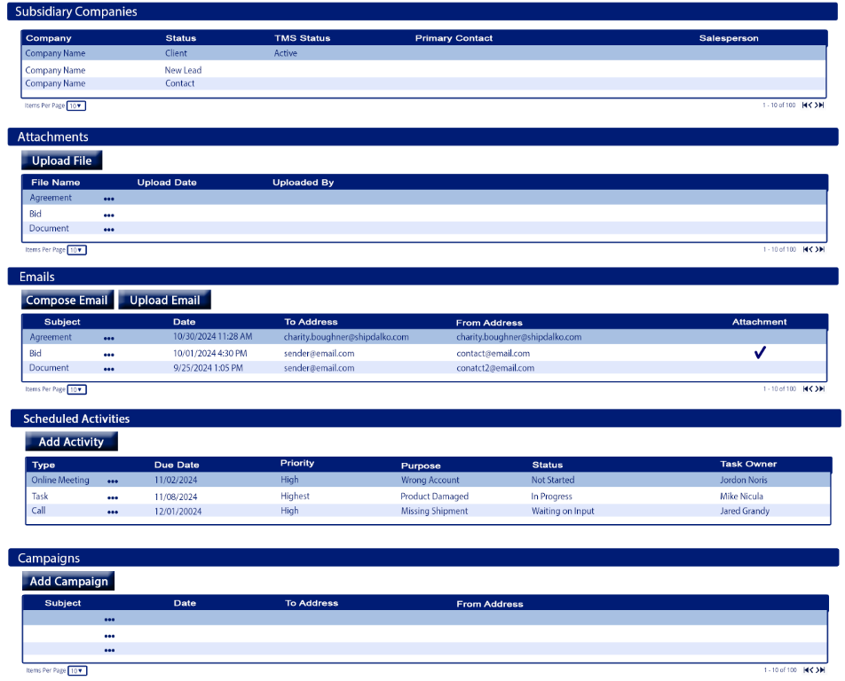
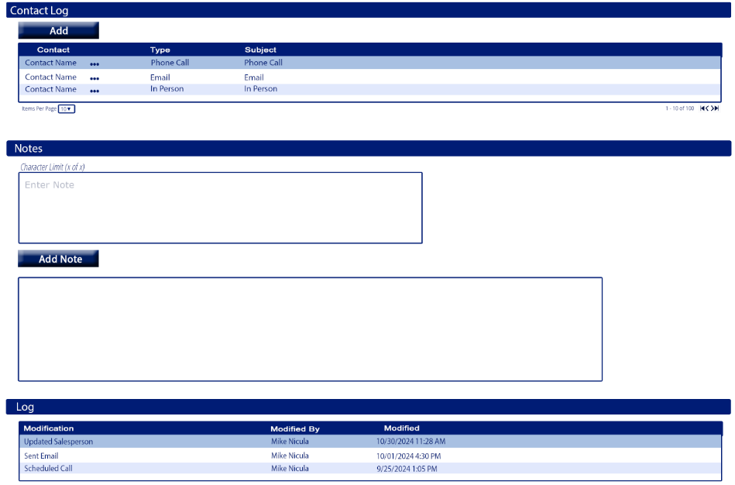

*should like the image provided
*update the layout, colors, buttons, font, etc.
*There will be a top section (screen header) that contains the Lead Name, screen Action buttons and a Status flow feature. More detailed in a separate section of this document
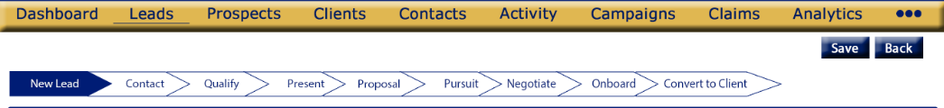

*the screen will be divided into 10 sections (not including the screen header) . Each one is collapsable. Each one will be detailed as it’s own section in this document.
- Company Information
- Contacts
- Subsidiary Companies
- Attachments
- Emails
- Activities
- Campaigns
- Contact Log
- Notes
- Log

Tab Order:
- Status
- Lead Source
- Client Type
- Parent Account
- Company Name
- Industry
- Annual Revenue
- Website
- LinkedIn
- Sales Territory
- Salesperson
- Office
- Last Contact
- Mailing Address: Country
- Mailing Address: Address 1
- Mailing Address: Address 2
- Mailing Address: City
- Mailing Address: State
- Mailing Address: Postal
- Physical Address: Same as Mailing Address checkbox (space bar to select)
- Physical Address: Country
- Physical Address: Address 1
- Physical Address: Address 2
- Physical Address: City
- Physical Address: State
- Physical Address: Postal

Required fields
- Client Type
- If Client Type is Subsidiary, then Parent Account is required
- Company Name
- Salesperson

Add Lead: Screen Header section

Purpose
Contains the action options for the screen
Shows a visualization of where the Lead is in the Status flow

Appearance
*refer to image for appearance/layout

Fields
Status Flow Chart
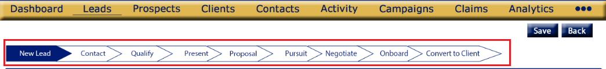

Function:
-visual depiction of what the Leads Status is
-provides a visual flow chart to the user of the steps of getting a Lead until conversion to client

Details
-flow chart
-read only
-controlled by the Company Information>Status field
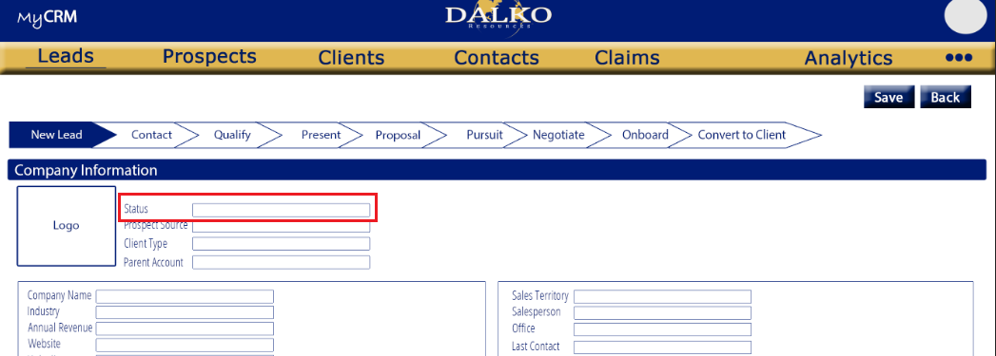
-layout, shape and order per the image provided
-flow chart steps:
  - New Lead
  - Contact
  - Qualify
  - Present
  - Proposal
  - Pursuit
  - Negotiate
  - Onboard
  - Conver to Client
- Flow Chart Formatting:
  - The Status the Lead is currently on is shaded Blue with white font
  - The statuses that have already been completed are shaded grey with blue font
  - Statuses that have not been competed yet are white with blue font
- Once the company’s status has been changed from Qualify to Present it will no longer be considered a Lead it will be updated to a Prospect

Save
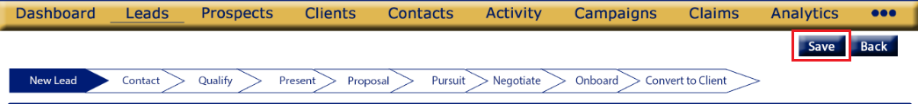

Function:
-Used to save a new Lead

Details
-button
-refer to image for placement and appearance

Validation:
-verify required fields are completed
  - Client Type
  - If Client Type is Subsidiary, then Parent Account is required
  - Company Name
  - Salesperson

Back
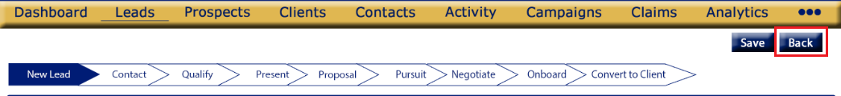

Function:
-Used to exit the Lead creation without saving

Details
-button
-refer to image for placement and appearance
-when clicked the user will be returned to the Leads screen and the new Lead will not be saved

Validation:
-changes not saved validation

Message: “The data entered has not been saved. Do you wish to proceed?”
Proceed: closes the alert, closes the Add Lead screen without saving the Lead, and returns the user to the Leads screen
Cancel: Closes the alert and returns the user to the Add Lead screen all fields remain as they were before the user clicked the Back button

Add Lead: Company Information section
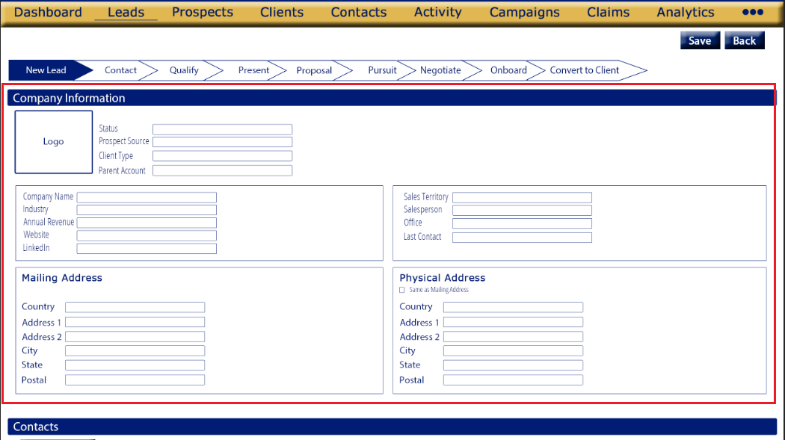
Purpose
Contains information about the company, lead information, etc.

Appearance
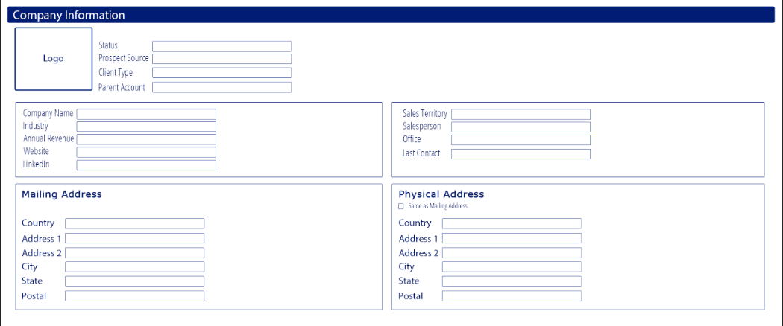
*there will a blue title bar which can collapse when clicked (refer to image for appearance & layout)
*the Company Information section will be divided into 5 subsections
-the top section will not have a boarder the other 4 sections will (refer to image)

Fields
Logo
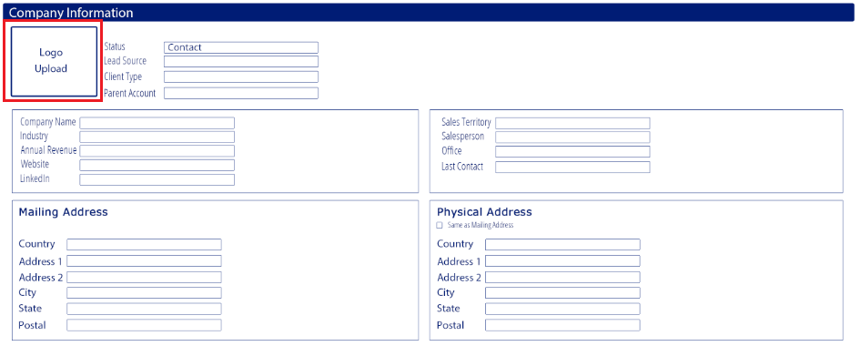

Function:
-used upload the company logo for the Lead
-will display the company logo once uploaded

Details
- show an image placeholder icon with the wording Logo Upload
-refer to image for placement
-hover text: “Upload company logo”
-opens an upload window where the user has the option to select a saved image or drag and drop an image
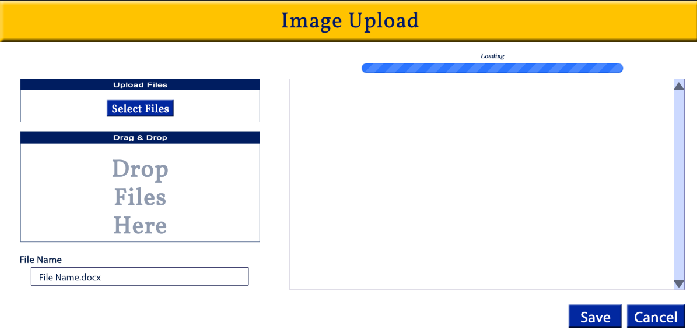
-once the image has been uploaded and saved the image will appear in the Logo placeholder location
Validation:
-

Status
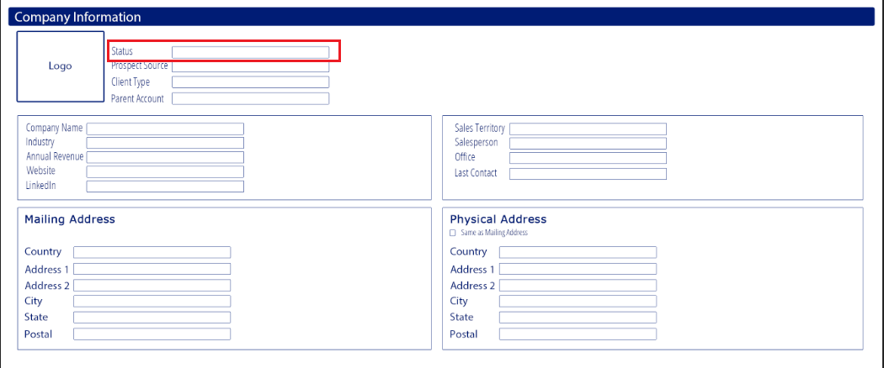

Function:
-used to determine the current Status of the Lead

Details
- dropdown menu, with first letter shortcut
-user can only select on
-the Status of a new Lead will default to New Lead
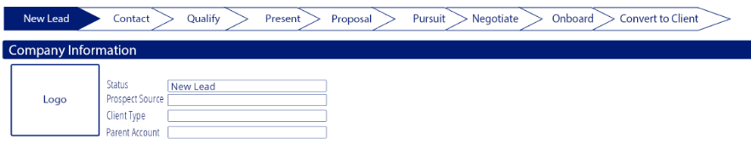
-the Status select will be shown in the Status Flow Chart
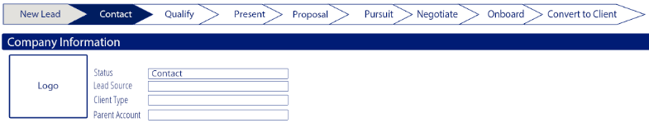
-the Status selected will be highlighted in blue in the Status Flow Chart and have white font
-all Statuses that come before the selected Status will be highlighted grey with blue font
-options to be listed in the order given below
-options:
  - New Lead
  - Contact
  - Qualify

Validation:
-Status is required to Save a Lead

Lead Source
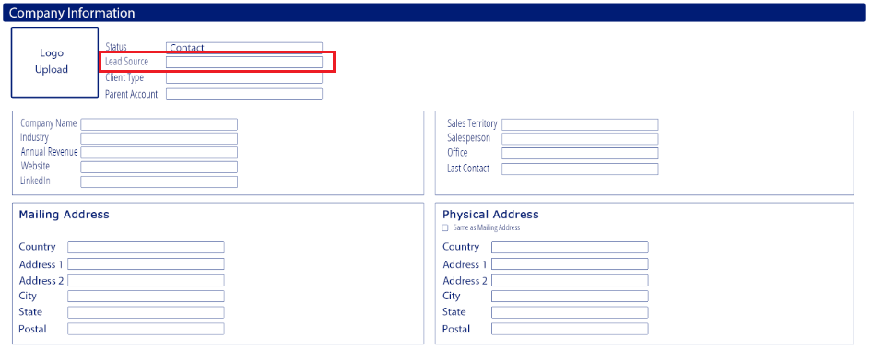

Function:
-information – details the source of the Lead

Details
- dropdown menu with first letter shortcut
-User can only select one
-List options alphabetically
-Options:
  - Advertisement
  - Cold Call
  - Employee Referral
  - Client Referral
  - Supplier Referral
  - External Referral
  - Trade Show
  - Web Research
  - Email Marketing
  - Website Visitor
  - Purchased List
  - Other

Validation:
-

Client Type
Blank or Standard Selected
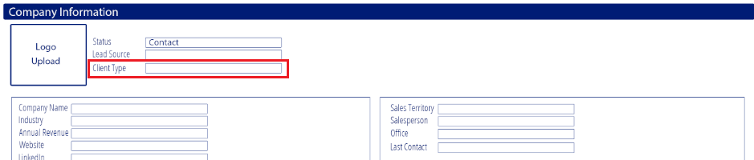

Parent Selected
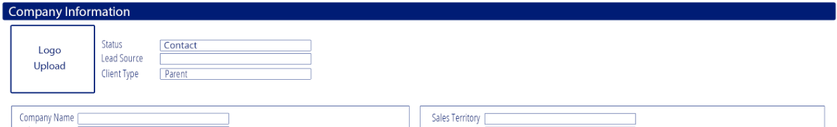

Subsidiary Selected
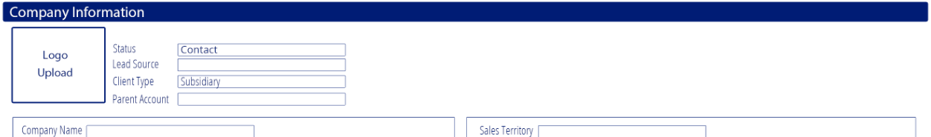

Function:
-determines of the company is a parent company, subsidiary or neither

Details
- dropdown menu with first letter shortcut
-User can only select one
-refer to image for placement/appearance
-List options in the order given
-Options:
  - Standard
  - Parent
  - Subsidiary
-Subsidiary
-if Subsidiary is selected an additional field will open, Parent Account
-companies that have the Client Type Subsidiary will appear in the Subsidiary Companies section of the Parent Company
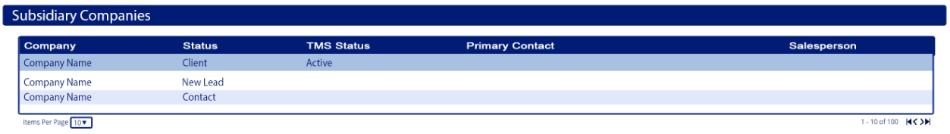
-a company with Client Type Subsidiary will not have any companies listed under their Subsidiary Companies section
-Parent
-If Parent is selected no additional fields will open
-all company types Subsidiary that have the Parent Company selected in their Parent Account field will show under the Parent company’s Subsidiary Companies section

-If Standard is selected no additional fields will open
-a company with Client Type Standard will not have any companies listed under their Subsidiary Companies section

Validation:
-required to save

Parent Account
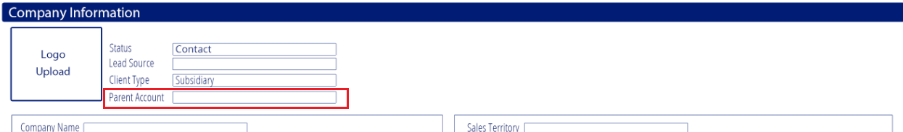

Function:
-determines which company is the Parent Account if the Lead’s Client Type is Subsidiary

Details
-the Parent Account field will only be shown if Client Type Subsidiary is selected
-if Client Type Standard or Parent are selected the Parent Account field will not be available
- dropdown menu with smart search, the more the user enters the more the options are filtered down
-User can only select one
-options should be sorted alphabetically
-options are any Lead, Prospect or Client that have the Client Type Parent selected
-if a company is Client Type Subsidiary it will be shown in the Subsidiary Companies section of the Parent Account selected

Validation:
-required to save if Client Type is Subsidiary

Company Name
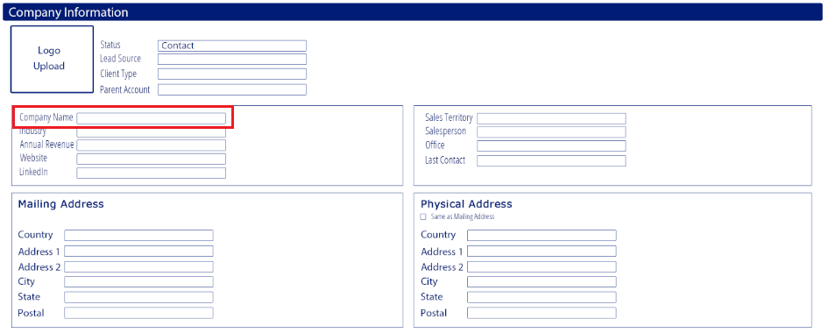

Function:
-used to enter the company name

Details
-open input field
-refer to image for placement/appearance

Validation:
-required to save

Industry
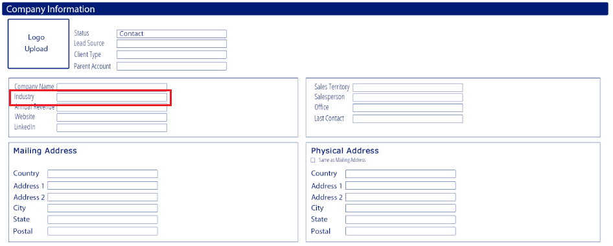

Function:
-used to add the industry(s) that the company can be classified under

Details
- multi select, dropdown menu with search
Ex:
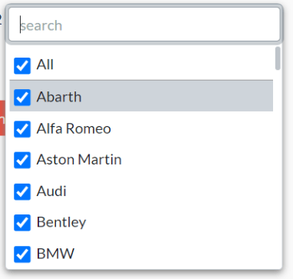
-refer to image for placement
-user can select multiple options
-options should be listed alphabetically
-options:
- Passenger Rail
- Logistics Company
- Track/MOW
- Rail
- Rail – Shortline
- Rail – Repair
- Rail – Parts
- Rail – New Car
- Power Generation
- Automotive
- Non-Rail Misc
- Mining
- Govt/Military
- Distributor
- Chemicals
- Cement
- Retail
- Agriculture
- Healthcare
- Clothing/Apparel
- Computer/Electronic
- Fabricated Metal Products
- Food Manufacturing
- Forestry/Logging
- Furniture
- Machinery
- Manufacturing
- Oil/Gas
- Petroleum/Coal Product Manufacturing
- Pipeline
- Plastic/Rubber Products Manufacturing
- Metal Manufacturing
- Paper Manufacturing
- Household Goods
- Wood Product Manufact
- Lumber/Building Supplies
- Pet Supplies

Validation:
-
Revenue
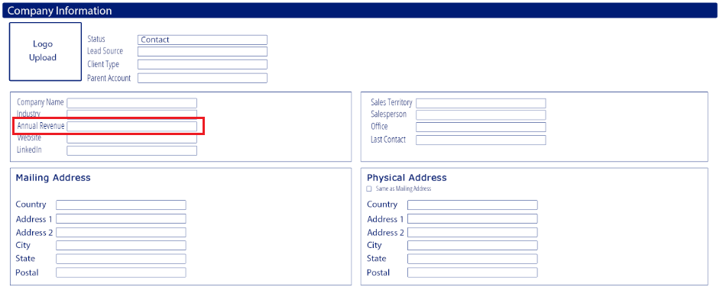

Function:
-informational field – company’s annual revenue

Details
-open input field
-formatting: currency
-refer to image for placement/appearance

Validation:
-

Website
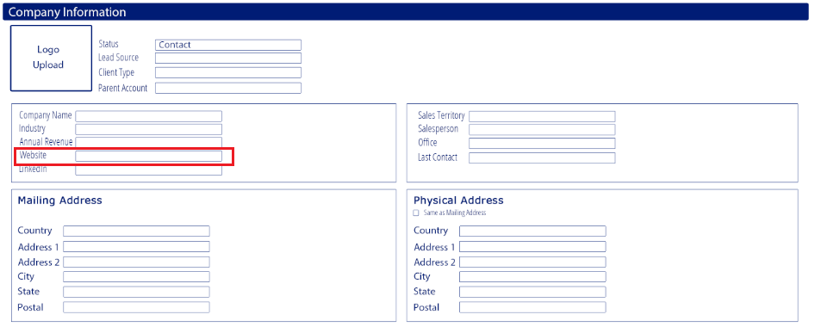

Function:
-informational field – company’s web address

Details
-open input field
-refer to image for placement/appearance

Validation:
-

LinkedIn
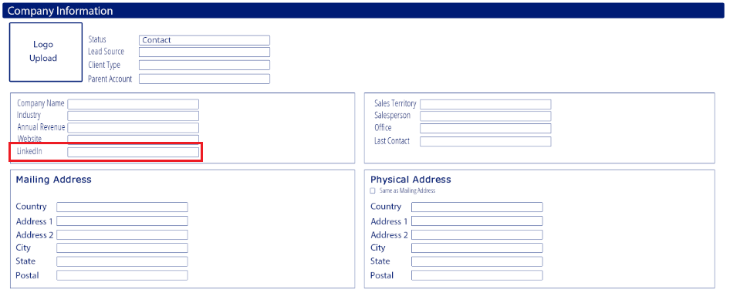

Function:
-informational field – company’s LinkedIn information

Details
-open input field
-refer to image for placement/appearance

Validation:
-

Sales Territory
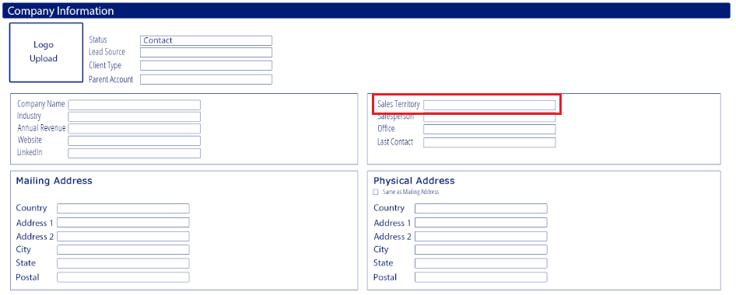

Function:
-informational field – the Sales Territory assigned to the company/Lead

Details
-dropdown menu with first letter shortcut
-refer to image for placement
-user can only select one
-options should be sorted alphabetically
-options:
- International
- Northeast
- Northwest
- Southwest
- Southeast

Validation:
-

Salesperson
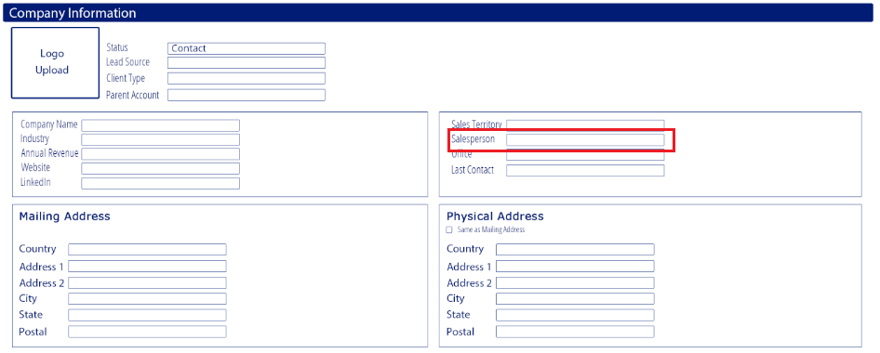

Function:
-informational field – the Salesperson assigned to the company/Lead
-visibility control - this field is also used to control Salesperson user permissions
-user type/role salesperson can only see company/Leads that they are assigned to

Details
-dropdown menu with first letter shortcut
-user can only select one
-options should be sorted alphabetically
-options come from users master, users that are role/type “Salesperson”
-full name should show

Validation:
- required to save

Office
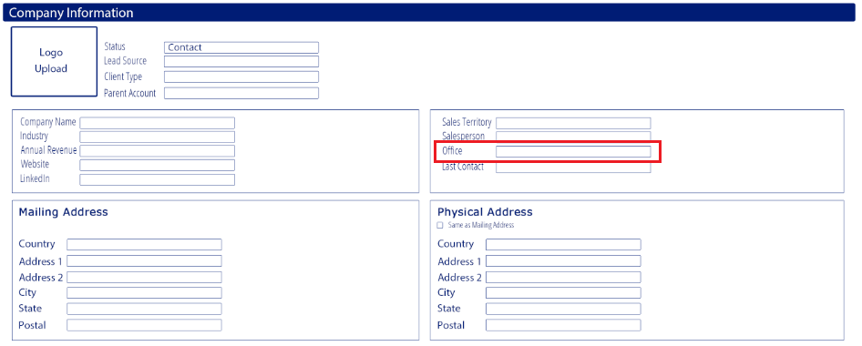

Function:
-informational field – the Office assigned to the company/Lead

Details
-open input

Validation:
-

Last Contact
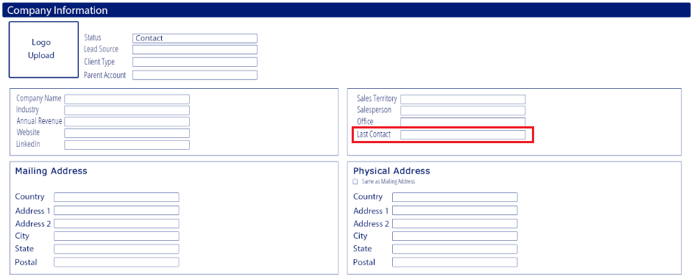

Function:
-informational field – date when the company/Lead was last contacted

Details
-date field: mm/dd/yyyy
-do not include the calendar in the tab order
-user can hand enter or select from the calendar

Validation:
-

Mailing Address: Country
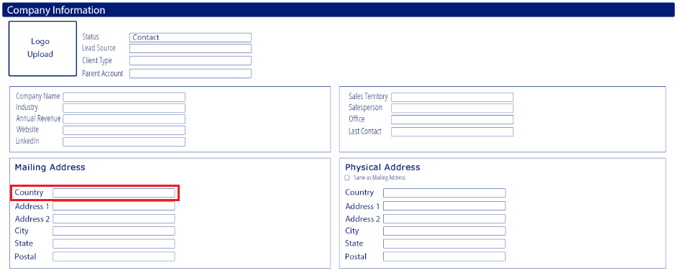

Function:
-informational field –company/Lead mailing address

Details
-open input

Validation:
-

Mailing Address: Address 1
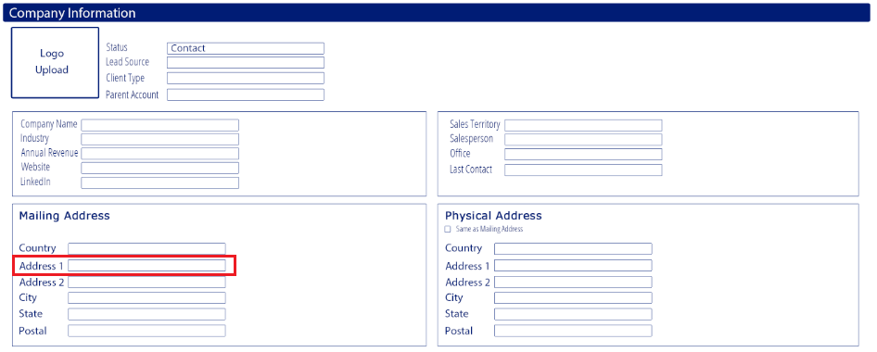

Function:
-informational field –company/Lead mailing address

Details
-open input field

Validation:
-

Mailing Address: Address 2
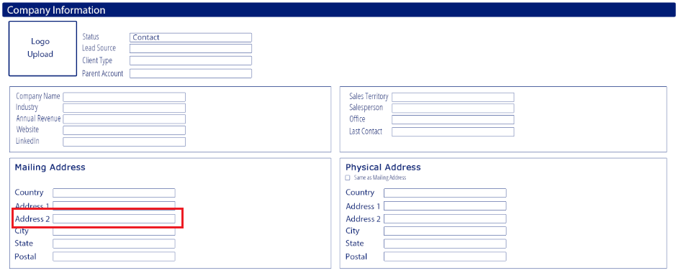

Function:
-informational field –company/Lead mailing address

Details
-open input field

Validation:
-

Mailing Address: City
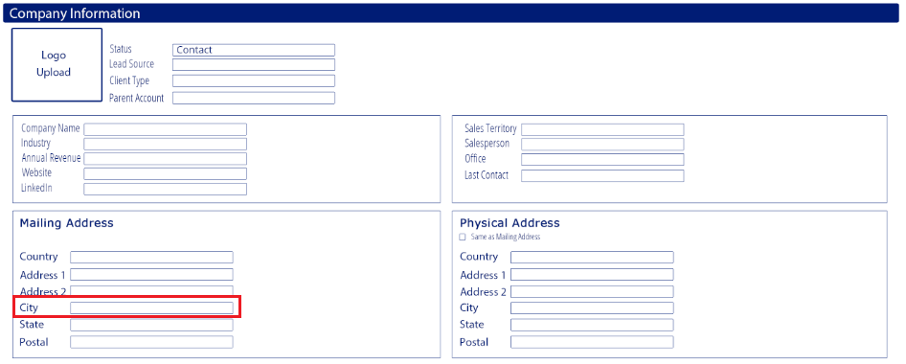

Function:
-informational field –company/Lead mailing address

Details
-open input

Validation:
-

Mailing Address: State
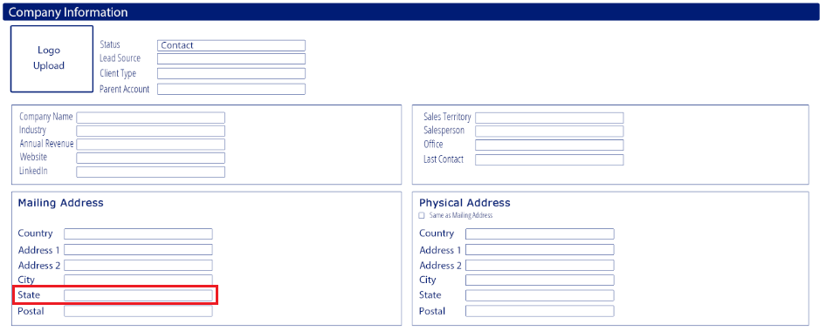

Function:
-informational field –company/Lead mailing address

Details
-open input

Validation:
-

Mailing Address: Postal
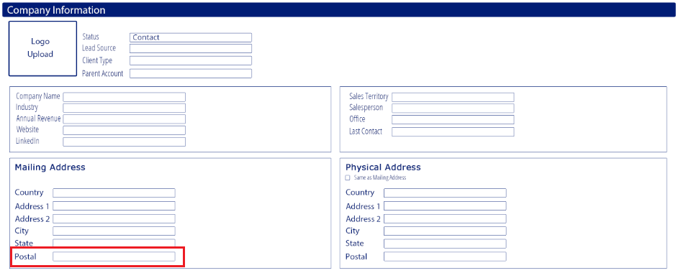

Function:
-informational field –company/Lead mailing address

Details
-open input

Validation:
-

Physical Address: Same as Mailing Address
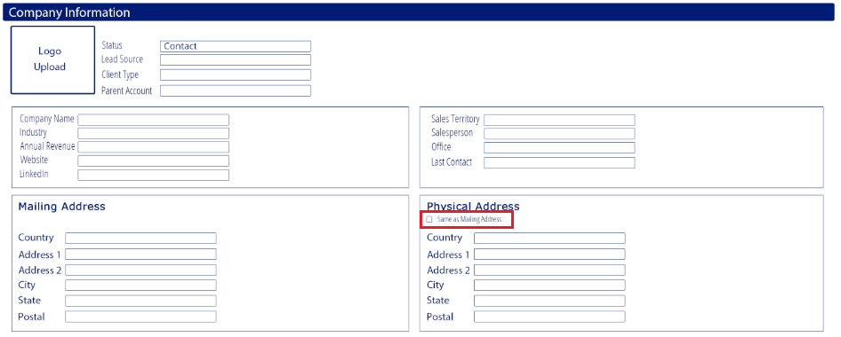

Function:
-indicates that the mailing and physical addresses are the same
-makes data entry more efficient, the user only needs to type out the mailing address

Details
-checkbox
-if selected the Physical Address boxes will be autocompleted with the mailing address data and will be locked
-if unselected the Physical Address fields can be entered by the user
Scenario:
- User enters mailing address
- User selects Same as Mailing Address
- System auto-completes the Physical Address fields with the Mailing Adress data and locks the Physical Address fields
- The user unselects the Same as Mailing Address checkbox
- The system unlocks the Physical Address fields, the data remains
The user can now modify the Physical Address fields

Scenario a:
- User enters mailing address
- User selects Same as Mailing Address
- System auto-completes the Physical Address fields with the Mailing Adress data and locks the Physical Address fields
- The user unselects the Same as Mailing Address checkbox
- The system unlocks the Physical Address fields, the data remains
- The user modifies the Physical Address fields
- The user clicks the Same as Mailing Address checkbox
- System auto-completes the Physical Address fields with the Mailing Adress data and locks the Physical Address fields

Validation:
-

Physical Address: Country
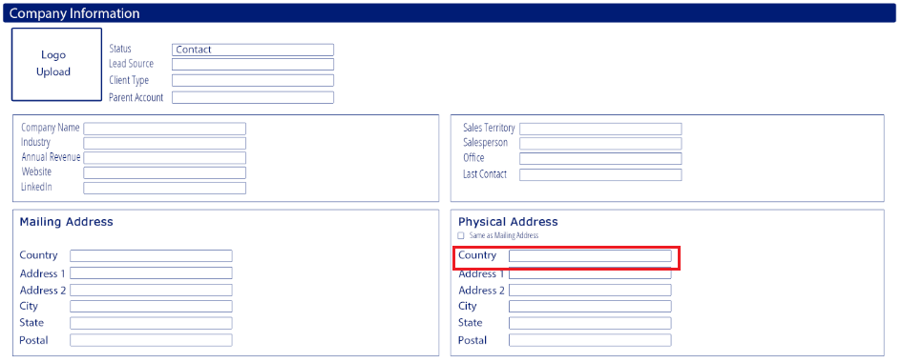

Function:
-informational field –company/Lead physical address

Details
-open input

Validation:
-

Physical Address: Address 1
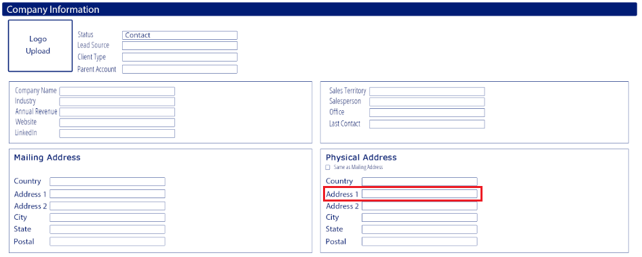

Function:
-informational field –company/Lead physical address

Details
-open input field

Validation:
-

Pysical Address: Address 2
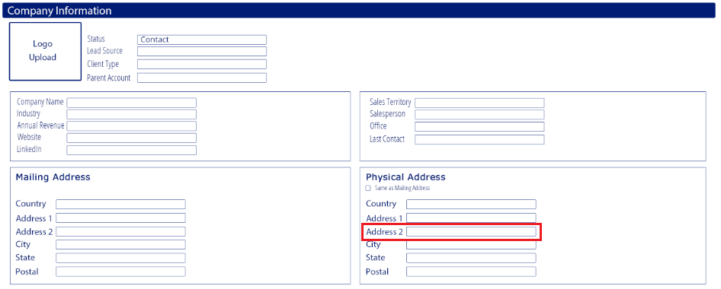

Function:
-informational field –company/Lead physical address

Details
-open input field

Validation:
-

Physical Address: City
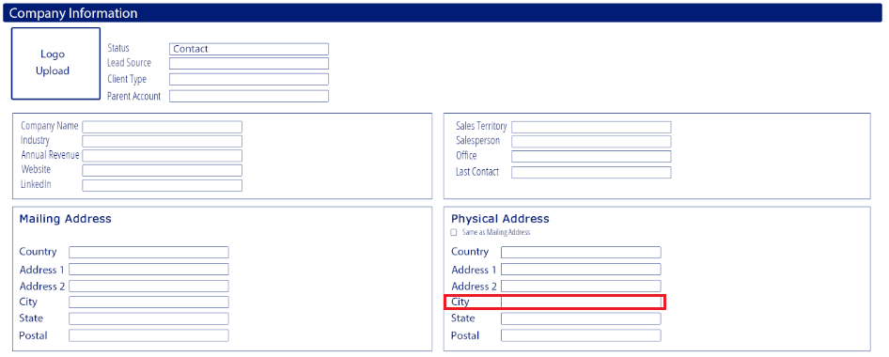

Function:
-informational field –company/Lead physical address

Details
-open input

Validation:
-

Physical Address: State
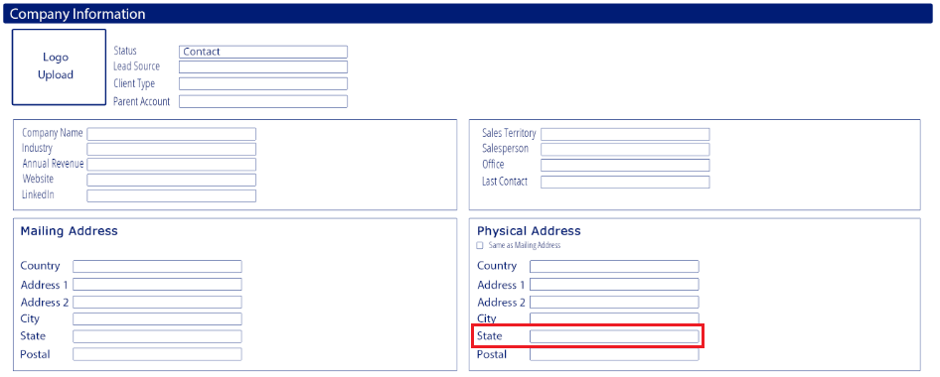

Function:
-informational field –company/Lead physical address

Details
-open input

Validation:
-

Physical Address: Postal
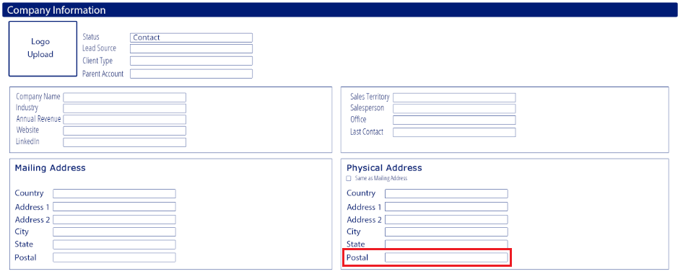

Function:
-informational field –company/Lead physical address

Details
-open input

Validation:
-

Add Lead: Contacts section
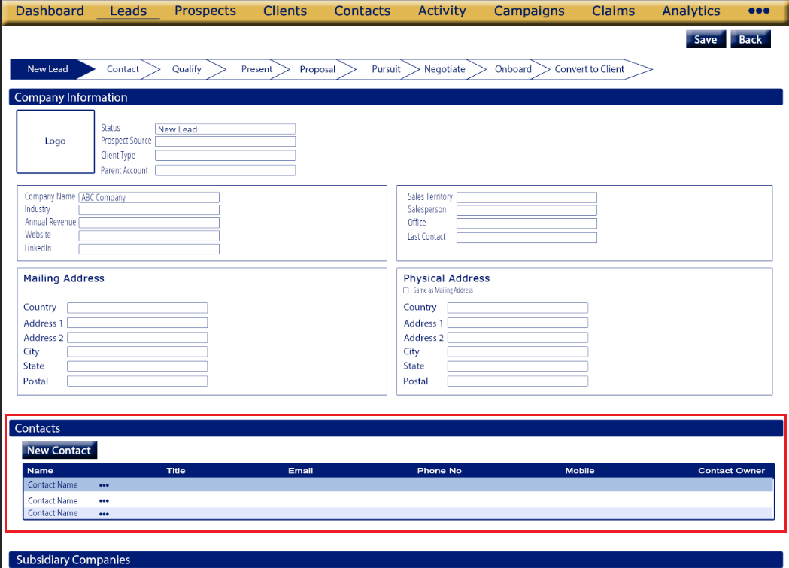
Purpose
-Contains contact information for the company/lead information
-allows the user to add new contact

Appearance
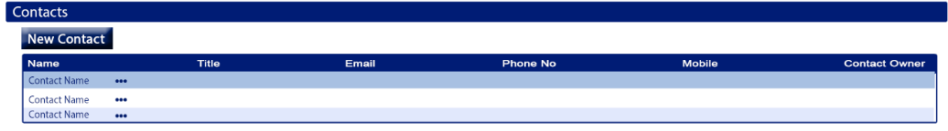
*located between the Company Information section and Subsidiary Companies section
*there will a blue title bar which can collapse when clicked (refer to image for appearance & layout)
*the Contact section will have a table and a Add new Contact button

Fields
New Contact
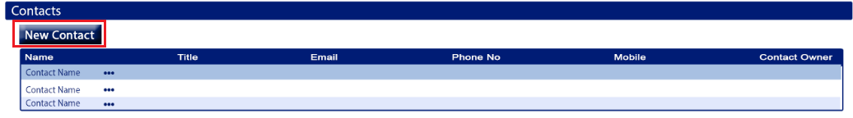
Function:
-used to add a new contact to the company/Lead

Details
- button
-refer to image for placement
-hover text: “Add New Contact”
-opens the New Contact screen
-after the user saves the contact from the New Contact screen
- they will be returned to the Add Lead screen
- the contact will be saved under the Contacts section of the company/Lead it was added from
- the contact will be saved in the Contact screen
-when clicked the New Contact screen will open with the Company Name field defaulted to the Company Name the Add Contact was started from
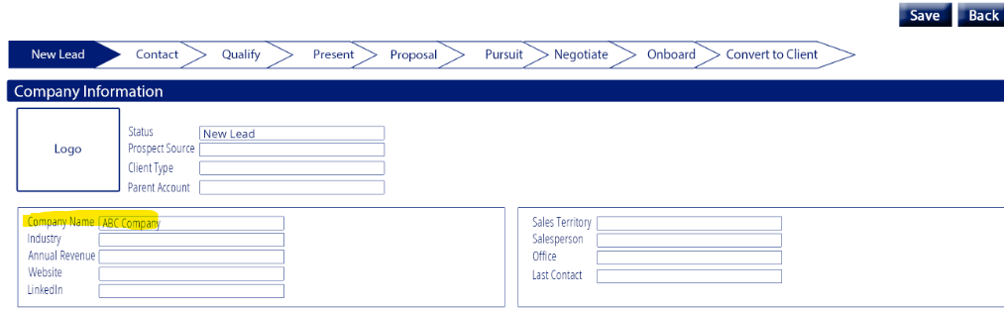
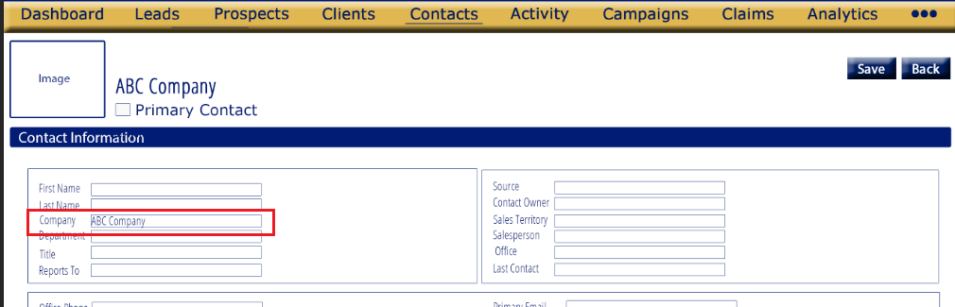

Validation:
-

Contacts Table
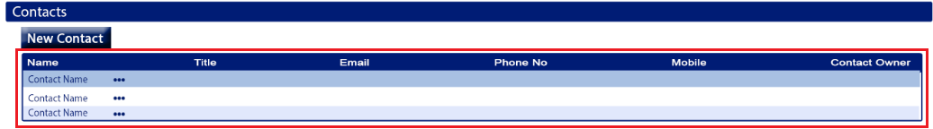
Function:
-provide information about the company/Lead’s contacts

Details
-refer to image for placement
-all columns should be sortable
-columns should be in the order shown in the image
-contacts in the table should be sorted by Name by default
-columns:
- Name
  - Displays full contact name
  - Comes from the Add Contact>Contact Information>First & Last Name fields
- Title
  - Comes from the Add Contact>Contact Information>Title field
- Email
  - comes from the Add Contact>Contact Information>Primary Email field
- Phone No
  - comes from the Add Contact>Contact Information>Office Phone field
- Mobile
  - comes from the Add Contact>Contact Information>Mobile field
- Contact Owner
  - comes from the Add Contact>Contact Information> Contact Owner field
-each contact should have a More Menu located between the Name and Title column
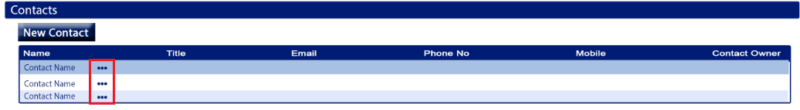

Validation:
-

Contacts Table: More Menu

Function:
-give the user more functions related to the company/Lead’s contacts

Details
-refer to image for placement
-should be a 3 dot menu icon
-hover text: “More options”
-options should be listed in the order given below
Options:
- Edit/View
- Email
- Delete

-Options:
- Edit/View
  - Opens the Edit/View Contact screen for the selected contact
- Email
  - Opens the New Email window with the selected contact’s primary email defaulted in the To field
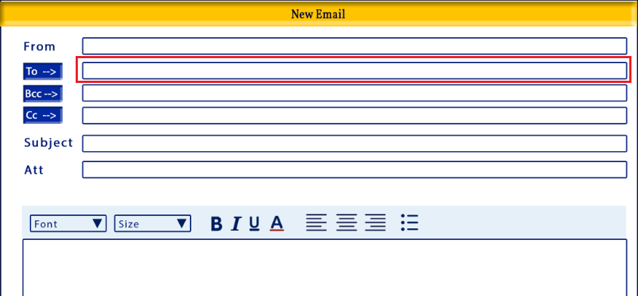
- Delete
  - Deletes the selected contact
    - When deleted is will be deleted from the Lead Contact Section as well as the Contacts screen
  - When clicked an alert should open
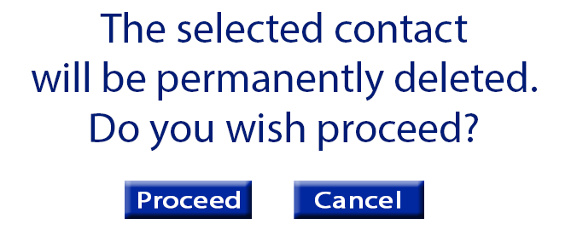
    - Message: “The selected contact will be permanently deleted. Do you wish to proceed?
    - Proceed button – closes the alert, deleted the contact and returns the user to the Add Lead screen
    - Cancel – closes the alert, and returns the user to the Add Lead screen without deleting the contact
Validation:
-

Add Lead: Subsidiary Companies section

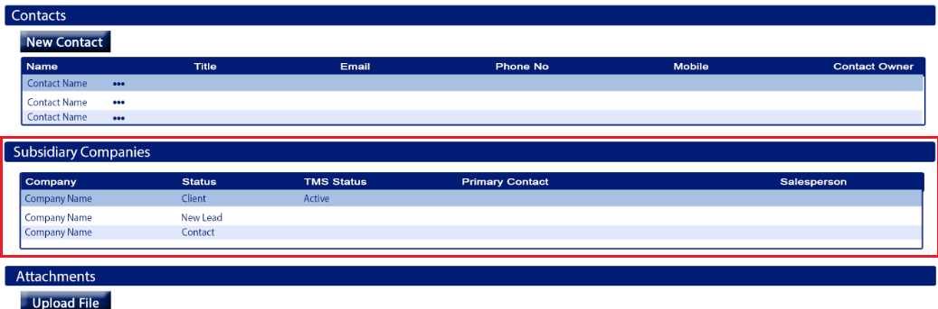
Purpose
-Contains information about the company/lead subsidiary companies
-informational only

Appearance
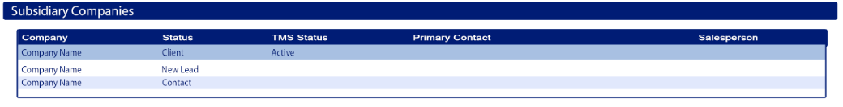
*located between the Contacts section and Attachments section
*there will a blue title bar which can collapse when clicked (refer to image for appearance & layout)
*this section will have a table with information about subsidiary companies

Fields
Contacts Table
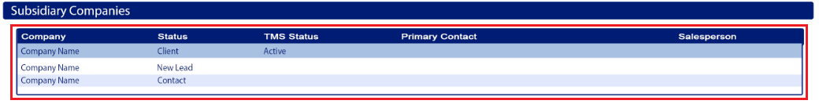
Function:
-provide information about the company/Lead’s subsidiary companies

Details
-refer to image for placement
-all columns should be sortable
-columns should be in the order shown in the image
-only companies/leads that are Client Type Parent will have data under the Subsidiary Companies section
-companies/leads that are Client Type Subsidiary will never have any data in the Subsidiary Companies section
-the data in this section comes from companies (leads, prospects and/or clients) that are Client Type Subsidiary and have the selected company/lead as their Parent Account
-the table should be sorted by Company by default
-columns:
  - Company
  - Status
  - TMS Status
  - Primary Contact
  - Salesperson

-column details:
  - Company
    - Comes from the subsidiary’s Company Name field of the lead, prospect or client that has the selected company/lead mapped as their Parent Account
  - Status
    - Comes from the subsidiary’s Status field of the lead, prospect or client that has the selected company/lead mapped as their Parent Account
  - TMS Status
    - Comes from the subsidiary’s TMS Status field of client that has the selected company/lead mapped as their Parent Account
    - The TMS Status will only be available for companies that are Status Client
  - Primary Contact
    - Comes from the subsidiary’s contact section of the lead, prospect or client that has the selected company/lead mapped as their Parent Account. It will be the name of the contact that is flagged as the primary contact for that subsidiary company
  - Salesperson
    - Comes from the subsidiary’s Salesperson field of client that has the selected company/lead mapped as their Parent Account
    - If there is more than one salesperson assigned to the subsidiary company all should be shown with a forward slash between them
Ex: JARED GRANDY/LEE BOWDISH

Validation:
-

Add Lead: Attachments section
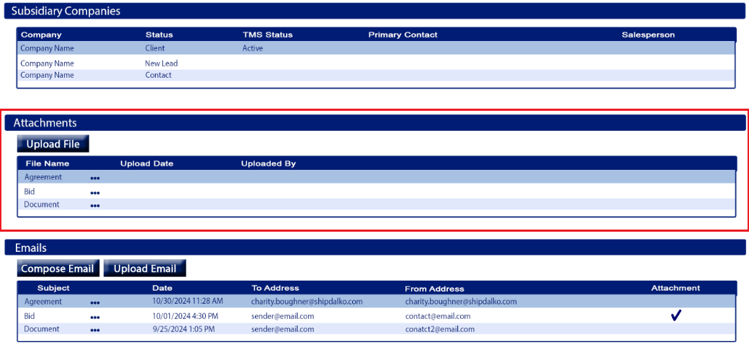
Purpose
-contains attachments/documents that users have upload for company/lead
-allows the user to upload files for company/lead

Appearance
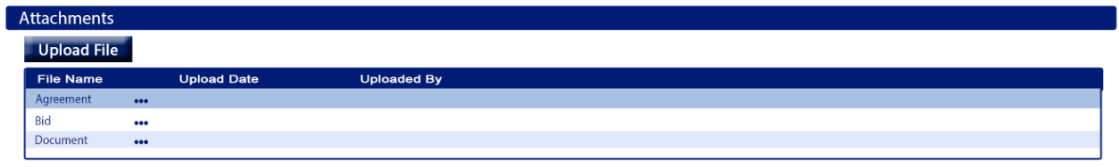
*located between the Subsidiary Companies section and Emails section
*there will a blue title bar which can collapse when clicked (refer to image for appearance & layout)
*the Attachments section will have a table and an Upload File button

Fields
Upload File
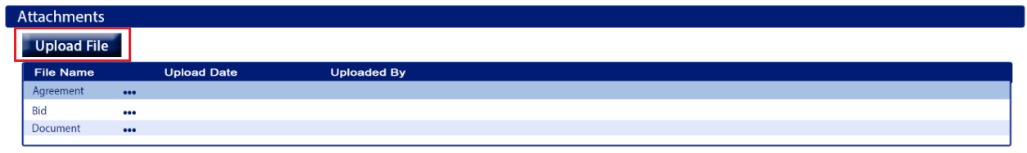
Function:
-used to upload files to the company/Lead

Details
- button
-refer to image for placement
-hover text: “Upload File”
-opens the Upload File/Document window
-after the user saves the file it will be saved/shown in the Attachments table

Validation:
-

Attachments Table
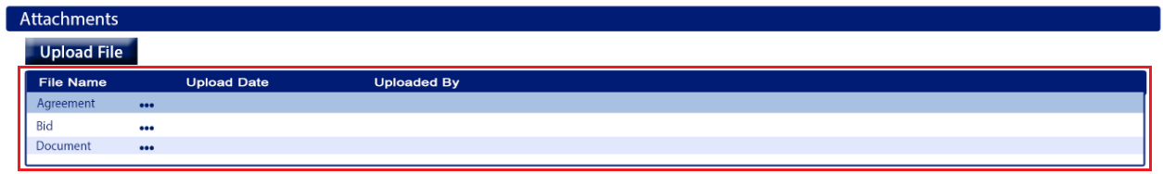
Function:
-provide information about the company/Lead’s attachments
-user can view, rename, email or delete uploaded files

Details
-refer to image for placement
-all columns should be sortable
-columns should be in the order shown in the image
-attachments in the table should be sorted by Uploaded Date by default, newest to oldest
-columns:
- File Name
    - The file name assigned by the user
- Uploaded Date
    - The date the file was uploaded
  - Uploaded By
    - The full name of the user that uploaded the file
-each attachment should have a More Menu located between the File Name and Uploaded Date column
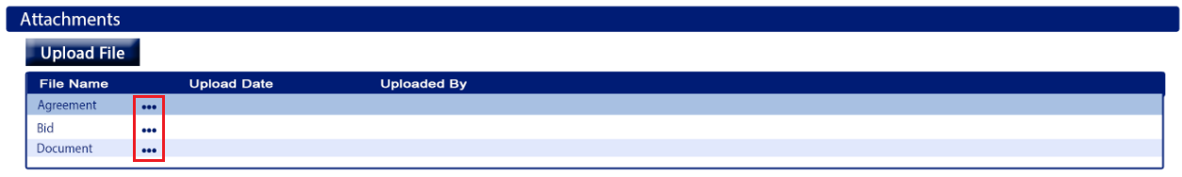

Validation:
-

Attachments Table: More Menu

Function:
-give the user more functions related to the company/Lead’s attachments

Details
-refer to image for placement
-should be a 3 dot menu icon
-hover text: “More options”
-options should be listed in the order given below
Options:
- View
- Email
- Delete
- Rename

-Options:
- View
  - Opens the attachment file
- Email
  - Opens the New Email window with the selected file attached
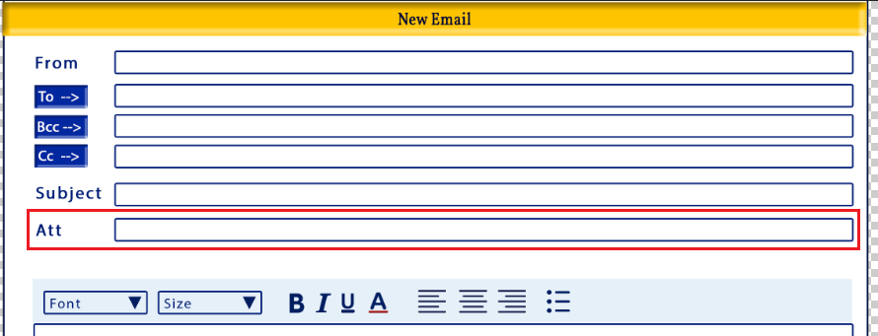
- Delete
  - Deletes the selected attachment/file
  - When clicked an alert should open
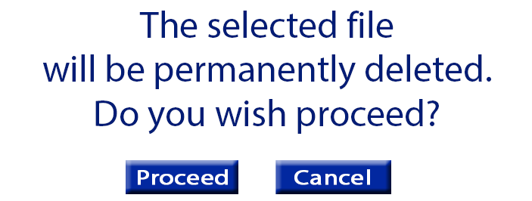
    - Message: “The selected file will be permanently deleted. Do you wish to proceed?
    - Proceed button – closes the alert, deleted the file and returns the user to the Add Lead screen
    - Cancel – closes the alert, and returns the user to the Add Lead screen without deleting the file
- Rename
  - Allows the user to rename the file
  - Opens the Rename File popup
    - Refer to image below for appearance and wording
    - There should be an open input field that displays the current file name, and the user can modify it
    - To the right of the file name input field the file extension should be shown, this is non-editable
      - Rename updates the file name
        - Fiel name required
      - Cancel closes the alert without updating the file name
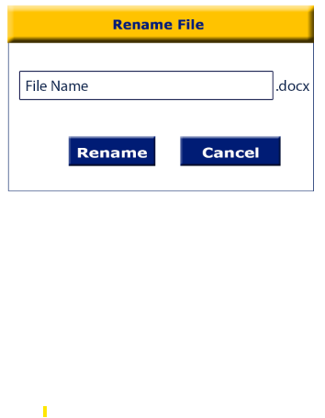

Validation:
-

Upload Attachment Window
Appearance
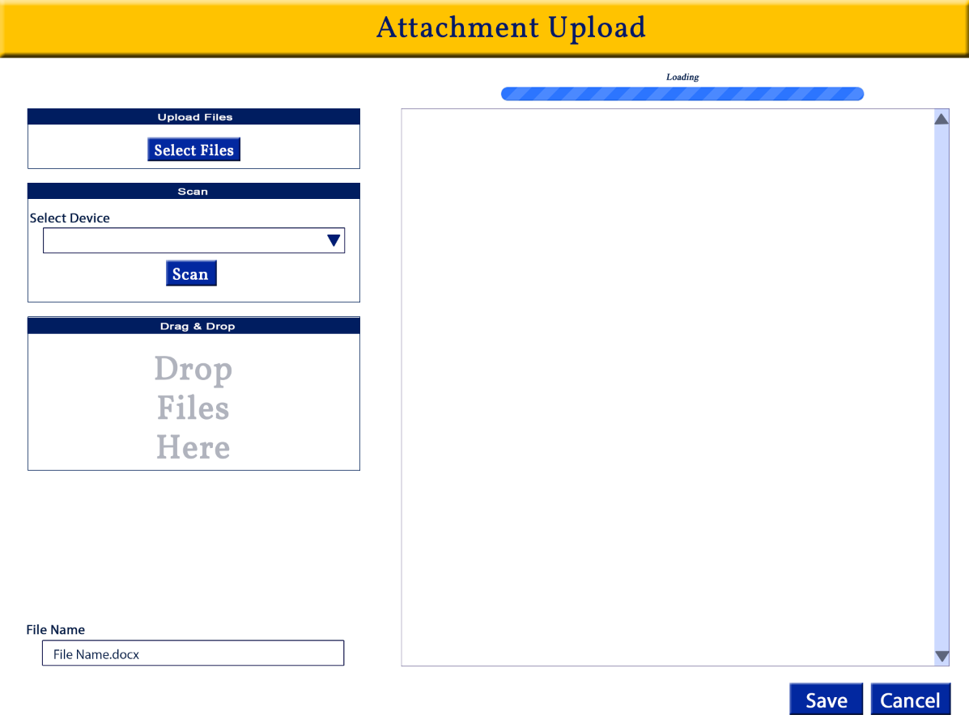

Tab Order:
- Select Files
- Device Selection
- Scan
- File Name
- Save
- Cancel

Required
-in order to save:
- A file must be uploaded
- File name is required
Fields
Select Files
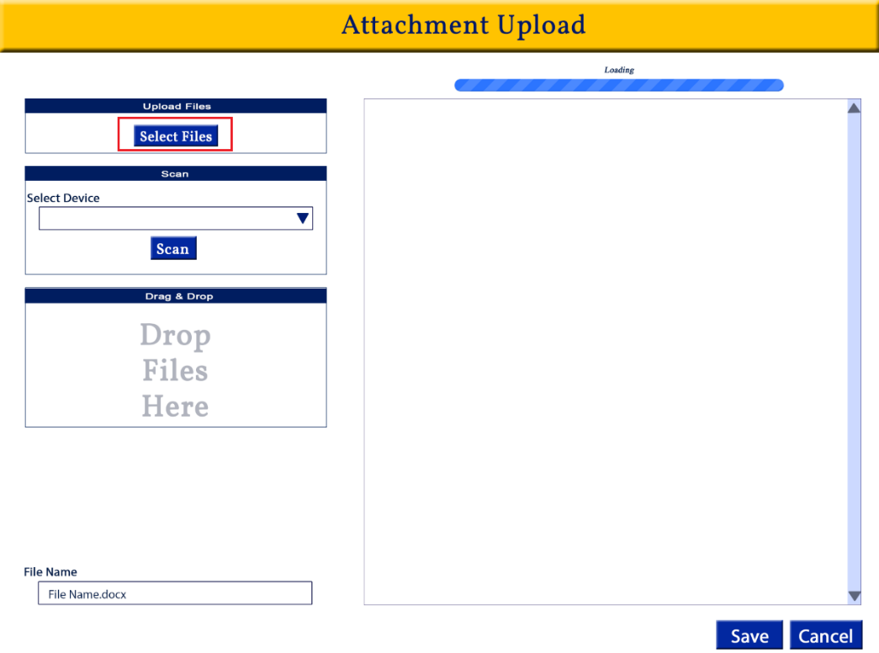
Function:
-Allows the user to select a file saved to the user’s computer or other locations
Details:
-refer to image for placement & appearance
-opens a window to locate the file on the user’s computer. Once selected the file should upload into the preview panel (right section of the image above)
-all file formats accepted
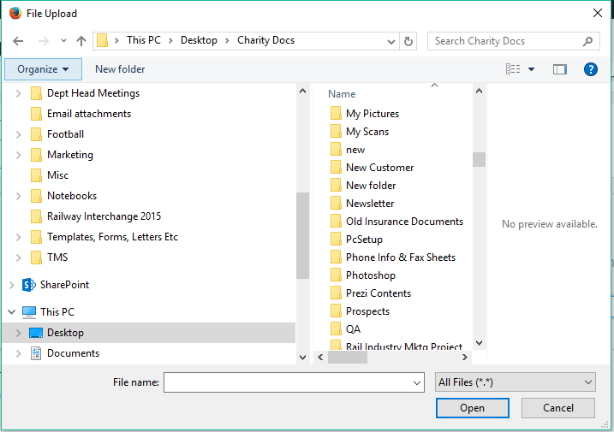

Validation:
-

Select Device
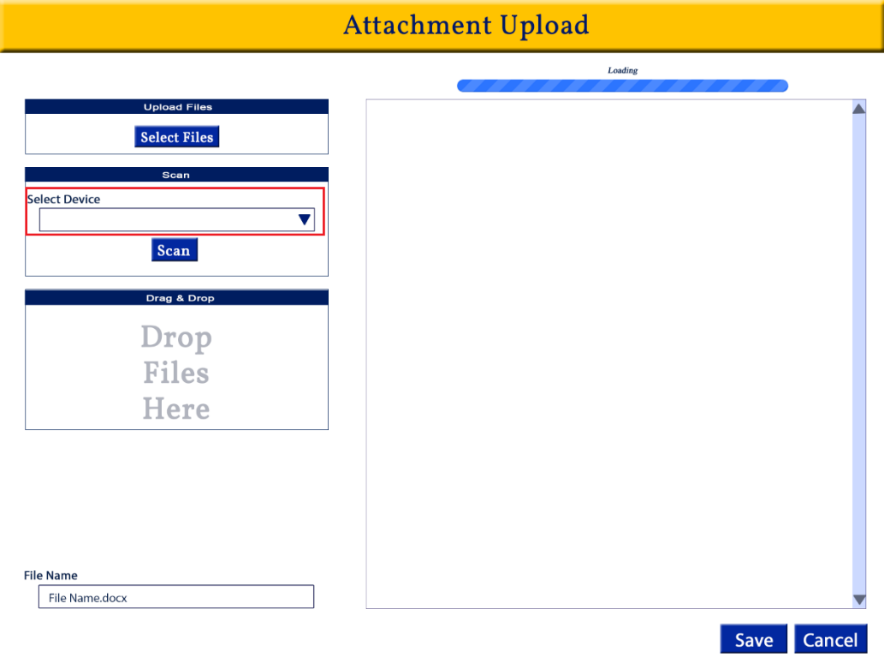
Function:
-Allows the user to select the device that they want to use to Scan a document
Details:
-dropdown menu
-displays all available devices
-sort options alphabetically
-refer to image for placement and appearance

Validation:
-required if the user tries to use the Scan button
Alert message: Please select the Device for scanning

Scan
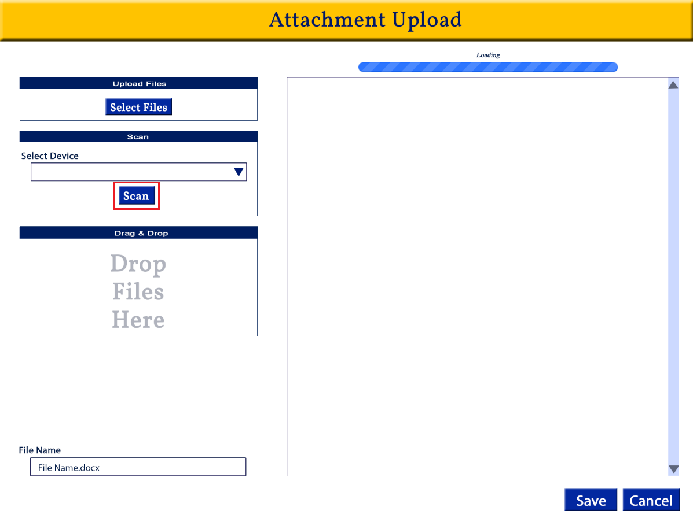
Function:
-starts the scanning process
Details:
-button
-refer to image for placement and appearance
-when selected, it starts the scanning process & loads the file into the preview panel

Validation:
-the Select Device field is required if the user tries to use the Scan button
Alert message: Please select the Device for scanning

Drag & Drop
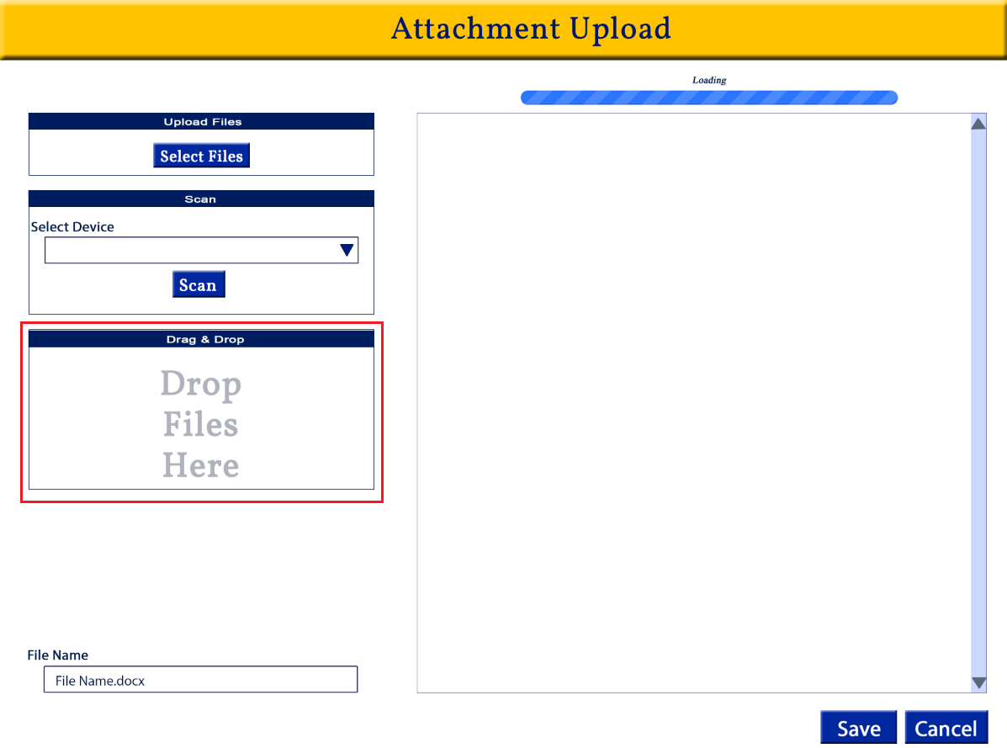

Function:
-allows the user to drag a file from their computer, email or other source and drop it for upload
Details:
-refer to image for placement and appearance
-user should be able to drag & drop files from anywhere on their computer or email
-once dropped here the upload process should begin and the file should load into the preview panel
-all file formats accepted

Validation:
-

File Name
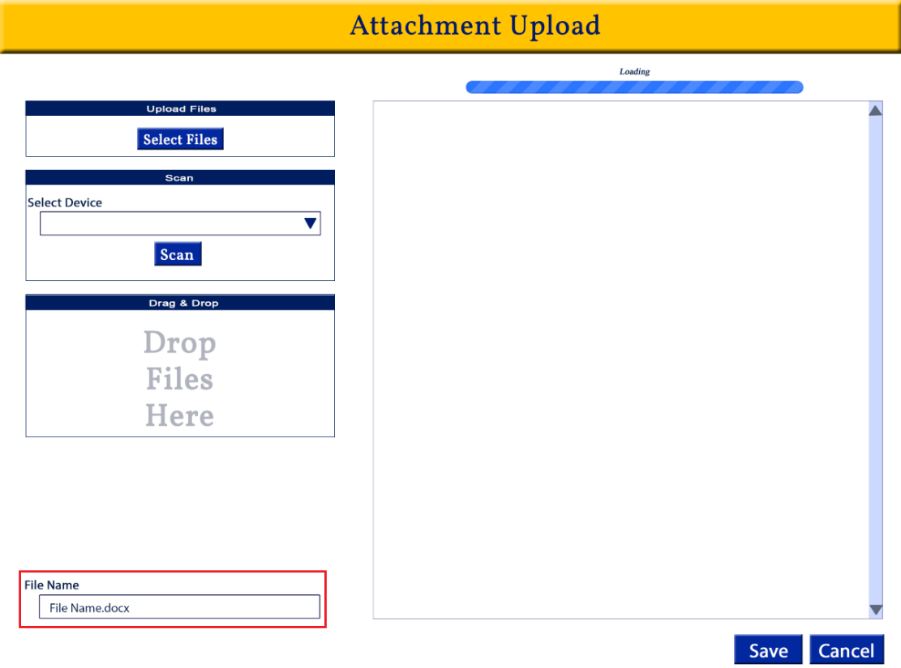
Function:
-the name of the file that will appear in the system
Details:
– text box
-open character
-if the file name is longer than the character limit there should be an on screen message below the file name in red italicized font
“Character limit of __ exceeded”
-if the user uses the Upload or Drag & Drop function the file name should automatically populate with the File Name field
-user should be able to modify the name
-if the user uses the Select Files function the file name should automatically populate with the File Name field
-user should be able to modify the name
-if the scan function is used
-if a file name is automatically generated, populate this into the New File Name field
-user should be able to modify
-if no file name is generated when a document is scanned the New File Name field should be blank
User can modify
-when the file is saved, this is the name that will appear on screen
-File Name is displayed in the Attachment section
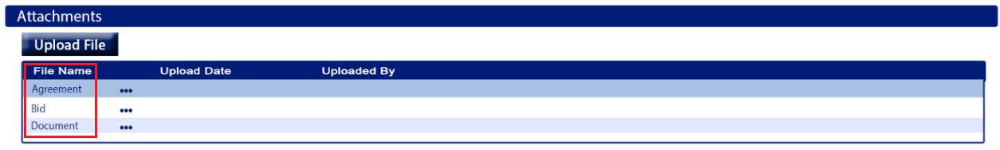
Validation:
-required field

Progress bar
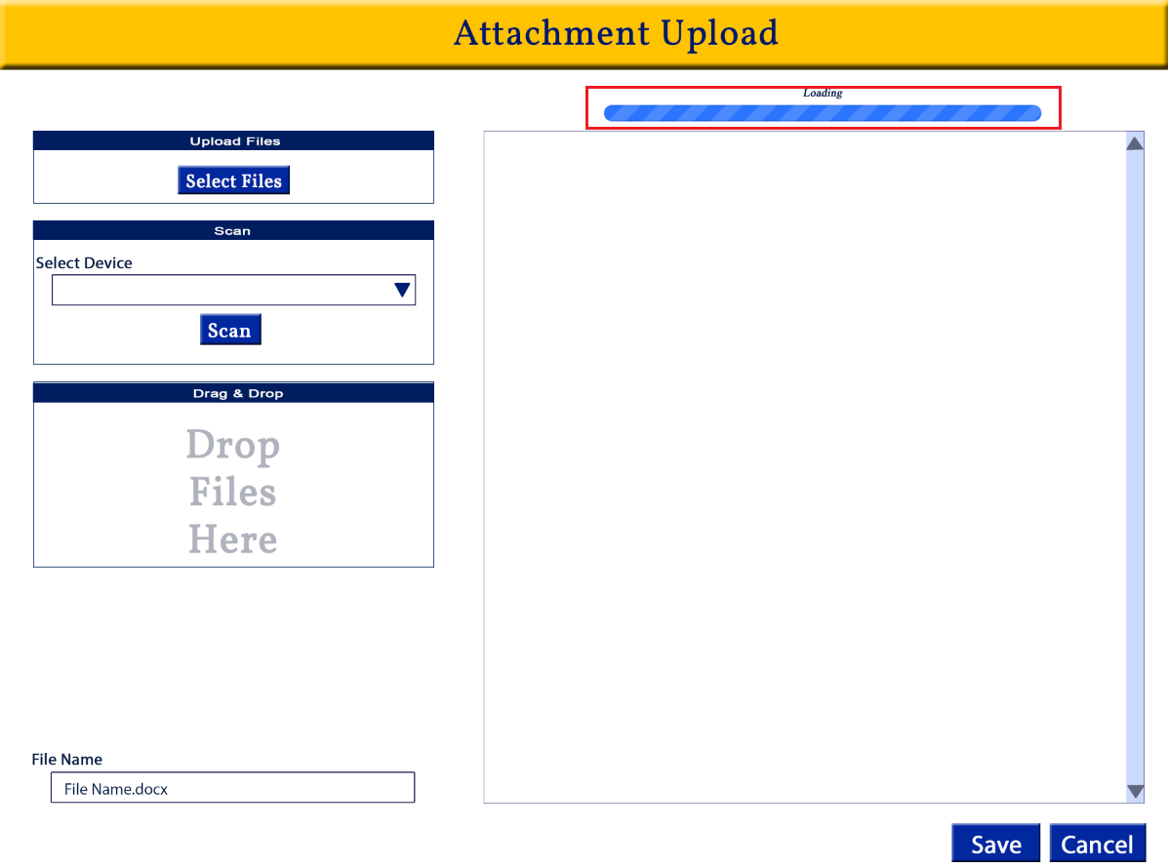

Function:
-tracks the process of the file upload and provides a visual for the user
Details:
-should track the process of the file upload
-when an upload is in progress the word Loading should appear above the Progress Bar
-when the file upload is complete the word Completed should appear above the Progress Bar
Colors:
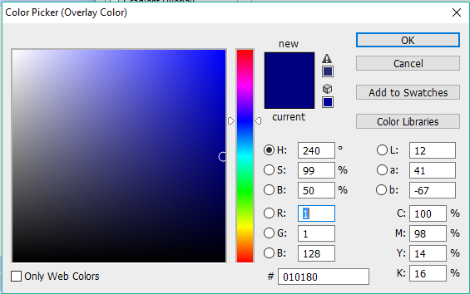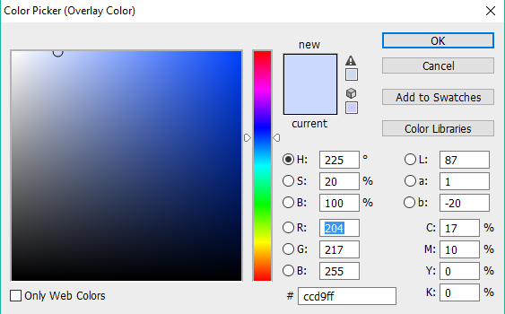

Validation:
-

Preview Panel
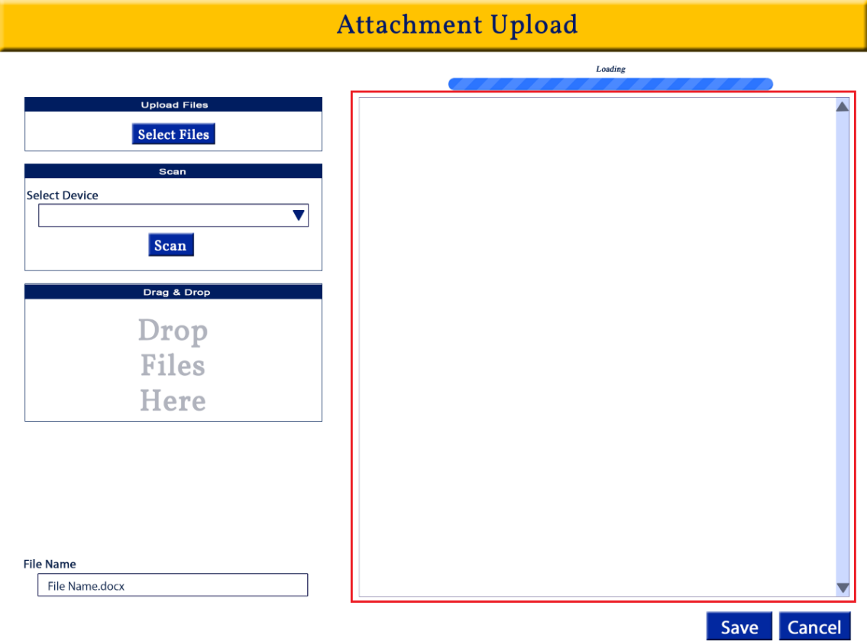

Function:
-shows a preview of the file that the user is attempting to upload
-the preview panel allows the user to review what is being uploaded before it is saved to the shipment
Details:
-displays a preview of the file that the user is attempting to upload
-display all file formats
-user should be able to see all pages if there are multiple

Validation:
-

Save
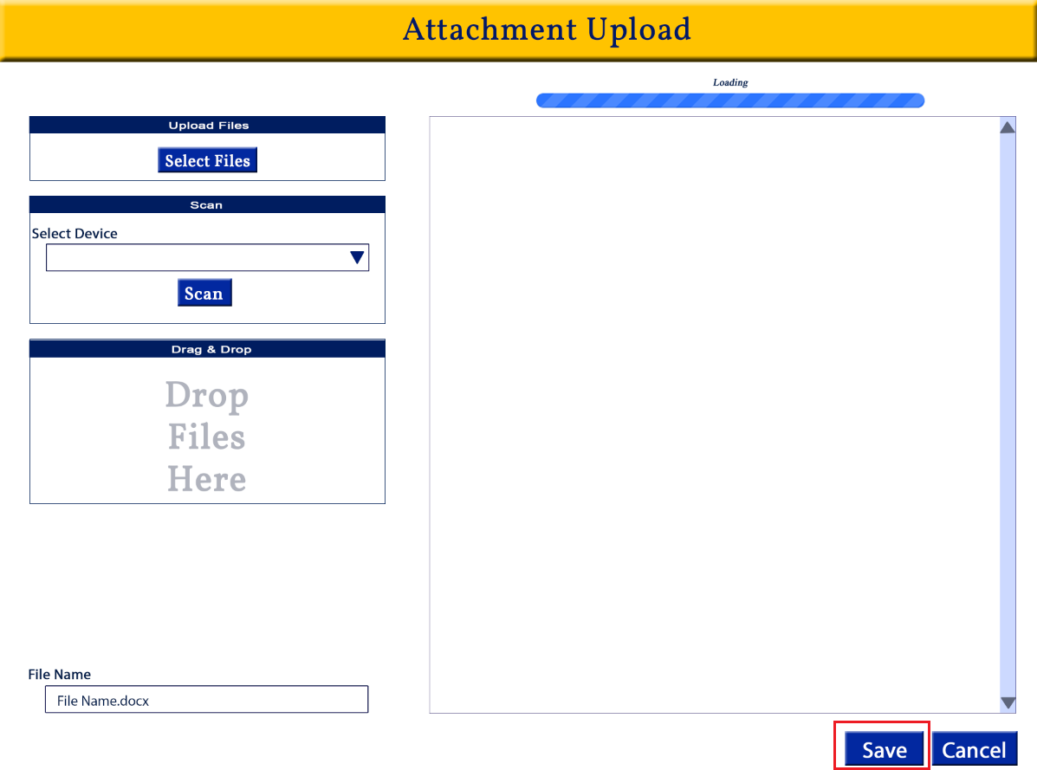
Function:
-saves the uploaded file to the Attachments section of the company/Lead

Details:
-button
-refer to image for placement and appearance
-when selected, it saves the file that was uploaded to the company in the attachments section along with the file details
-file should be saved with the File Name, the date is was saved and the full name of the user that uploaded the file
-window will close after it is save and return the user to the Add Lead screen

Validation:
-

Cancel
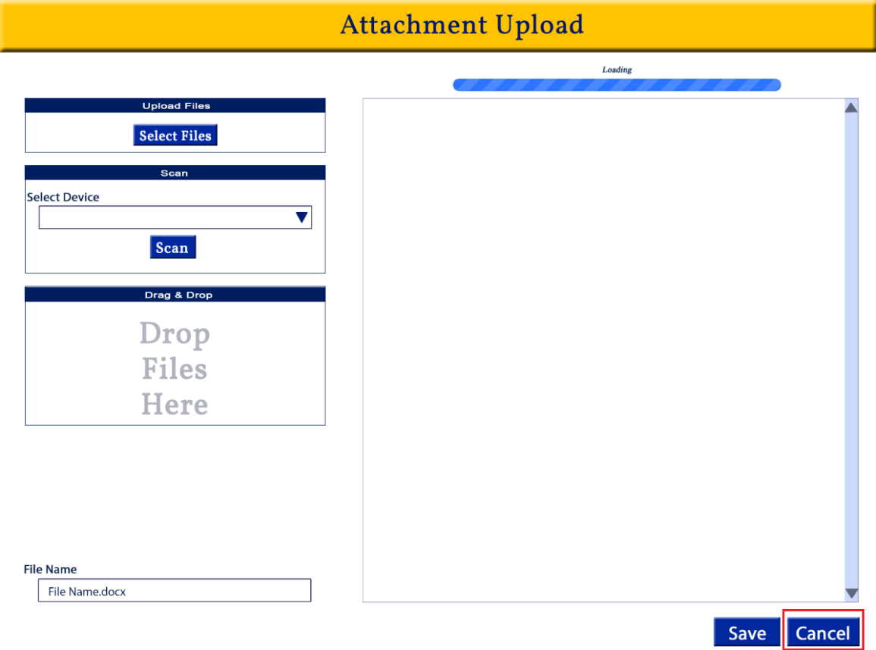
Function:
-closes the File Upload window without saving

Details:
-button
-refer to image for placement and appearance
- closes the File Upload window without saving and returns the user to the Add Lead Attachment section
-does not add any documentation to the company/lead

Validation:
-If the user has made changes to any fields and/or added a file and click the Cancel button there should be a Changes Not Saved Alert
Message:
Changes have not been saved. Do you wish to save changes or proceed without saving?

Save button – saves the file and associate information, closes the alert and returns the user to the Add Lead screen Attachments section

Proceed button – closes the alert and returns the user to the Add Lead screen Attachments section without saving the file
Cancel button – closes the alert and returns the user to the File Upload screen they were on prior to clicking the Cancel button

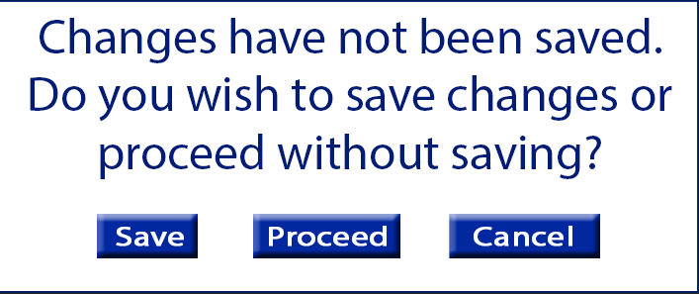

-if no changes were made or files added the alert should not open

Add Lead: Emails section
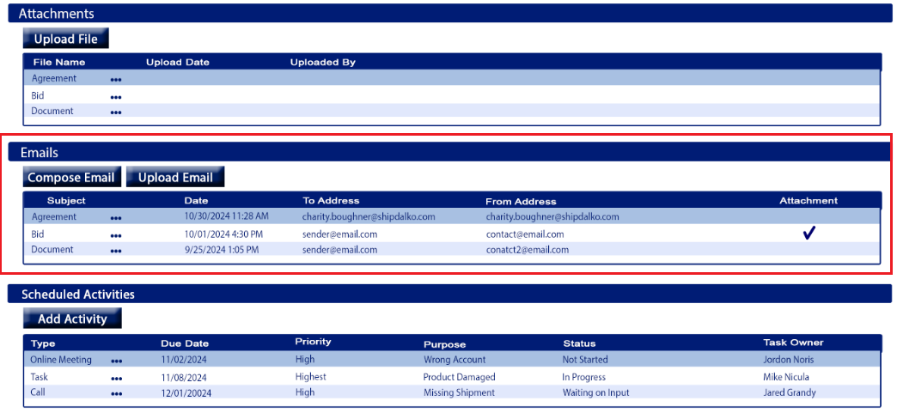
Purpose
-contains emails that users have upload for company/lead or emailed from CRM
-allows the user to upload emails for company/lead
-allows the user to send emails directly from the CRM Add Lead screen & the sent email will be store in the Emails table

Appearance
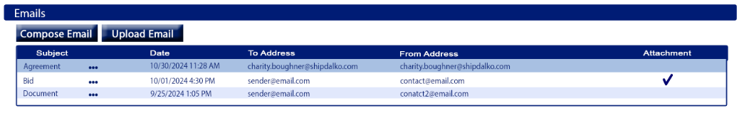
*located between the Attachments section and Activities section
*there will a blue title bar which can collapse when clicked (refer to image for appearance & layout)
*the section will have a table, Compose Email button and an Upload Email button
Fields
Compose Email
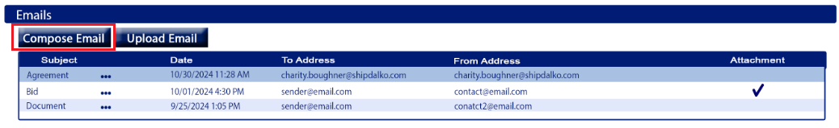
Function:
-used to create & send an email, then store that email under the company/Lead it was created under

Details
- button
-refer to image for placement
-hover text: “New Email”
-opens the New Email window
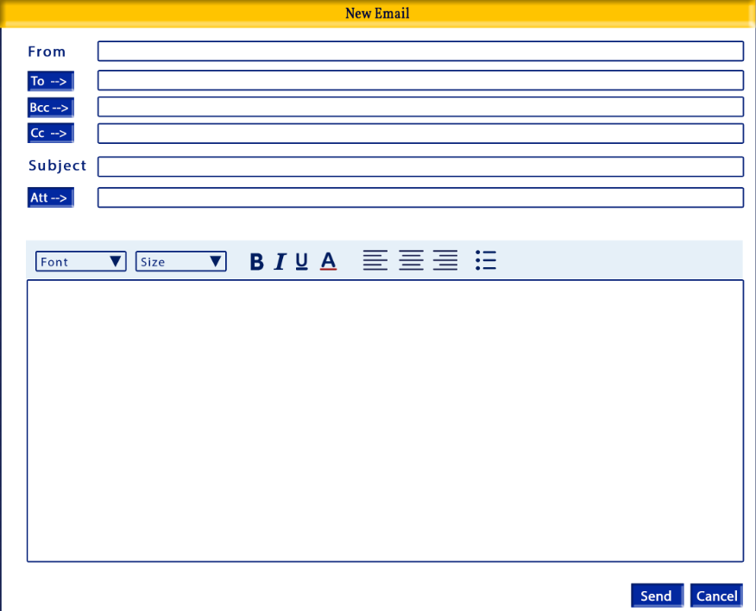
-after the user sends the email the email and will be saved/shown in the Emails table
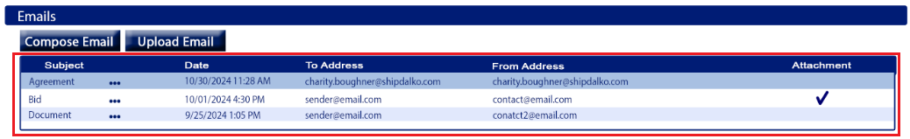

Validation:
-

Upload Email
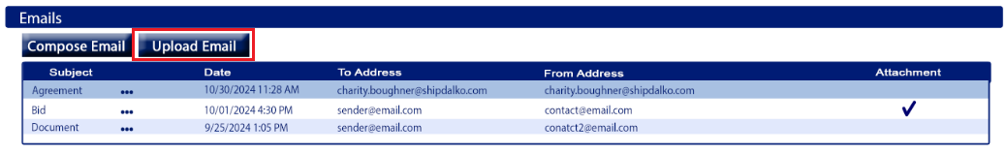
Function:
-used to upload emails to the company/Lead

Details
- button
-refer to image for placement
-hover text: “Upload Email”
-opens the Upload File/Document window
-after the user saves the email file it will be saved/shown in the Emails table


Validation:
-

Emails Table
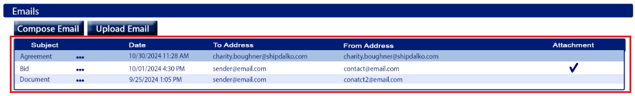
Function:
-provide information about the company/Lead’s past email
-user can view or delete saved emails

Details
-refer to image for placement
-all columns should be sortable
-columns should be in the order shown in the image
-emails in the table should be sorted by Date (newest to oldest) then To Address by default
-columns:
- Subject
    - The email’s subject line
- Date
    - The date the email was sent
  - To Address
    - The email address(s) the email was sent to (Email To line)
  - From Address
    - The email address(s) that the email was sent from (Email From line)
  - Attachment
    - Displays whether the email had an attachment to not
    - If the email has an attachment there should be a checkmark in this column for that email

-each attachment should have a More Menu located between the Subject and Date column
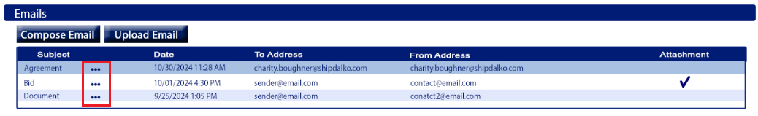

Validation:
-

Email Table: More Menu

Function:
-give the user more functions related to the company/Lead’s saved emails

Details
-refer to image for placement
-should be a 3 dot menu icon
-hover text: “More options”
-options should be listed in the order given below
Options:
- View
- Delete

-Options:
- View
  - Opens the email, view only user cannot edit
- Delete
  - Deletes the selected saved email
  - When clicked an alert should open

    - Message: “The selected file will be permanently deleted. Do you wish to proceed?
    - Proceed button – closes the alert, deletes the saved email and returns the user to the Add Lead screen
    - Cancel – closes the alert, and returns the user to the Add Lead screen without deleting the email

Emails section: Upload Email Window
Appearance
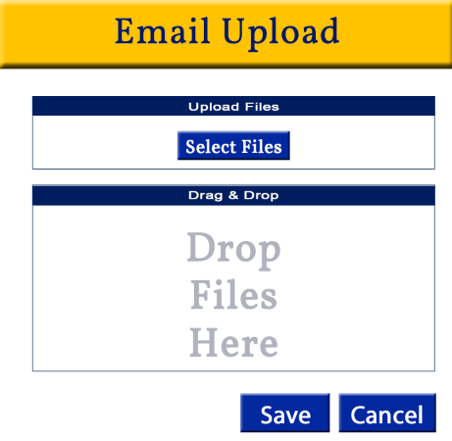

Tab Order:
- Select Files
- Save
- Cancel

Required
-in order to save:
- A file must be uploaded

Fields
Select Files
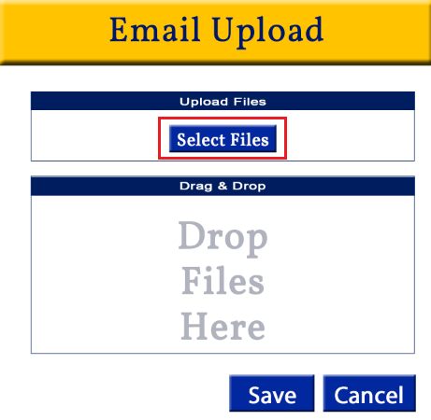
Function:
-Allows the user to select an email saved to the user’s computer or other locations
Details:
-refer to image for placement & appearance
-opens a window to locate the email on the user’s computer. Once selected the email should upload
-the email will not be saved to the Company/Lead Email section until the user Saves



Validation:
-

Drag & Drop
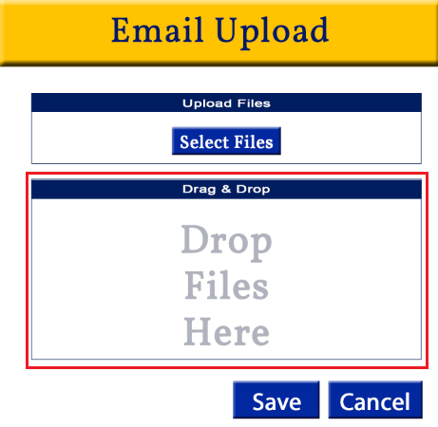

Function:
-allows the user to drag an email from their computer, email program or other source and drop it for upload
Details:
-refer to image for placement and appearance
-user should be able to drag & drop files from anywhere on their computer or email
-once dropped here the upload process should begin
-the email will not be saved to the Company/Lead Email section until the user Saves

Validation:
-

Save
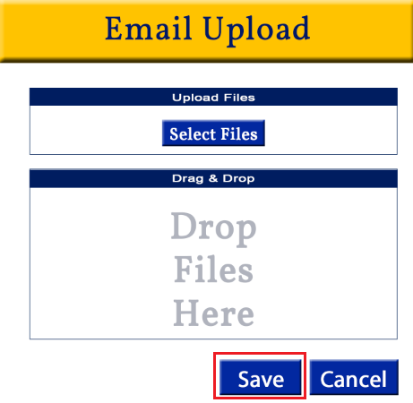
Function:
-saves the uploaded email to the Emails section of the company/Lead

Details:
-button
-refer to image for placement and appearance
-when selected, it saves the email that was uploaded to the company in the Emails section along with the email details
-window will close after it is saved and return the user to the Add Lead screen

Validation:
-

Cancel
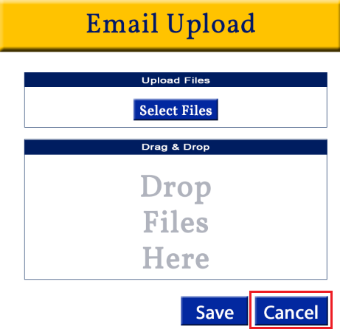
Function:
-closes the Email Upload window without saving

Details:
-button
-refer to image for placement and appearance
- closes the Email Upload window without saving and returns the user to the Add Lead Emails section
-does not add any email to the company/lead

Validation:
-If the user has added a file and click the Cancel button there should be a Changes Not Saved Alert
Message:
Changes have not been saved. Do you wish to save changes or proceed without saving?

Save button – saves the file and associate information, closes the alert and returns the user to the Add Lead screen Attachments section

Proceed button – closes the alert and returns the user to the Add Lead screen Attachments section without saving the file
Cancel button – closes the alert and returns the user to the File Upload screen they were on prior to clicking the Cancel button



-if no changes were made or files added the alert should not open

Add Lead: Activities section
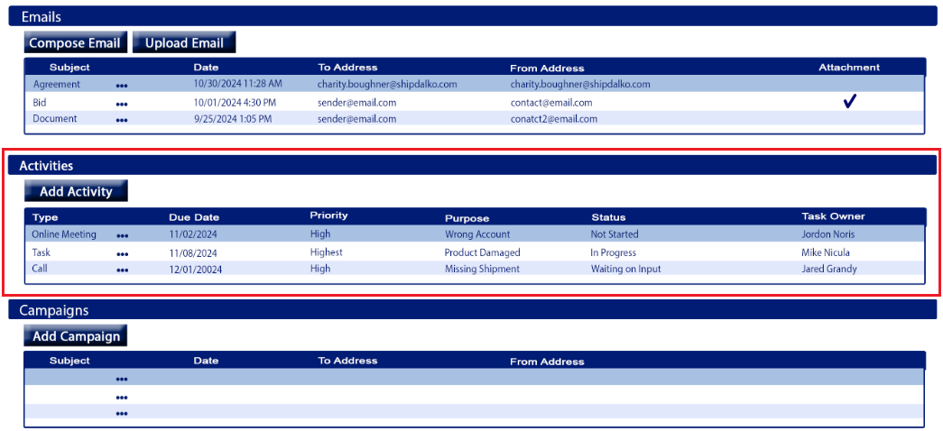

Purpose
-contains activities that users have scheduled and/or completed for company/lead
-allows the user to add activities for company/lead

Appearance
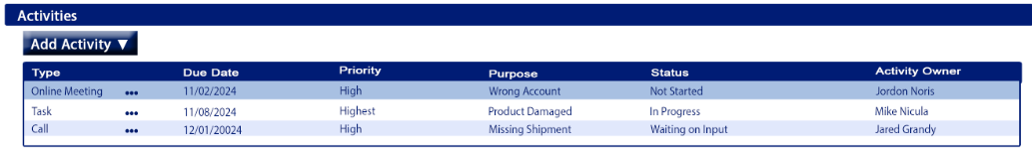
*located between the Emails section and Campaigns section
*there will a blue title bar which can collapse when clicked (refer to image for appearance & layout)
*the section will have a table, and an Add Activity button

Fields
Add Activity
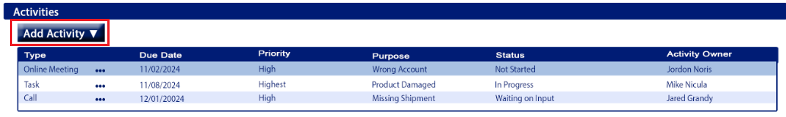
Function:
-used to add an activity, then store that activity under the company/Lead it was created under

Details
- button
-refer to image for placement
-hover text: “Add New Activity”
-when clicked there should be a dropdown menu with Activity options
-Activity options should be listed alphabetically
-Activity options:
- Call
- Event
- Meeting
- Task
-once an Activity type is chosen the corresponding Add Activity screen will open
-each Activity type will be detailed in the Add Activities document, until then use the existing Add Activities screen
-the screen will open with the Company Name field defaulted to the Company Name the Add Activity was started from
-after the user saves the Activity from the Add Lead screen
- they will be returned to the Add Lead screen
- the Activity will be saved under the Activities section in the Activities table of the company/Lead it was added from
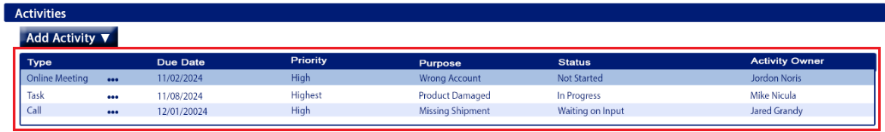
- the Activity will be saved in the Activity screen

Validation:
-

Activities Table

Function:
-provide information about scheduled and past activities for the company/Lead’s
-user can view, update and delete existing Activities

Details
-refer to image for placement
-all columns should be sortable
-columns should be in the order shown in the image
-Activities in the table should be sorted by Due Date by default, newest to oldest
-columns:
- Type
    - Type of Activity:
      - Call, Event, Meeting or Task
- Due Date
    - The date the activity is due
  - Priority
    - The priority level of the Activity
  - Purpose
    - The purpose of the Activity
  - Status
    - The status of the Activity
  - Activity Owner
    - The owner of the Activity

-each Activity should have a More Menu located between the Type and Due Date columns
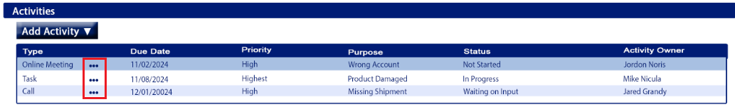

Validation:
-

Activities Table: More Menu

Function:
-give the user more functions related to the company/Lead’s saved activities

Details
-refer to image for placement
-should be a 3 dot menu icon
-hover text: “More options”
-options should be listed in the order given below
Options:
- View/Update
- Delete

-Options:
- View
  - Opens the Activity, the user can view and/or update the Activity details
- Delete
  - Deletes the selected saved Activity
  - When clicked an alert should open
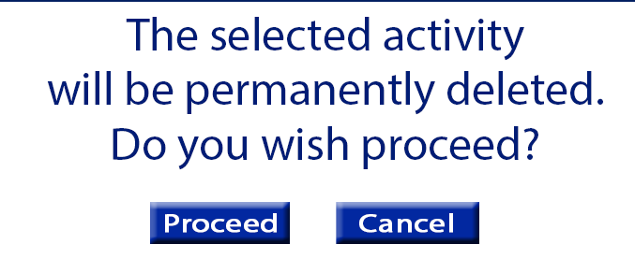
    - Message: “The selected activity will be permanently deleted. Do you wish to proceed?
    - Proceed button – closes the alert, deletes the activityand returns the user to the Add Lead screen
    - Cancel – closes the alert, and returns the user to the Add Lead screen without deleting the activity

Add Lead: Campaigns section
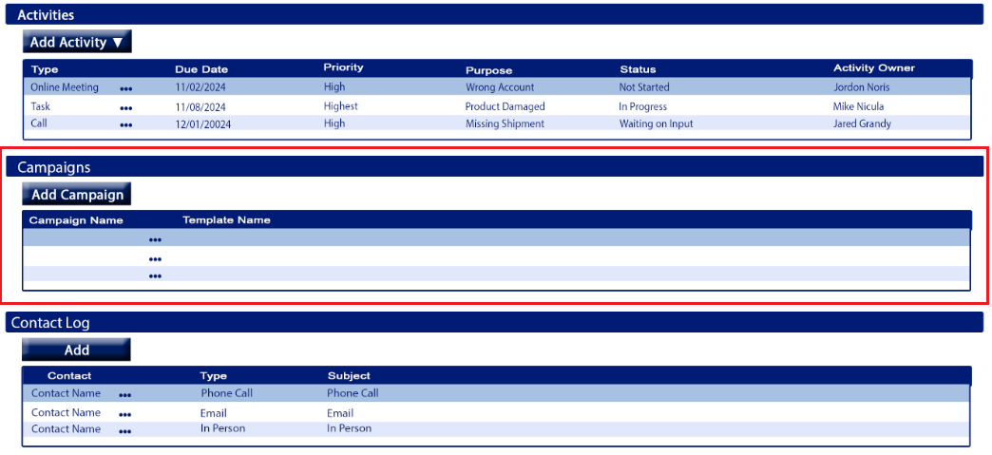

Purpose
-shows the campaigns used for company/lead

Appearance
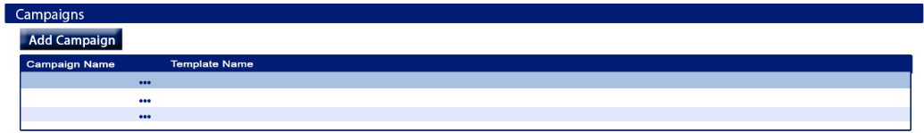
*located between the Activities section and Contact Log section
*there will a blue title bar which can collapse when clicked (refer to image for appearance & layout)
*the section will have a table, and an Add Campaign button

Fields
Add Campaign
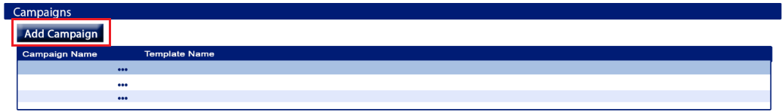
Function:
-used to add a campaign to the company/Lead it was created under

Details
**only updating the appearance and layout, functionality, rules, etc. stay the same as the existing
- button
-refer to image for placement and appearance
-hover text: “Add Campaign”

Validation:
-

Campaign Table
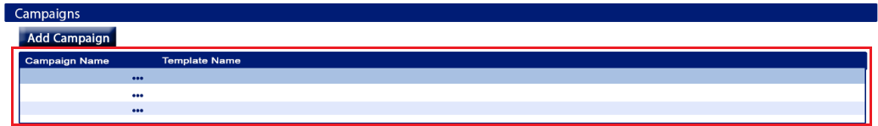
Function:
-provide information about campaigns for the company/Lead’s
-user can view an existing Activity or remove it from the Company/Lead

Details
-refer to image for placement
-all columns should be sortable
-columns should be in the order shown in the image
-Campaigns in the table should be sorted by Campaign Name by default
-columns:
- Campaign Name
- Template Name

-each Campaign should have a More Menu located between the Campaign Name and Template Name columns
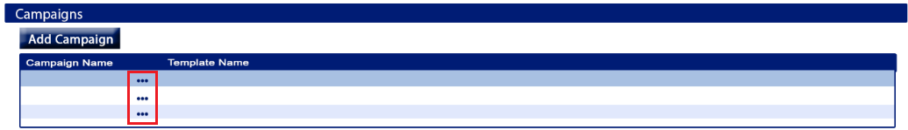

Validation:
-

Campaigns Table: More Menu

Function:
-give the user more functions related to the company/Lead’s campaigns

Details
-refer to image for placement
-should be a 3 dot menu icon
-hover text: “More options”
-options should be listed in the order given below
Options:
- View
- Remove

-Options:
- View
  - Opens the Campaign, same functionality as the current systems view campaign link
- Delete
  - Removes the Campaign from the company/lead but does not delete it from the Campaigns screen
Validation
-

Campaign Table

Function:
-provide information about campaigns for the company/Lead’s
-user can view an existing Activity or remove it from the Company/Lead

Details
-refer to image for placement
-all columns should be sortable
-columns should be in the order shown in the image
-Campaigns in the table should be sorted by Campaign Name by default
-columns:
- Campaign Name
- Template Name

-each Campaign should have a More Menu located between the Campaign Name and Template Name columns


Validation:
-

Campaigns Table: More Menu

Function:
-give the user more functions related to the company/Lead’s campaigns

Details
-refer to image for placement
-should be a 3 dot menu icon
-hover text: “More options”
-options should be listed in the order given below
Options:
- View
- Remove

-Options:
- View
  - Opens the Campaign, same functionality as the current systems view campaign link
- Delete
  - Removes the Campaign from the company/lead but does not delete it from the Campaigns screen
Validation
-

Add Lead: Contact Log section
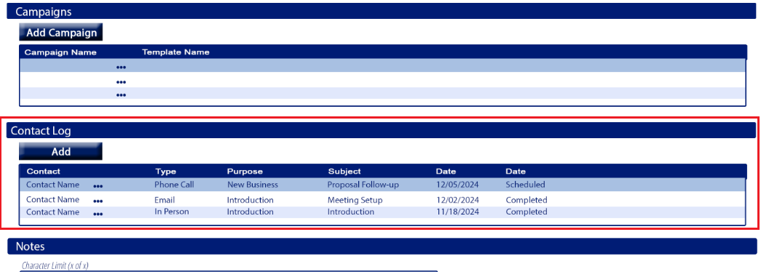

Purpose
-a log of all contact made with the company/lead

Appearance
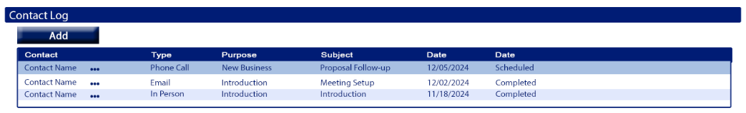
*located between the Campaigns section and Notes section
*there will a blue title bar which can collapse when clicked (refer to image for appearance & layout)
*the section will have a table, and an Add button

Fields
Add
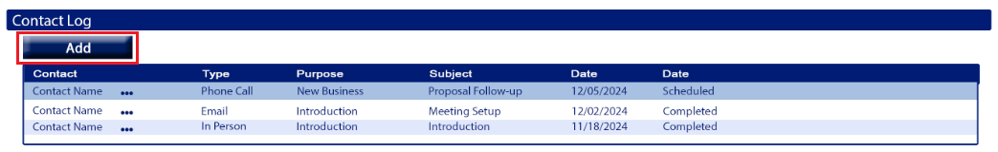
Function:
-used to add a contact log to the company/Lead

Details
- button
-refer to image for placement and appearance
-hover text: “Add log entry”
-Open Add Log screen

Validation:
-

Contact Log Table
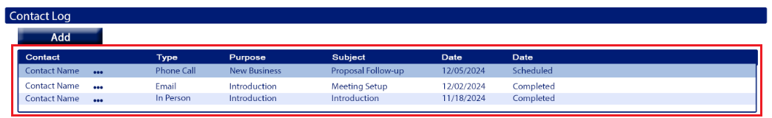
Function:
-provide information about contacts that have been made with the company/Lead’s
-user can view an existing log and or update the log entry for the Company/Lead

Details
-refer to image for placement and appearance
-all columns should be sortable
-columns should be in the order shown in the image
-the table should be sorted by Date by default, newest to oldest
-columns:
- Contact
    - Name of the contact
- Type
    - Contact log type:
  - Purpose
    - Purpose of the contact
  - Subject
    - The subject of the contact
  - Date
    - Date of contact
  - Status
    - The status of the contact

-each Contact Log should have a More Menu located between the Contact and Type columns
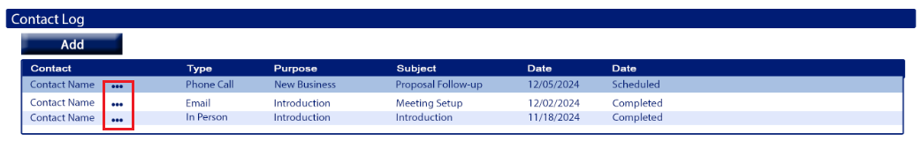

Validation:
-

Contact Log Table: More Menu

Function:
-give the user more functions related to the company/Lead’s contact log

Details
-refer to image for placement
-should be a 3 dot menu icon
-hover text: “More options”
-options should be listed in the order given below
Options:
- View/Update
- Delete

-Options:
- View/Update
  - Opens the log, the user can view and close or update the log and save
- Delete
  - Deletes the contact log entry
  - When clicked an alert should open
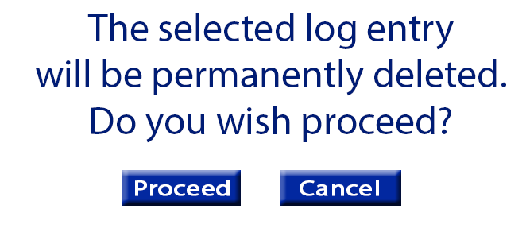
    - Message: “The selected log entry will be permanently deleted. Do you wish to proceed?
    - Proceed button – closes the alert, deletes the log entry and returns the user to the Add Lead screen
    - Cancel – closes the alert, and returns the user to the Add Lead screen without deleting the contact log entry
Validation
-

Contact Log Add/View window
Purpose
-used to add new contact logs
-used to view/update existing contact logs

Appearance
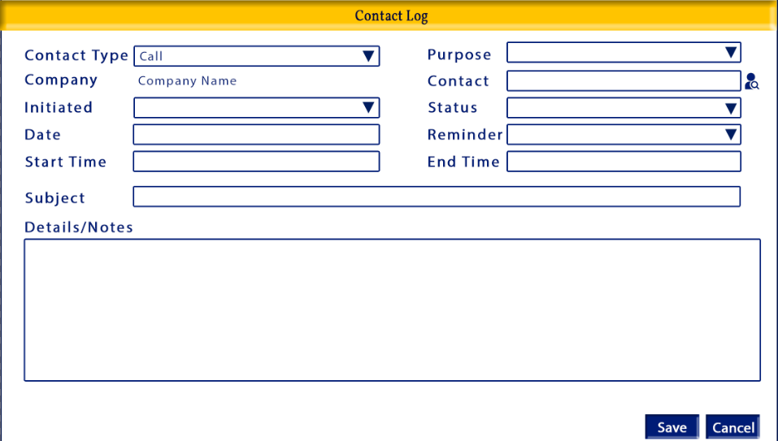

Tab Order:
- Contact Type
- Purpose
- Contact
- Initiated
- Status
- Date
- Reminder
- Start Time
- End Time
- Subject
- Details/Notes
- Save
- Cancel

Required
- Contact Type
- Purpose
- Contact
- Initiated
- Status
- Date

Fields

Fields
Contact Type
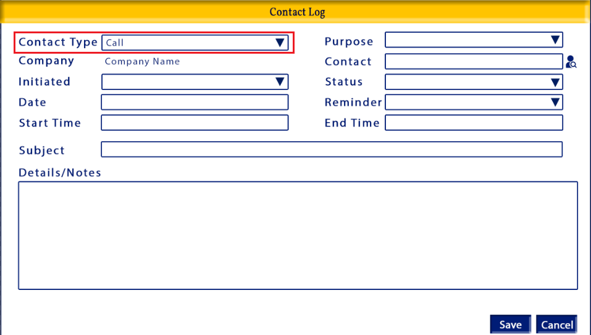
Function:
-informational, classifies what type of contact was made with the company/lead

Details
-dropdown menu, with first letter shortcut
-blank by default
-options should be sorted alphabetically
-options:
- Conference Call
- Email
- In Person
- Online Meeting
- Phone Call
- Text
Validation
-required to save

Purpose
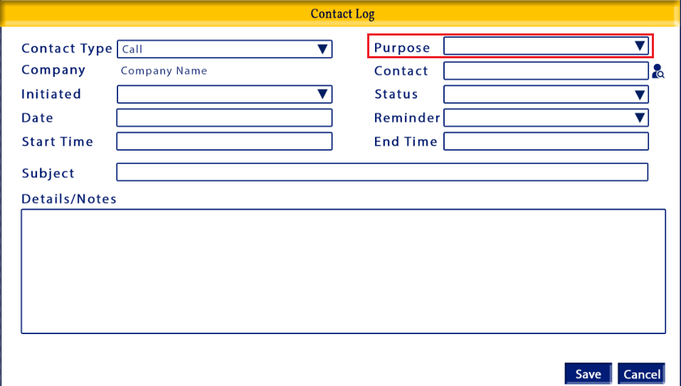
Function:
-informational, determines the general purpose of the contact made with the company/lead

Details
-dropdown menu, with first letter shortcut
-blank by default
-options should be sorted alphabetically
-options:
- Carrier Related
- Case – Claims
- Case – General
- Case – MySource
- Deal
- Introduction
- Invoice Related
- Maintenance
- MySource
- New Business
- New Service Announcement
- Other
- Pricing
- Quote
- Supplier Related
Validation
-required to save

Company
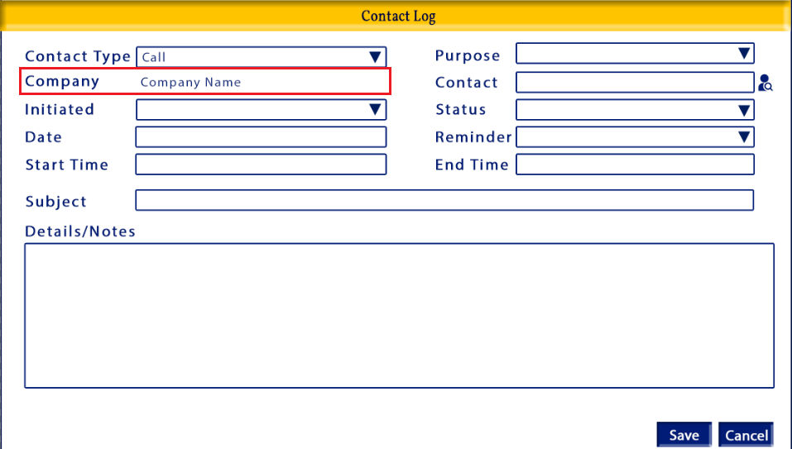
Function:
-informational, displays the name of the company/lead that the contact log window was opened from

Details
-view only field
-populated by the system
-displays the came of the company the contact log window was opened from
Validation
-

Contact
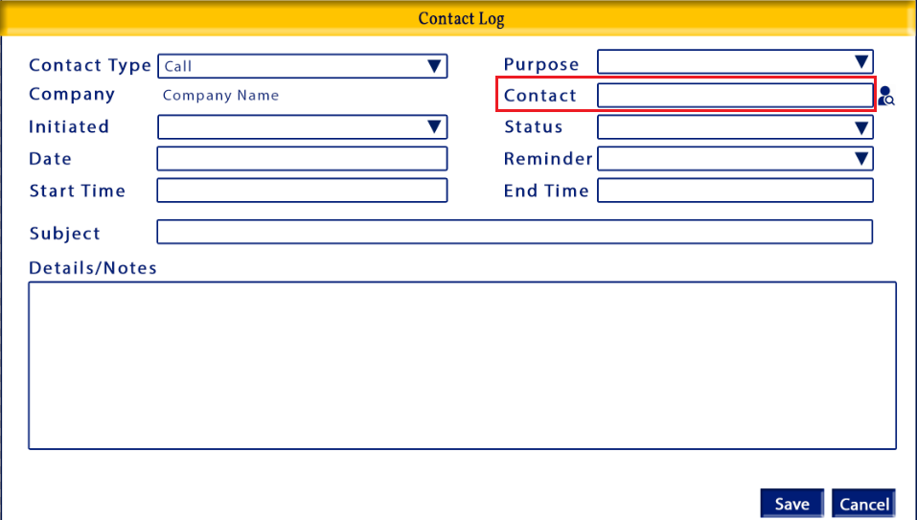
Function:
-informational, displays the name of the person(s) that were contacted

Details
-open input field
-blank by default
-can be hand entered or populated by the Contact Lookup window
Validation
-required

Contact Lookup
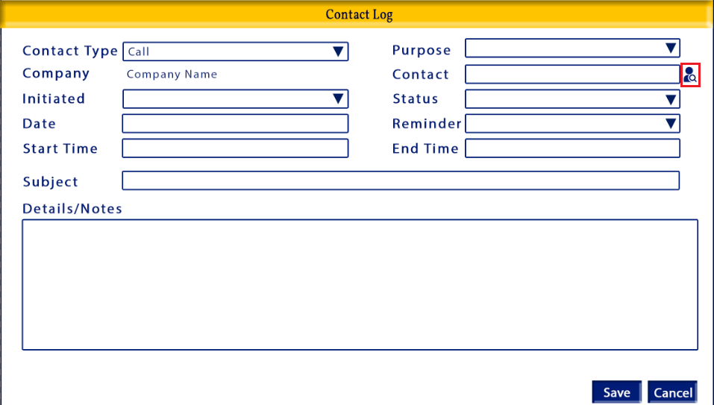
Function:
-used to find contacts and add them to the contact log

Details
-button
-refer to image above for appearance and placement
-when clicked the Contact Lookup window will open
-hover text: “Contact Lookup”
Validation
-required to save

Initiated
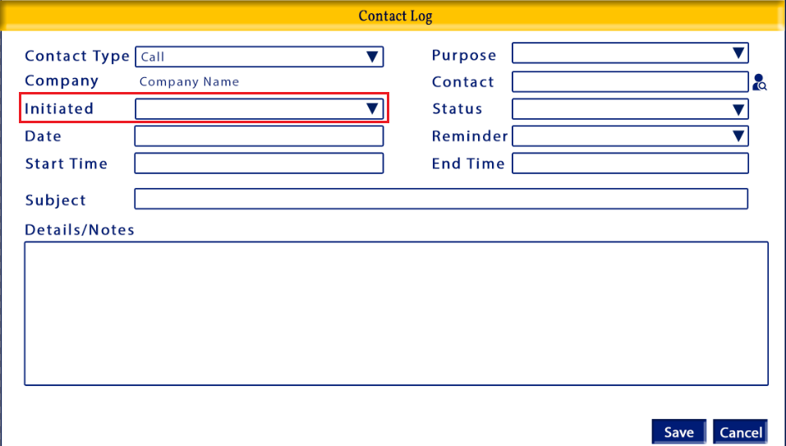
Function:
-determines if the contact was initiated or received

Details
-dropdown menu, with first letter shortcut
-blank by default
-options should be sorted alphabetically
-options:
- Inbound
- Outbound

Validation
-required to save

Status
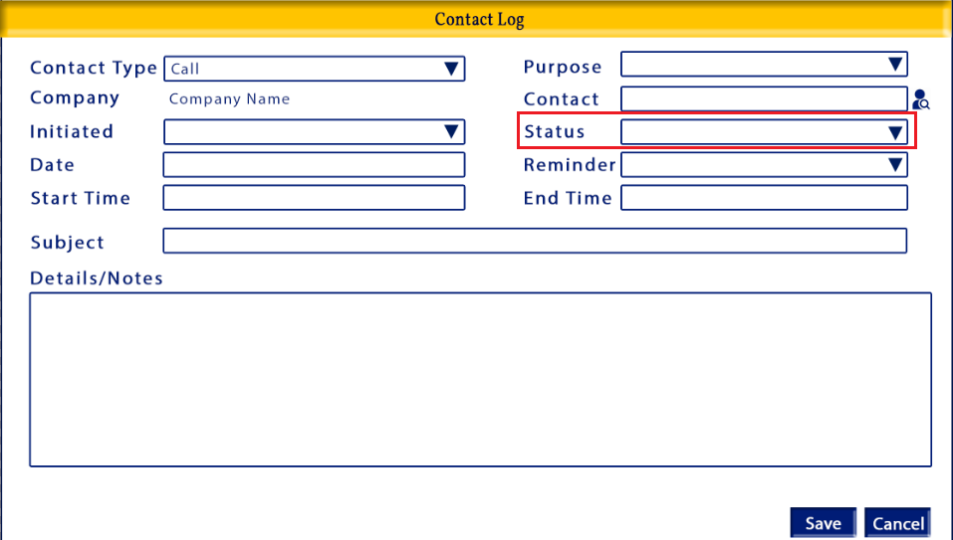
Function:
-determines the status of the contact

Details
-dropdown menu, with first letter shortcut
-blank by default
-options should listed in the order given
-options:
- Scheduled
- In Progress
- Completed
- Canceled

Validation
-required to save

Date
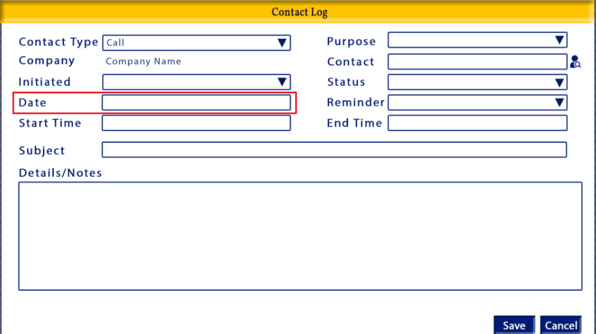
Function:
-determines the date of the contact

Details
-date field
-user can manually enter the date or select from the calendar
-calendar should not be included in the tab order
-blank by default
-user can select any date past, current or future

Validation
-required to save

Reminder
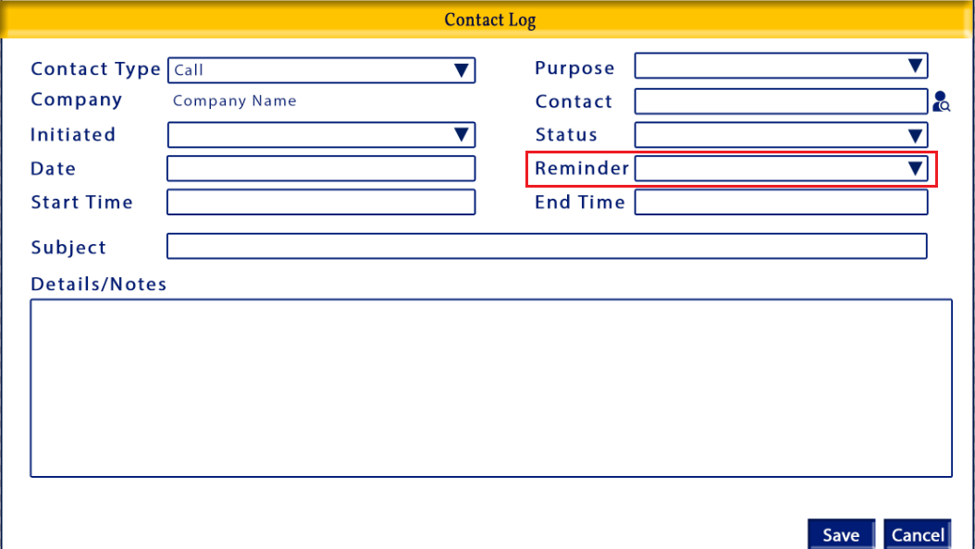
Function:
-controls if there will be a reminder about the contact

Details
-dropdown menu
-blank by default
-optional field
-user can only select one
-options listed in the order given
Options:
- At time of event
- 5 minutes before
- 10 minutes before
- 15 minutes before
- 30 minutes before
- 1 hour before
- 2 hours before
- 3 hours before
- 4 hours before
- 5 hours before
- 6 hours before
- 7 hours before
- 8 hours before
- 9 hours before
- 10 hours before
- 11 hours before
- 12 hours before
- 1 day before
- 2 days before
- 1 week before
-a reminder will be sent to the user about the contact at the set reminder time based on the Date and Start Time saved to the contact log

Validation
-

Start Time
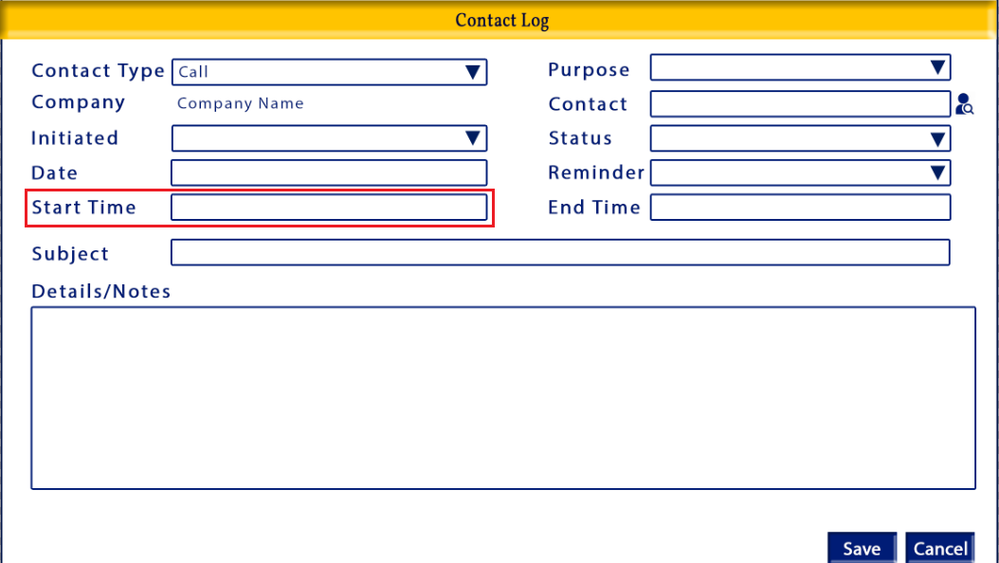
Function:
-determines the start time of the contact
-used to determine when the reminder will be sent out, if a reminder is selected

Details
-time field
-user should be able to type the time in or click the clock icon to select a time
-time selection window should not be included in the tab order
-optional
-use the link below for the time field and use the section that reflects the images shown in this document
https://developer.mozilla.org/en-US/docs/Web/HTML/Element/input/time
-time format h:mm a

hour is numbers only
minutes is numbers only
AM/PM is selection based
If the user types A AM is selected if the user types P PM is selected
AM/PM should be display in all-caps

-before a time is entered there should be dashes where the data will be entered
-when the clock icon is clicked the time options should look like the image below


Validation:
-the start time cannot be greater (after) than the end time

End Time
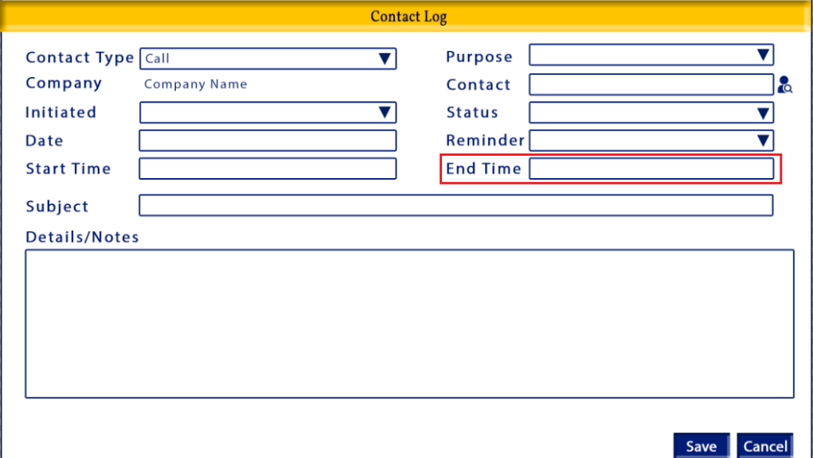
Function:
-determines the end time of the contact
Details
-time field
-user should be able to type the time in or click the clock icon to select a time
-time selection window should not be included in the tab order
-optional
-use the link below for the time field and use the section that reflects the images shown in this document
https://developer.mozilla.org/en-US/docs/Web/HTML/Element/input/time
-time format h:mm a

hour is numbers only
minutes is numbers only
AM/PM is selection based
If the user types A AM is selected if the user types P PM is selected
AM/PM should be display in all-caps

-before a time is entered there should be dashes where the data will be entered
-when the clock icon is clicked the time options should look like the image below


Validation:
-the start time cannot be greater (after) than the end time

Subject
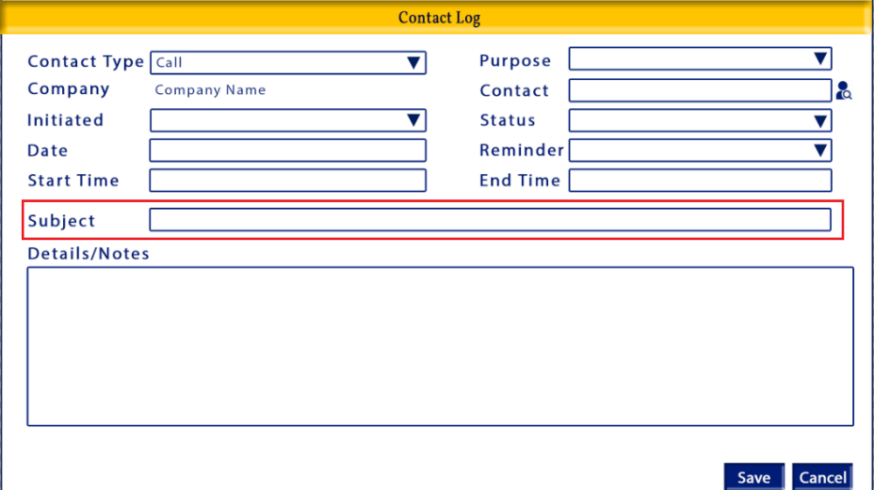
Function:
-provides a quick summary of the subject of the contact
Details
-open input
-blank by default
-character limit 100
-when the user reaches the character limit they should not be able to type any more and there should be an alert that the 200 character limit has been reached

Validation:
-required

Details/Notes
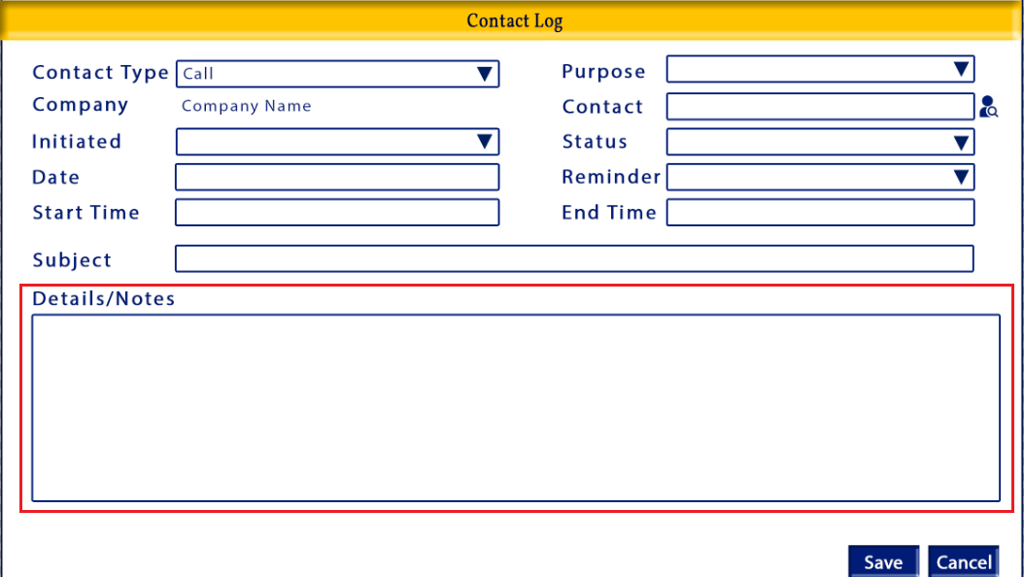
Function:
-provides the details of the contact
Details
-open input
-blank by default
-no character limit
-optional

Validation:
-

Validation
-required to save

Save
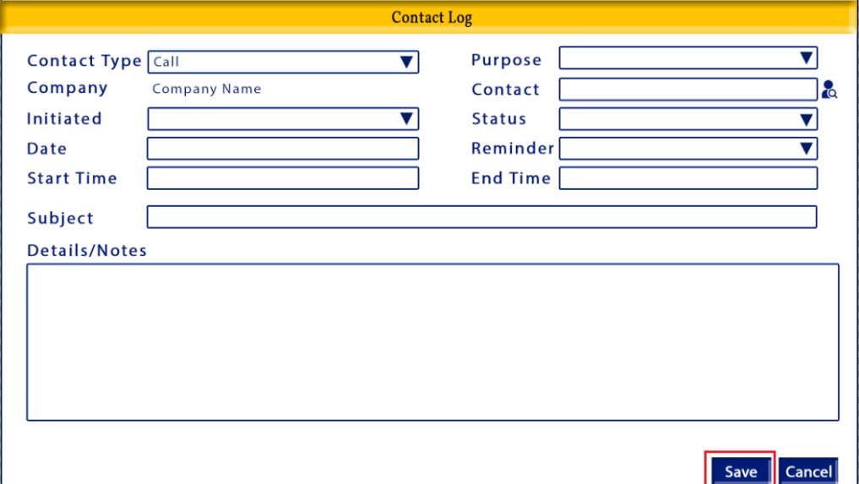
Function:
-Used to save a new contact log or changes to an existing contact log

Details
-button
-refer to image for placement and appearance
-closes the Contact Log window, saves the Contact Log and returns the user to the Add Lead screen

Validation:
-verify required fields are completed
  - Contact Type
  - Purpose
  - Contact
  - Initiated
  - Status
  - Date
  - Subject

Cancel
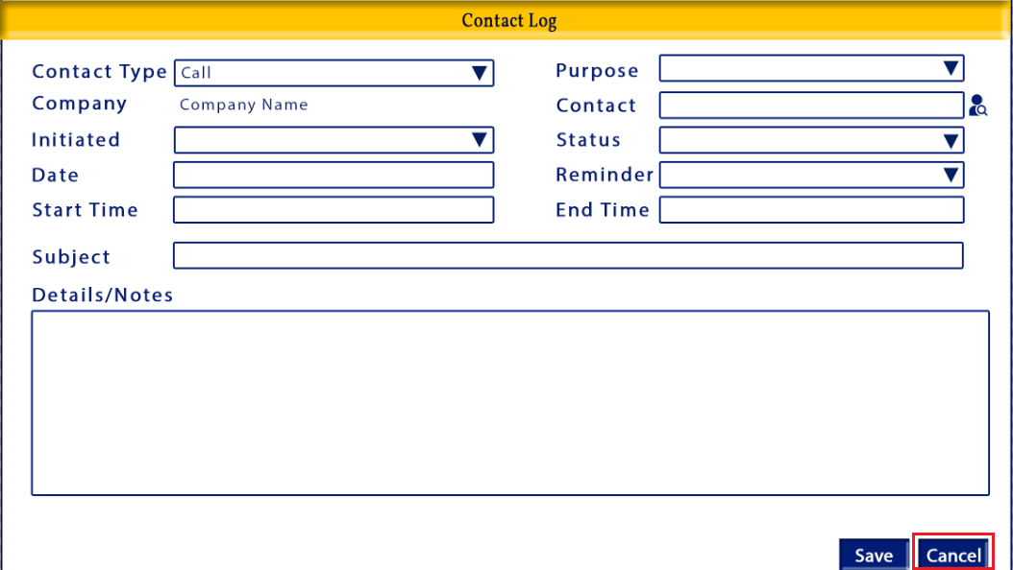
Function:
-closes the Contact Log window without saving a new log, or updating an existing

Details
-button
-refer to image for placement and appearance
-closes the Contact Log window without saving and returns the user to the Add Lead screen

Validation:
-changes not saved validation
-should only open if data had been entered into a field for a new log or modified in an existing log

Message: “The information entered has not been saved. Do you wish to proceed?”
Proceed: closes the Contact Log window without saving, and returns the user to the Add Lead screen
Cancel: Closes the alert and returns the user to the Add Contact Log window all fields remain as they were before the user clicked the Back button

Add Lead: Notes section
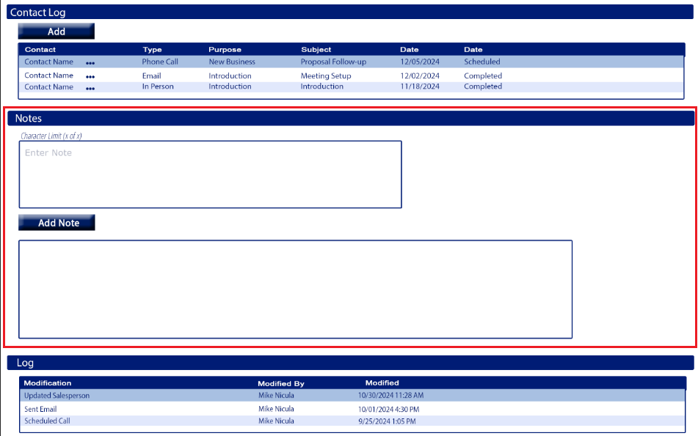

Purpose
-notes about the company/lead

Appearance
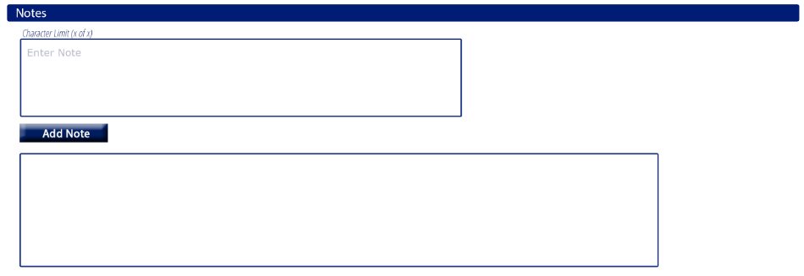
*located between the Contact Log section and Log section
*there will a blue title bar which can collapse when clicked (refer to image for appearance & layout)

Fields

Note input field
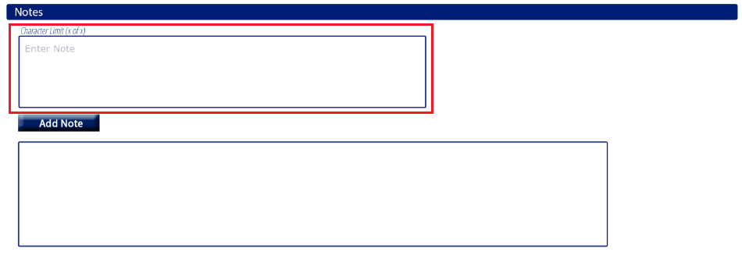
Function:
-Allows the user to enter a note about the company/lead
Details
– text field
-open format
-entered by user
-200 character limit
-there should be a character limit countdown above the field
-Character Limit (200 of 200) as characters are entered the first number reduces (150 of 200)
-once the character limit is hit the character limit countdown should turn red
-once the user hits the character limit the system should not allow them to continue to type
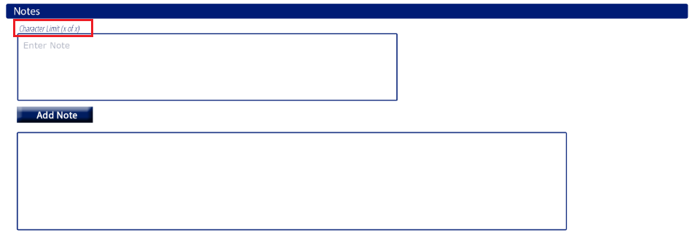

Validation:
-If there is a note in the Note input field and the user attempts to Save the Lead without clicking the Add Note button there should be an alert. If there is no entry in the Note input field this alert would not occur upon saving.
Message:
The Note that was entered has not been added to the Lead. Click the Add Note button before saving to add the note to the Lead’s file.
Okay button – closes the alert and returns the user to the Add Lead: Notes section where they can add the note then save.
Proceed button – the alert will close, the Lead will be saved without the note in the Note input field, and the user will be returned to the Leads screen.

Add Notes button
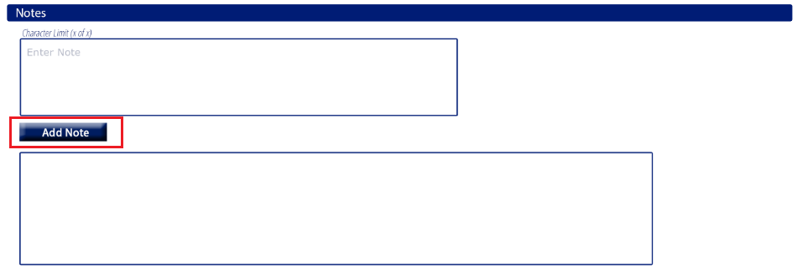
Function:
-Used to save a note entered in the Note input field to the Lead Notes Log field and to the Lead upon save
Details
--when selected it should save the note that was entered into the Note Log field into the notes section
-when a note is saved the notes should save as well as the date it was saved and the username of the user that saved it (see image below)
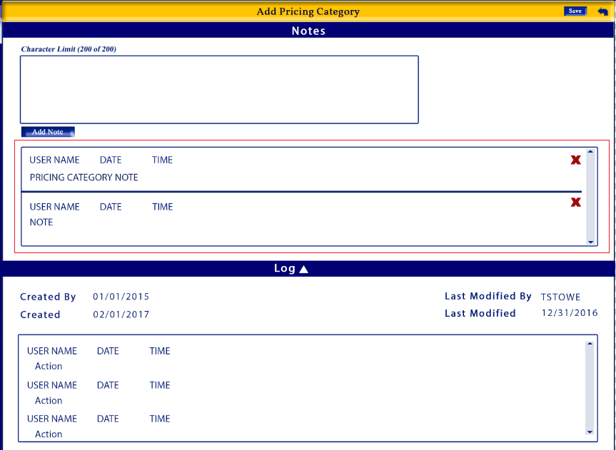

Validation:
-

Notes log
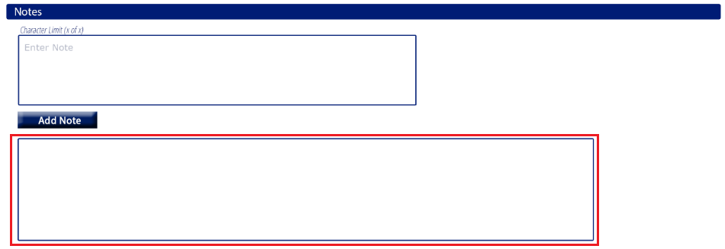
Function:
-Displays the notes that have been saved to the company/lead along with the username of the user that entered the note and the date and time the note was entered.

Details
-Notes displayed/formatted like the image below
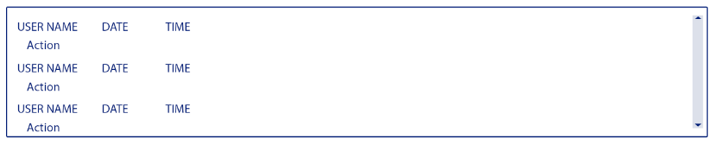
Validation:
-

Notes Delete button
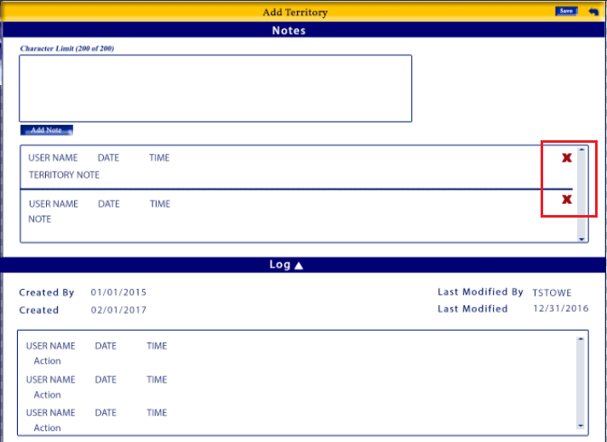
Function:
-Used to delete an existing note
Details
– beside each saved note
-will delete the note that was entered

Validation:
-There should be an alert message that opens when a user attempts to delete a note.
Message:
The selected note will be deleted permanently. Do you wish to proceed?
Proceed button – will delete note, close the alert and return the user to the Add Lead: Notes section
Cancel button – will exit the alert and return the user to the Add Lead: Notes section without deleting the note

Add Lead: Log section
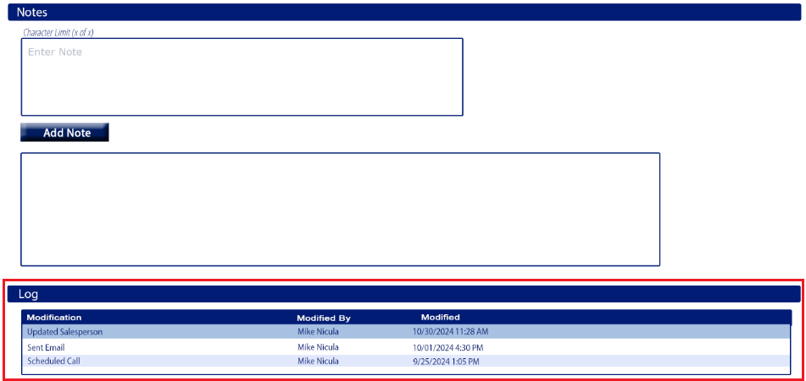

Purpose
-log shows changes made to the company/lead , who made the changes and when

Appearance
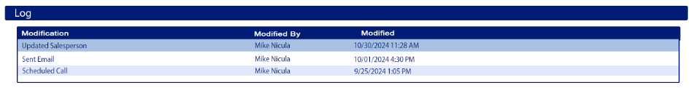
*last section of the Add Lead screen located after the Notes section
*there will a blue title bar which can collapse when clicked (refer to image for appearance & layout)

Fields
Contact Log Table
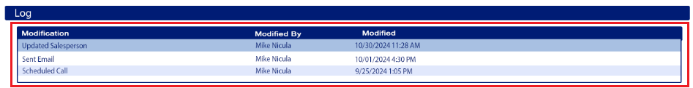
Function:
-provide information about changes made to the company/lead

Details
-refer to image for placement and appearance
-view only
-all columns should be sortable
-columns should be in the order shown in the image
-the table should be sorted by Modified by default, newest to oldest
-columns:
- Modification
    - The modification made to the company/lead
- Modified By
    - The full name of the user that modified the company/lead
  - Modified
    - The date and time of the change
    - Mm/dd/yyy hh:mm am/pm

Validation:
-

New Email window
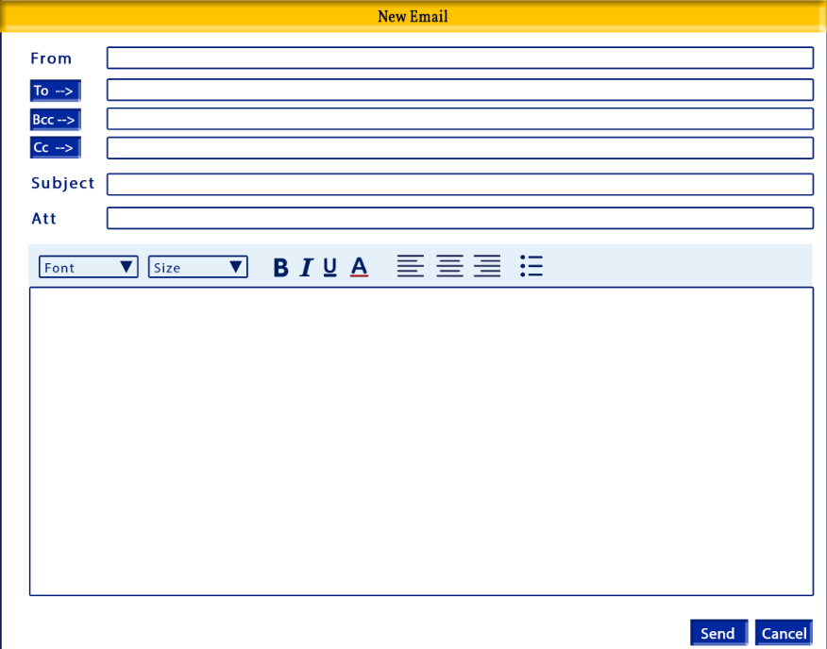
Purpose
-allows the user to send an email directly from CRM

Appearance

*refer to image for appearance and layout

Tab Order:
- From
- To
- Bcc
- Cc
- Subject
- Email body
- Send
- Cancel

Required
- From
- To
- Subject
Fields

From
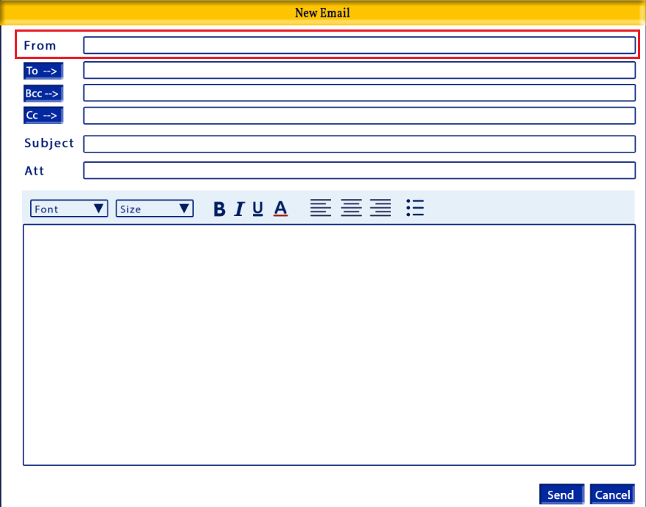

Function:
-determines the from email address for the email being sent
Details:
-email field
-defaults to the user’s email address
-user can modify

Validation:
-required field
-must be in proper email format

To button
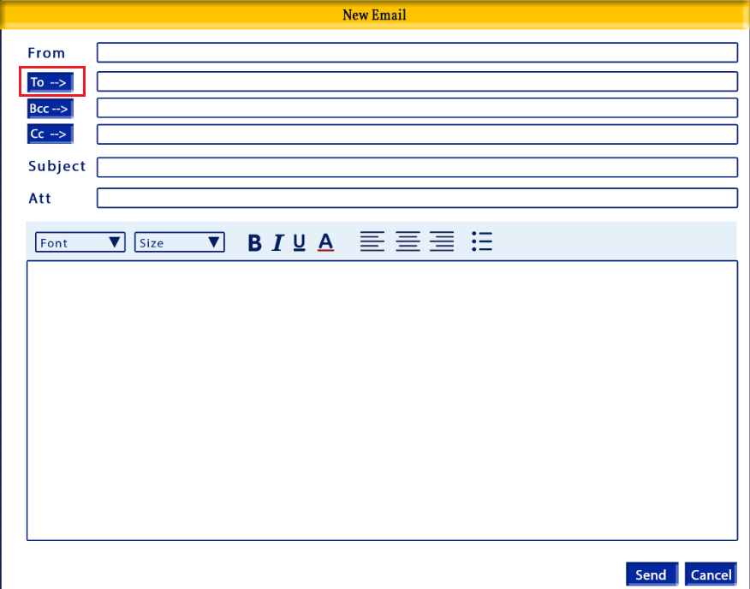
Function:
-opens the Email Lookup window where a user can find an email address to be added to the To input field
Details:
-button
-the Email Lookup window will be detailed in the document below
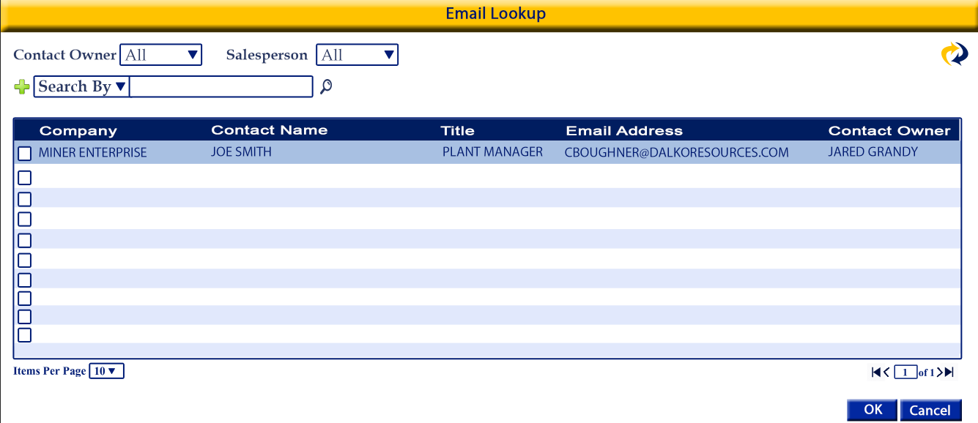
-hover text: Email Lookup

Validation:
-

To input field
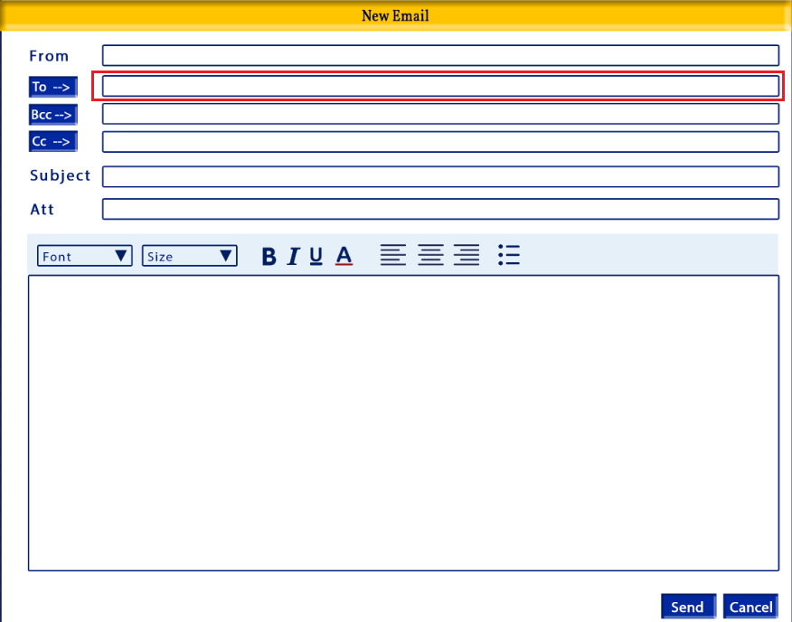
Function:
-input field where the user enters email addresses that the email is to be sent to

Details:
-input field
-manually entered by the user of completed by the To button option
-if the To button option was used the user can still add or modify the To input field

-user can enter more than one email address with a semi colon separator
Validation:
-required

Bcc button
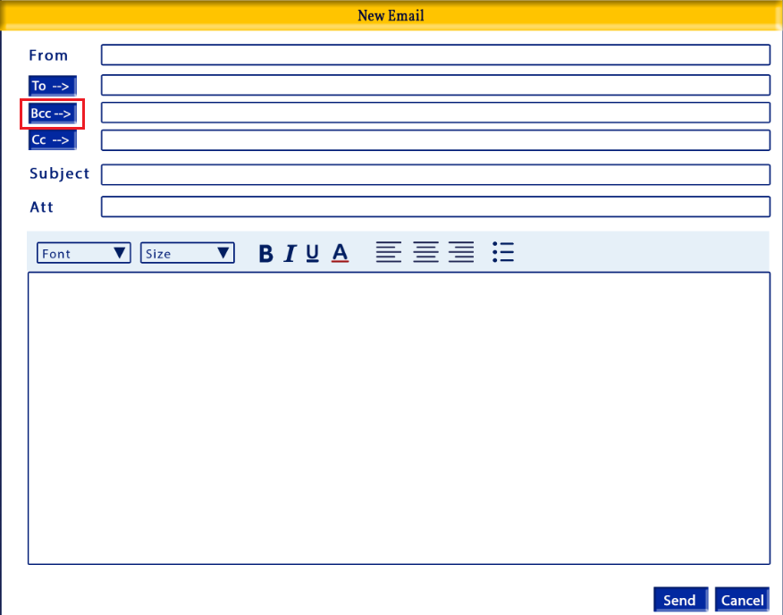
Function:
-opens the Email Lookup window where a user can find an email address to be added to the Bcc input field
Details:
-button
-the Email Lookup window will be detailed in the document below

-hover text: Email Lookup
Validation:
-

Bcc input field
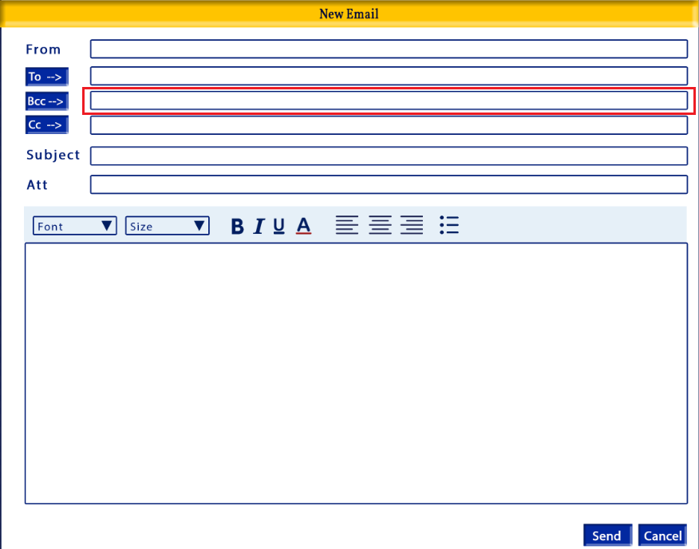
Function:
-input field where the user enters email addresses that will be blind copied in on the email being sent

Details:
-input field
-manually entered by the user of completed by the Bcc button option
-if the Bcc button option was used the user can still add or modify the To input field
-user can enter more than one email address with a semi colon separator
Validation:
-

Cc button
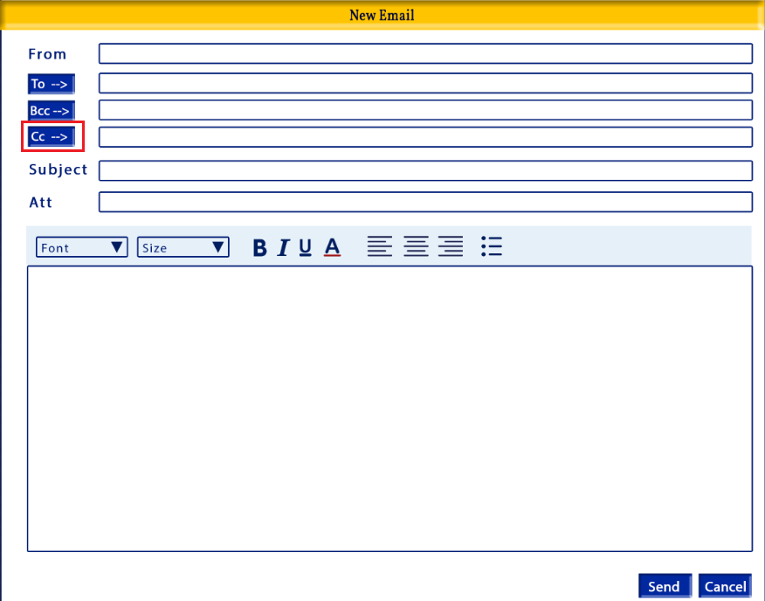
Function:
-opens the Email Lookup window where a user can find an email address to be added to the Cc input field
Details:
-button
-the Email Lookup window will be detailed in the document below

-hover text: Email Lookup
Validation:
-

Cc input field
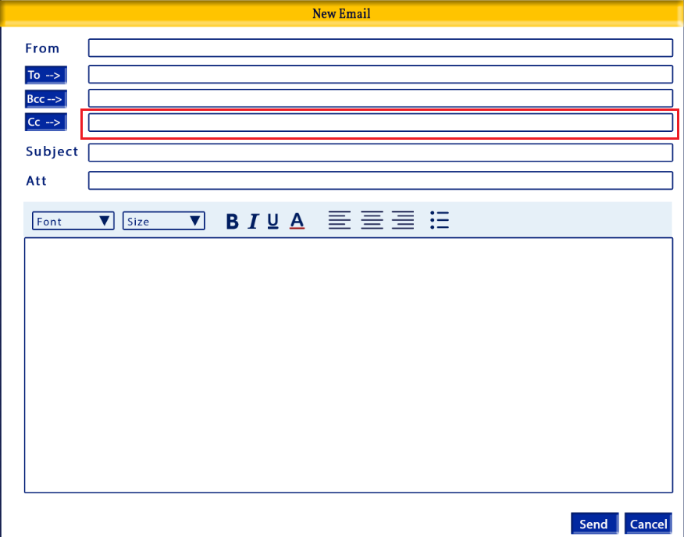

Function:
-input field where the user enters email addresses that will be copied in on the email being sent

Details:
-input field
-manually entered by the user of completed by the Cc button option
-if the Cc button option was used the user can still add or modify the To input field
-user can enter more than one email address with a semi colon separator
Validation:
-

Subject input field
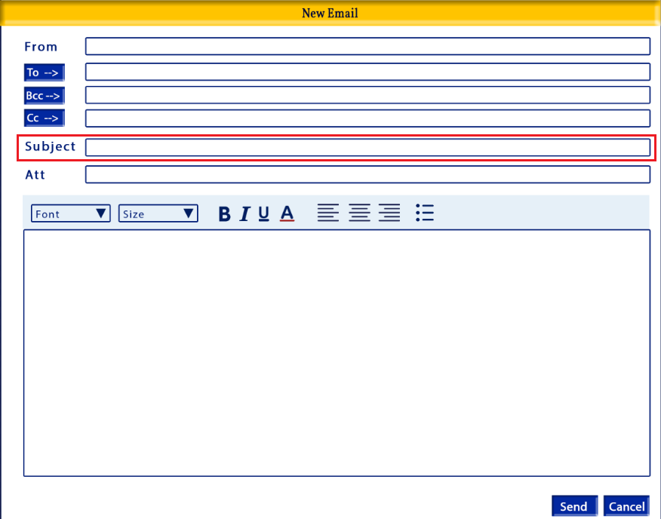

Function:
-allows the user to enter a email subject
Details:
-open character input field

Validation:
-required

Att
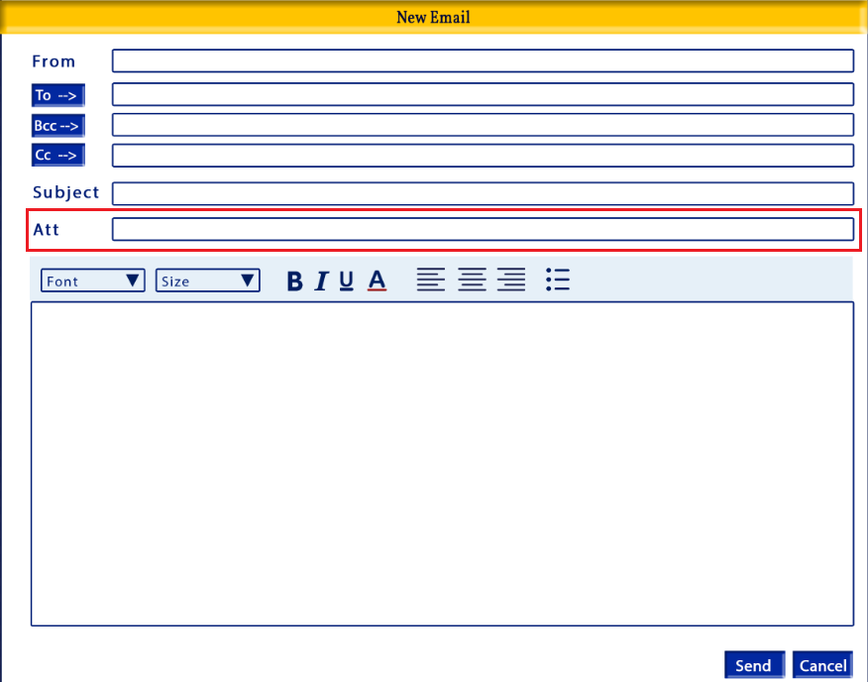

Function:
-displays the name of the document(s) being attached to the email
Details:
-hover text over the field label: Attachments
-user should be able to drag & drop files, or select from saved files

Validation:

Email Formatting
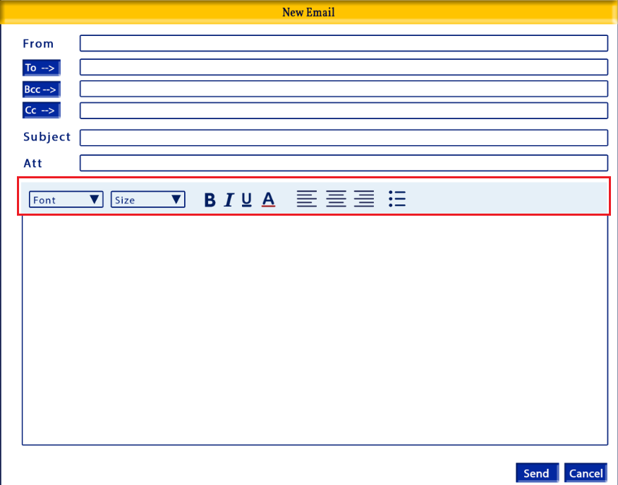

Function:
-allows the user to control the formatting of the font in the email body

Details:
-formatting options:
- Font type
- Font size
- Style: bold, italic, underlined
- Font color
- Alignment: alignment of text
- Bullets
-hover text for:
- Font type: “Font”
- Font size: “Font Size”
- Style – Bold: “Bold”
- Style – Italic: “Italic”
- Style – Underlined: “Underline”
- Font color: “Font Color”
- Left Alignment: “Left Alignment”
- Center Alignment: “Center Alignment”
- Right Alignment: “Right Alignment”
- Bullets: “bullets”

-font should be defaulted to Calibri
-user can change
-font size should be defaulted to 11
-user can change
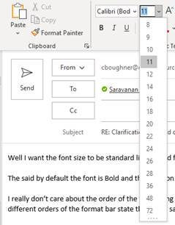

-email body font should be regular (not bold or italicized) by default, but the user can change through the formatting bar
-font color should be black by default
-email body should be left aligned by default

Validation:

Email Body
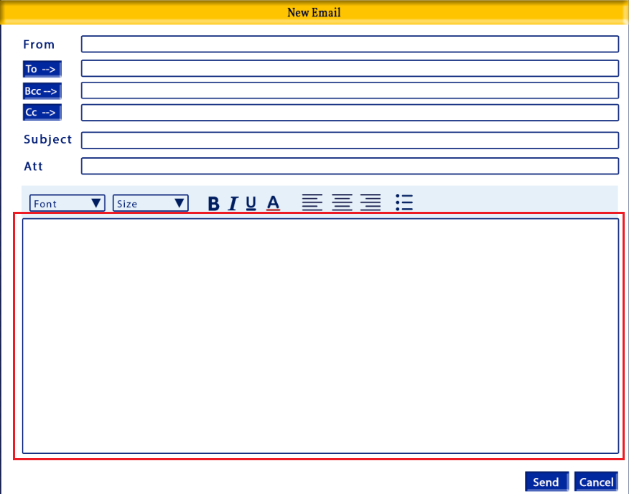
Function:
-allows the user to enter a custom email message

Details:
-open character input field
-no character limit
-optional
Validation:

Send button
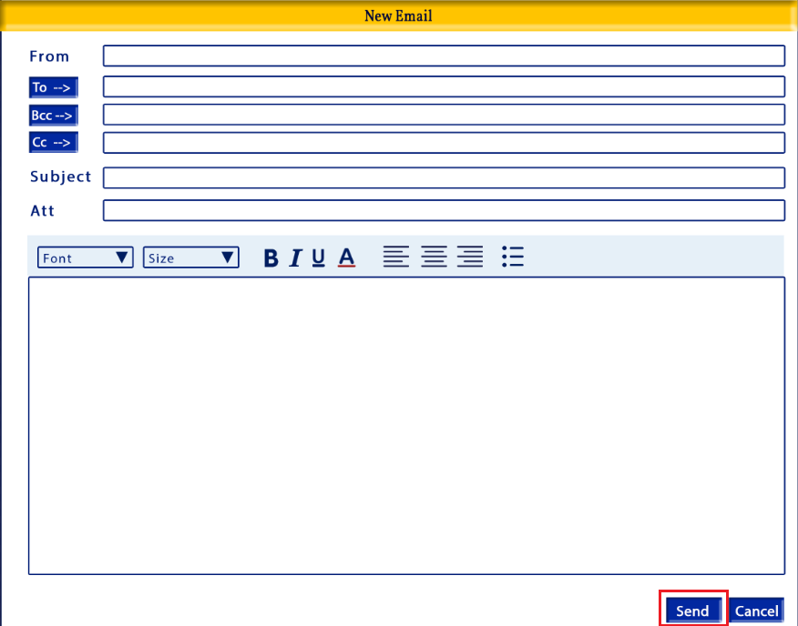

Function:
-sends the email with selected attachments to the email address(s) in the To, Bcc and/or Cc fields

Details:
-button
-after the email is sent the window should close and the user should be returned to the Add Lead screen

Validation:
-required fields must be completed before email can be sent
-if required fields are not completed there should be an alert detailing which fields need to be completed
Examples:
- From required
- To required
- Subject required

Cancel button
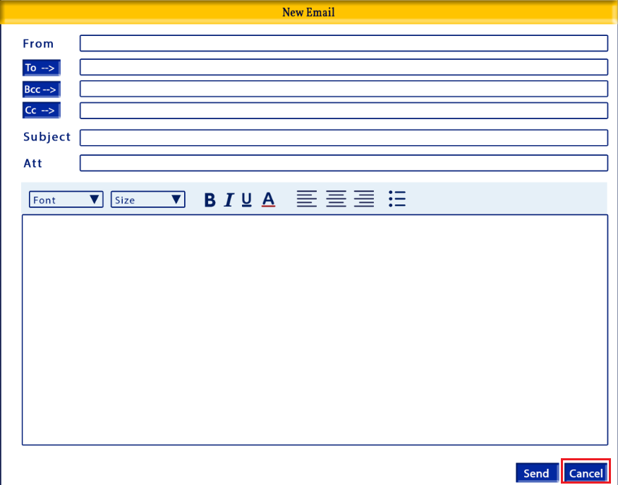

Function:
-returns the user to the Add Lead screen without sending the email

Details:
-button
-there should be an alert if the user clicks the Cancel button
Message:
Changes made this screen will be lost. Do you wish to proceed?
Buttons:
Proceed – the New Email screen will close, no email will be sentand the user will be returned to the Add Lead screen
Cancel – will close the alert and return the user to the New Email screen
Validation:
-

Email Lookup
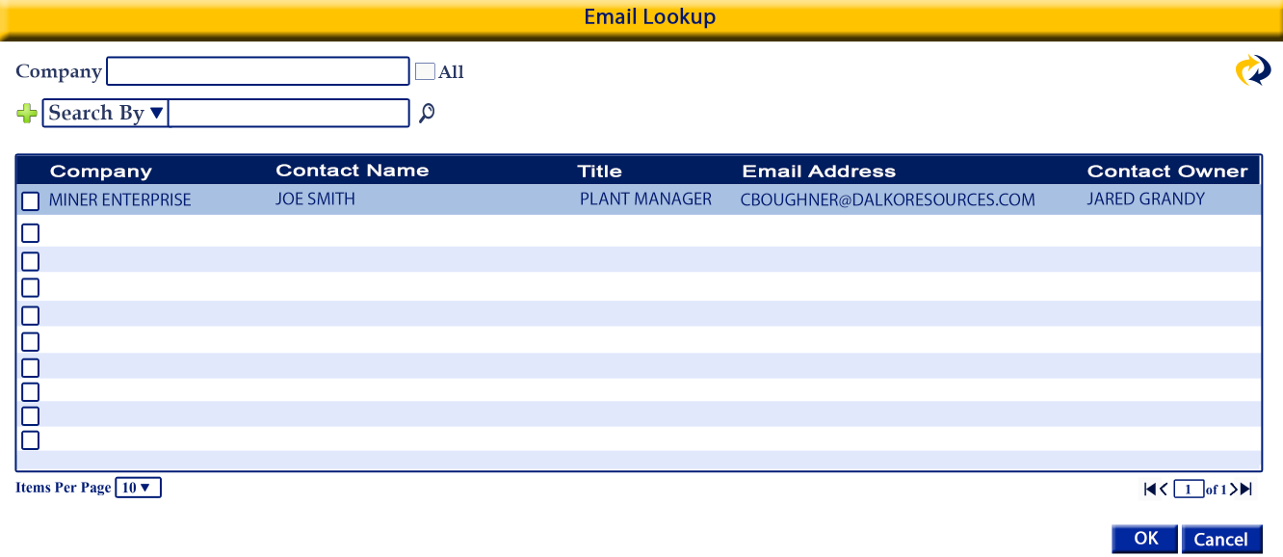
Purpose:
-To allow the user to find an email address of an existing contact to send an email to
-what contact the user can see is controlled by the Data Management settings

Appearance

*refer to image for appearance and layout

Tab Order:

- Company
- All
- Search By
- Search By input
- Find
- Add search option
**repeat 3-5

Required fields

Fields

Company
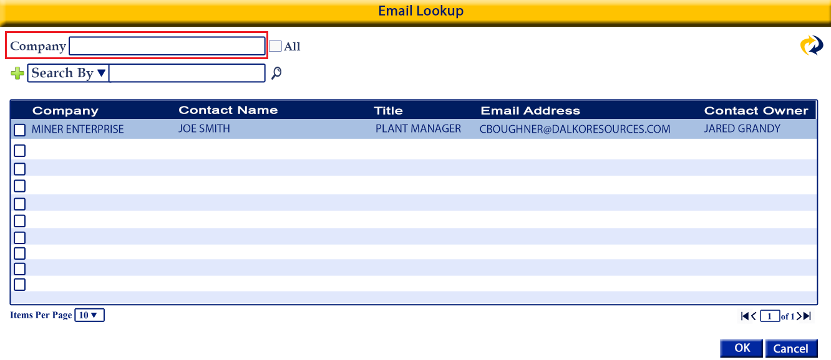
Function:
-will filter the results by company

Details:
-autocomplete search with dropdown
-all companies from Lead, Prospect and Clients
-looks at the Contact Company field
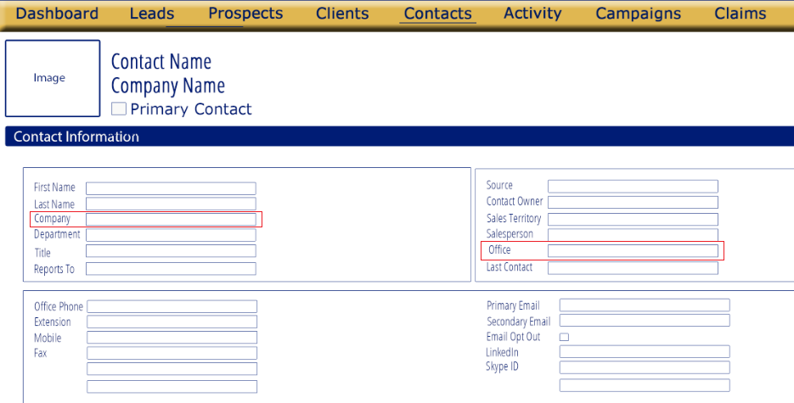

- should default to the Company the screen was opened from
-the user can modify
Ex: The user was in the Add Lead screen for XYZ Company when they open the new email window. The Company filter will default to XYZ Company

Validation:
-a company or All must be selected

All
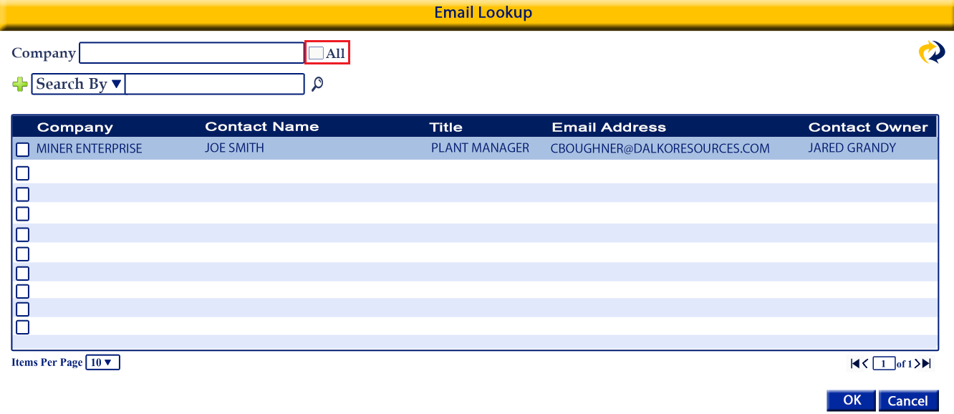

Function:
-when selected contacts with any company will be brought back
-limited to the companies the user has access to based on the Data Management setup

Details:
-checkbox
-unselected by default
-if selected the contact results will be for contact from all companies
-based on the user permissions
-if All is selected the Company input field will be locked

Validation:
-required if there is no company selected

Search
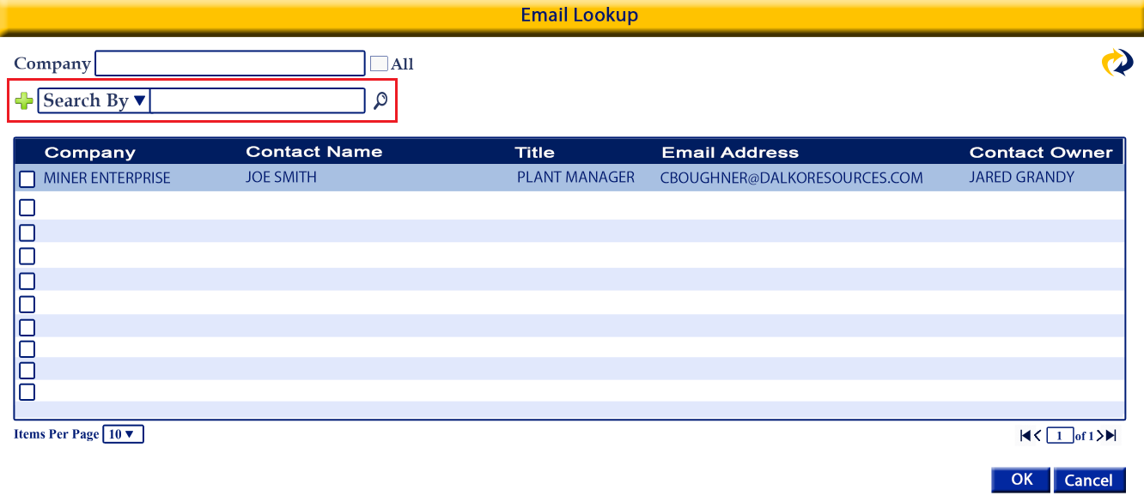
Function:
-Used to search the contact results based on the filters applied

Details
-Search by options are displayed in a dropdown menu. Once the user selects a Search by option the search input field will populate based on the users selection
*Input fields vary based on the Search By chosen
-the user has the ability to add as many Search By set as there are search by options available
-default the Search By to Contact Name
-user can modify
-sort Search By options alphabetically by Contact Name
-search by options:
  - Contact Name
    - Open input field
    - Like search
    - Looks at the Contact: Full Contact Name field
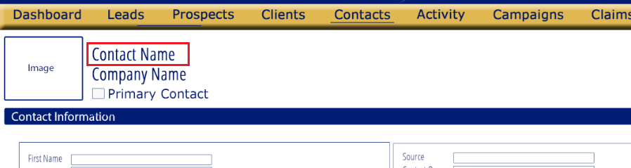
  - First Name
    - Open input field
    - Like search
    - Looks at the Contact: First Name field
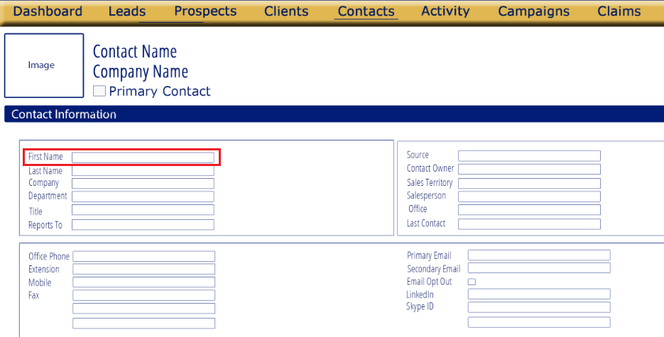
  - Last Name
    - Open input field
    - Like search
    - Looks at the Contact: Last Name field
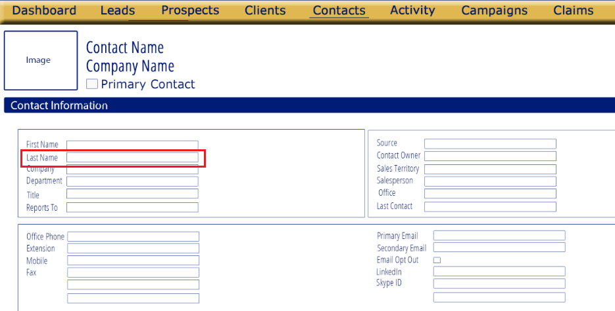

  - Title
    - Open input field
    - Like search
    - Looks at Contact: Title field
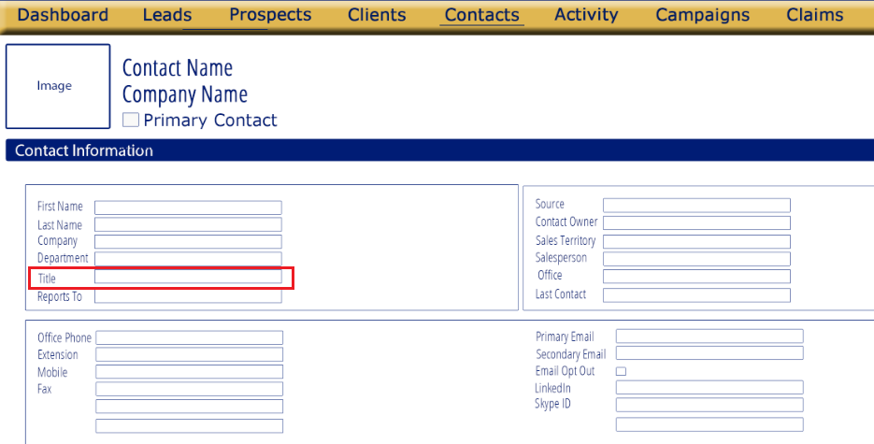
  - Phone
    - Open input field
    - Looks at Contact: Office Phone & Mobile
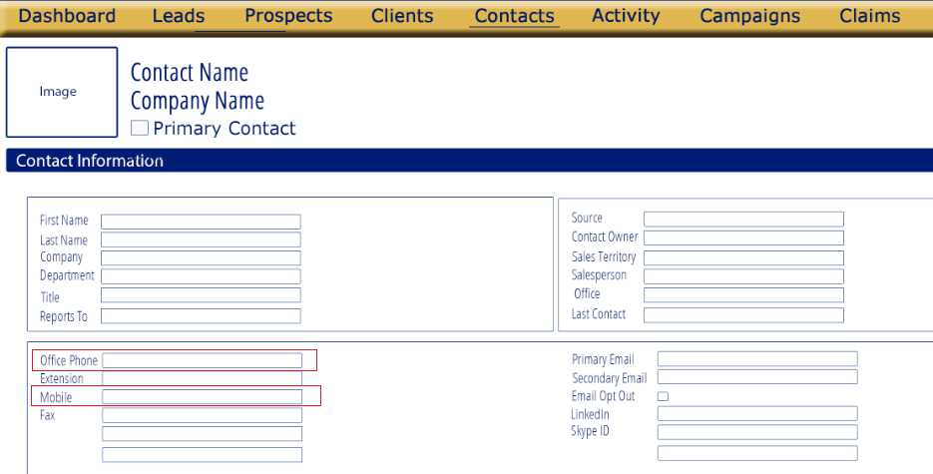
  - Contact Owner
    - Dropdown autocomplete menu
    - Options listed alphabetically
    - Options come from Users
    - Looks at Contact: Contact Owner
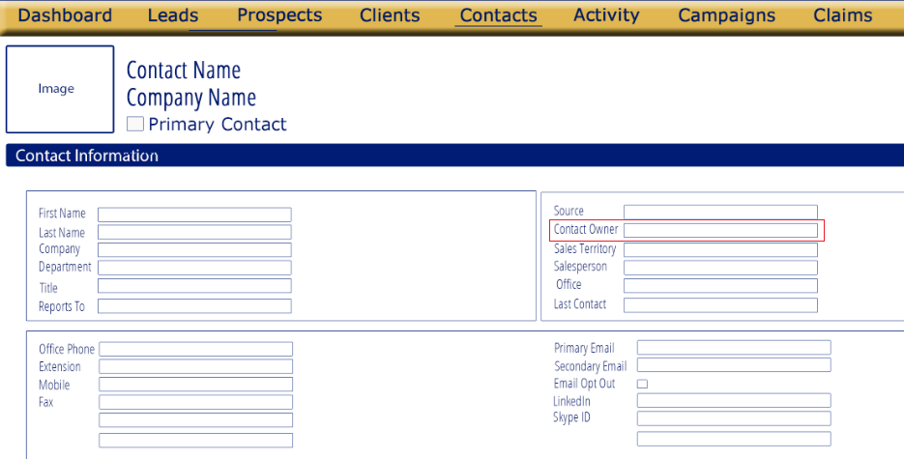

  - Department
    - Open input field
    - Like search
    - Looks at the Contact: Department field
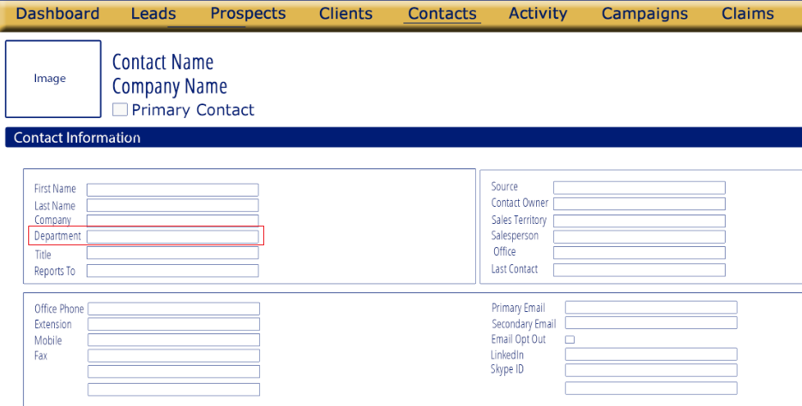
  - Reports To
    - Open input field
    - Like search
    - Looks at the Contact: Report To field
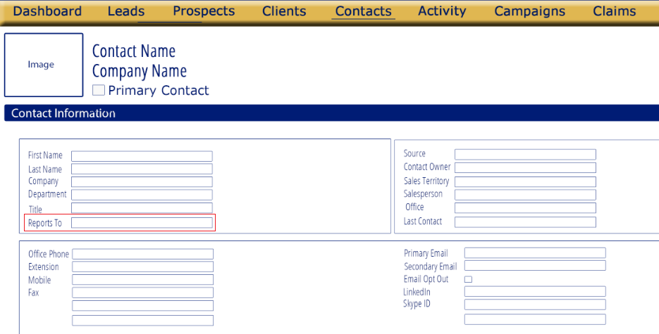
  - Source
    - dropdown menu with first letter shortcut
    - User can only select one
    - List options alphabetically
    - Options:
      - Advertisement
      - Cold Call
      - Employee Referral
      - Client Referral
      - Supplier Referral
      - External Referral
      - Trade Show
      - Web Research
    - Looks at the Contact: Source field
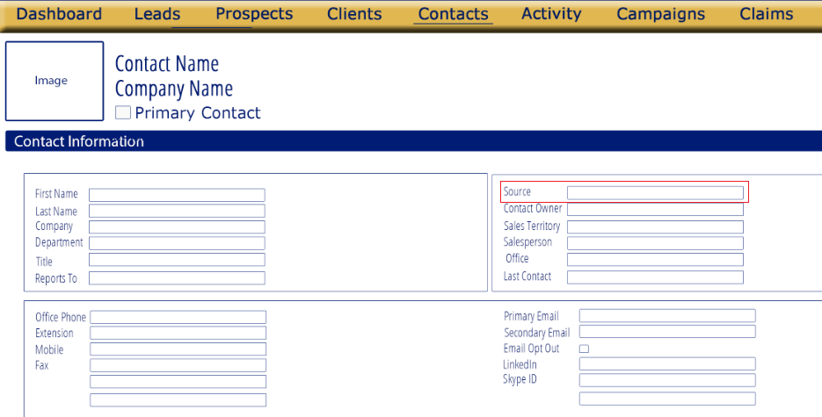
  - Sales Territory
    - dropdown menu with first letter shortcut
    - refer to image for placement
    - user can only select one
    - options should be sorted alphabetically
    - options:
      - International
      - Northeast
      - Northwest
      - Southwest
      - Southeast
    - Looks at the Contact: Sales Territory field
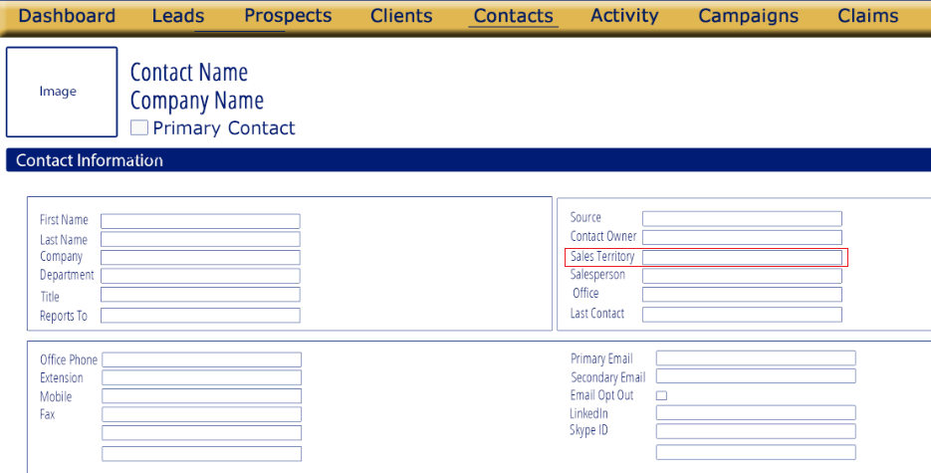

  - Salesperson
    - dropdown menu with first letter shortcut
    - user can only select one
    - options should be sorted alphabetically
    - options come from users master, users that are role/type “Salesperson”
    - full name should show
    - Looks at the Contact: Salesperson field
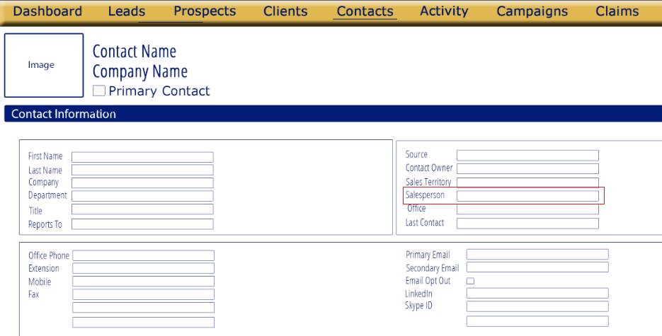
  - Office
    - Open input field
    - Like search
    - Looks at the Contact: Office field
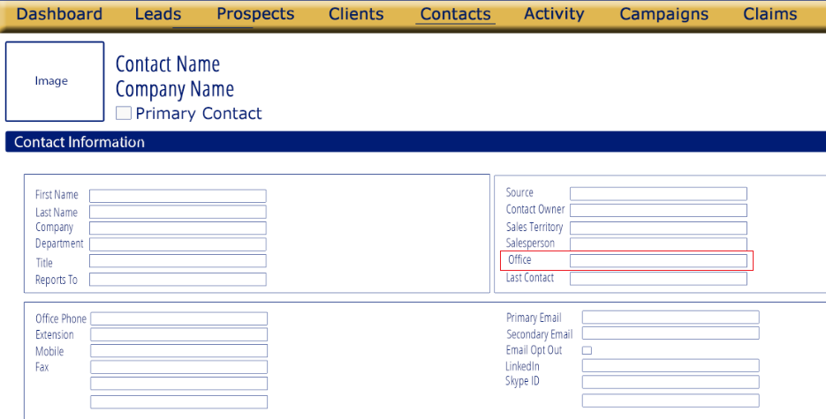

Items Per Page
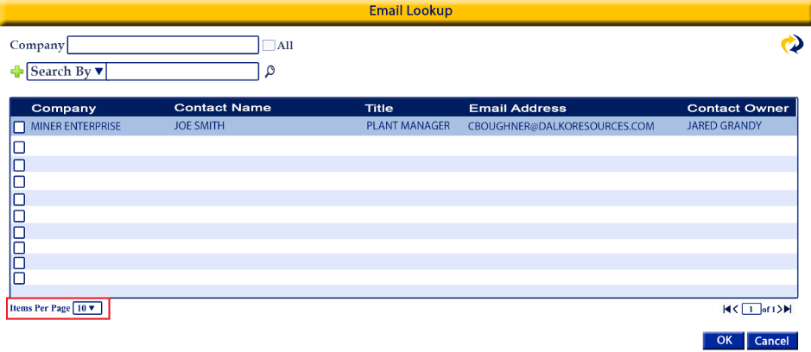
Function:
-Allows the user to choose how many results to show per page
Details
-dropdown menu
-options: 10, 25, 50, 100
-sort numerically
Validation:

Page Number
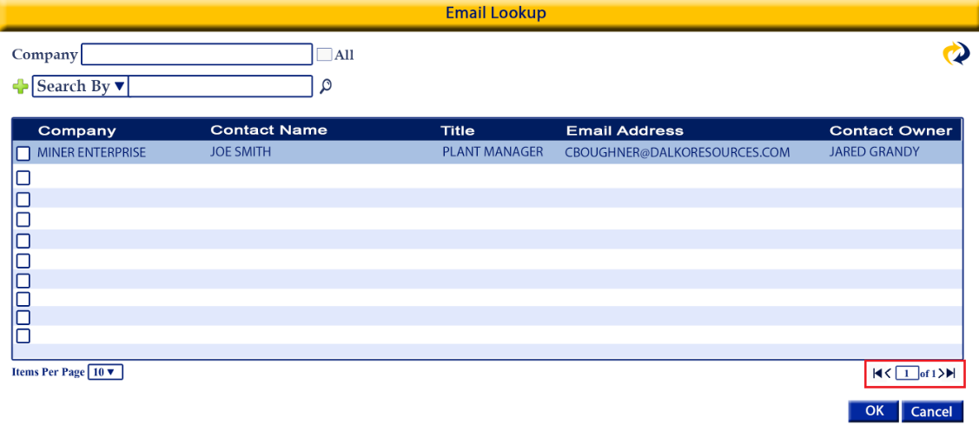
Function:
- displays the page number the user is currently on and how many pages there are in total
Details
-if the user enters a page number and uses the enter key it should jump to that page that the user entered
-single arrow move forward or back one page
-arrow with line jumps to first or last page
Validation:

Results Table
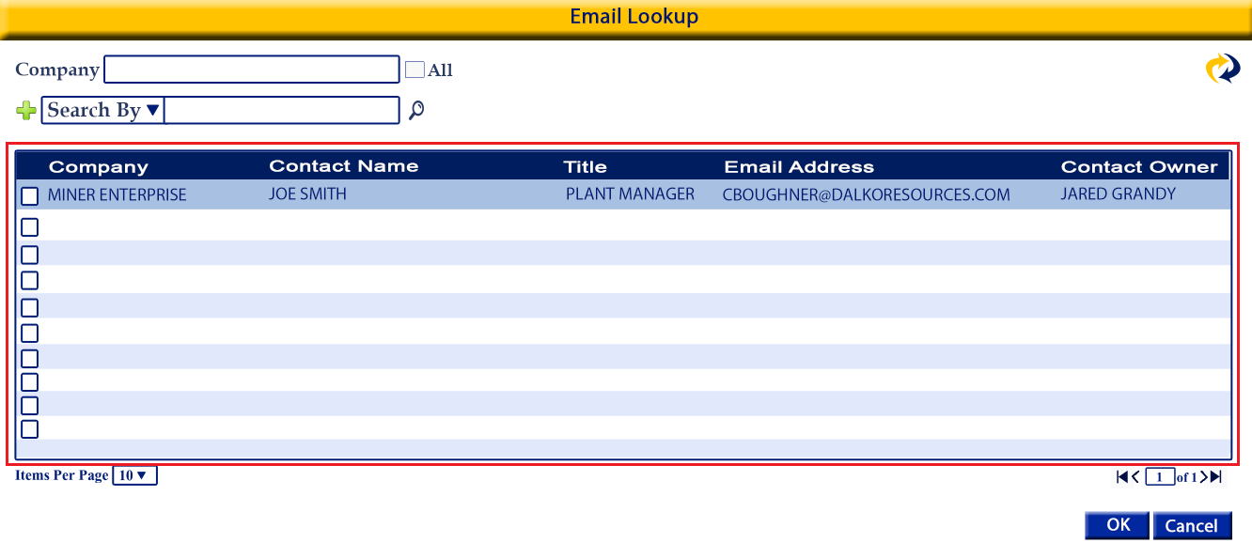
*results should be sorted by Contact Name by default
*the result table columns should be sortable
*refer to image for appearance and placement

Selection checkbox
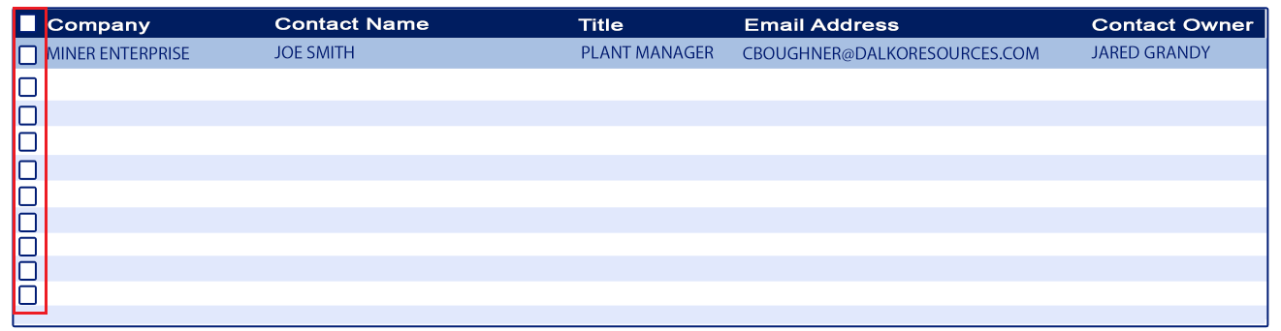
Function:
-allows the user to select one or more email addresses to be added to the email being created
-where the email address will be mapped is based on the email button clicked by the user: To, Bcc or Cc
Details:
-checkbox
-one for each contact
-located to the left of the Company
-user can select one or multiple
-there is All checkbox in the table title bar
-used to select all contacts, all pages, based on filters applied
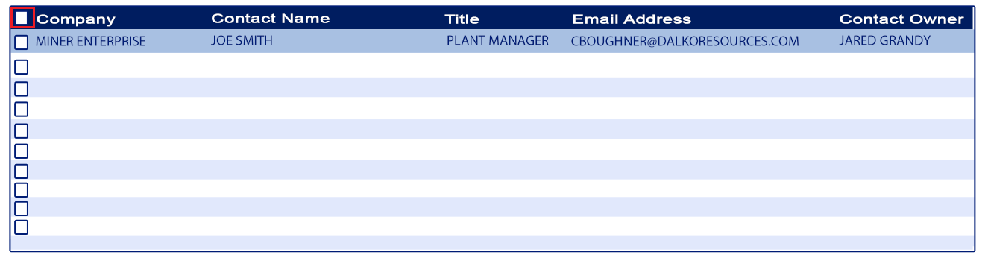

Validation:
-at least one must be selected if the Okay button is selected by the user
-if the user clicks Cancel instead of Okay no selection is required

Company
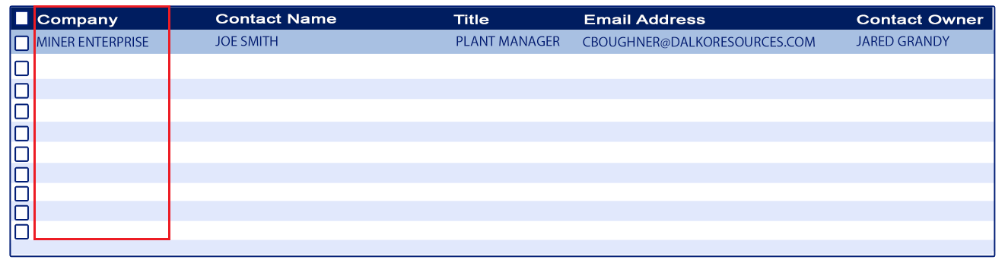
Function:
-displays the company of the contact
-informational

Details:
-comes from the Contact: Company field


Validation:

Contact Name
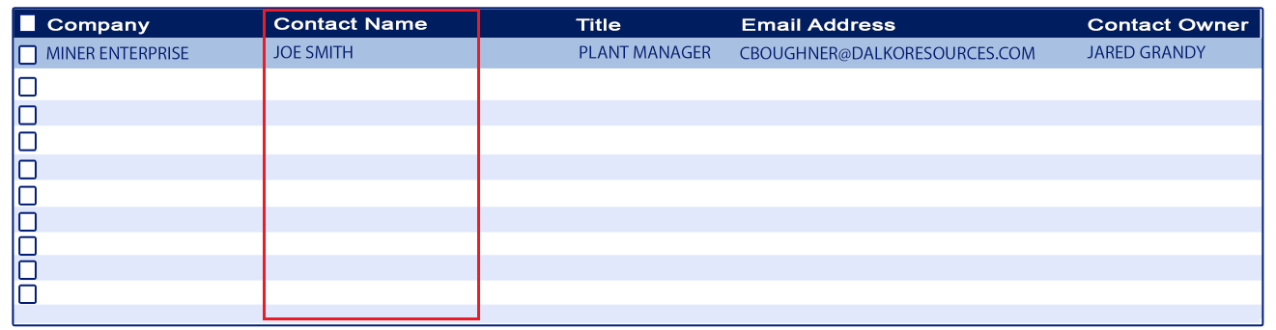
Function:
-displays the full name of the contact
-informational

Details:
-comes from Contact: Fuell Contact Name field


Validation:
-

Title
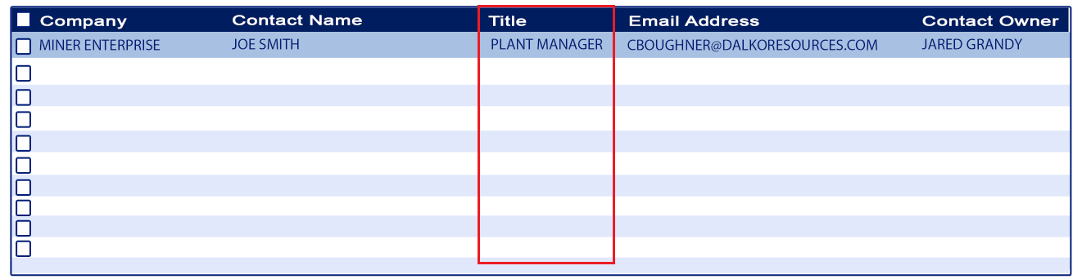
Function:
-displays the title of the contact
-informational

Details:
-comes from Contact: Title field


Validation:
-

Email Address
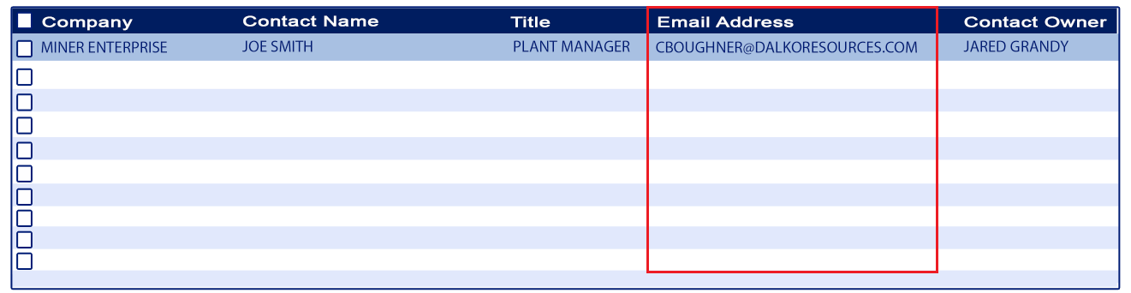
Function:
-displays the primary email address of the contact
-informational

Details:
-comes from the Contact: Primary Email field
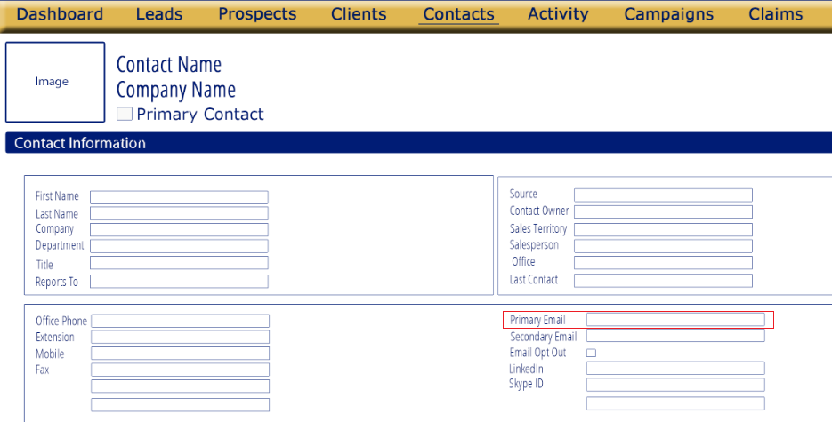

Validation:
-

Contact Owner
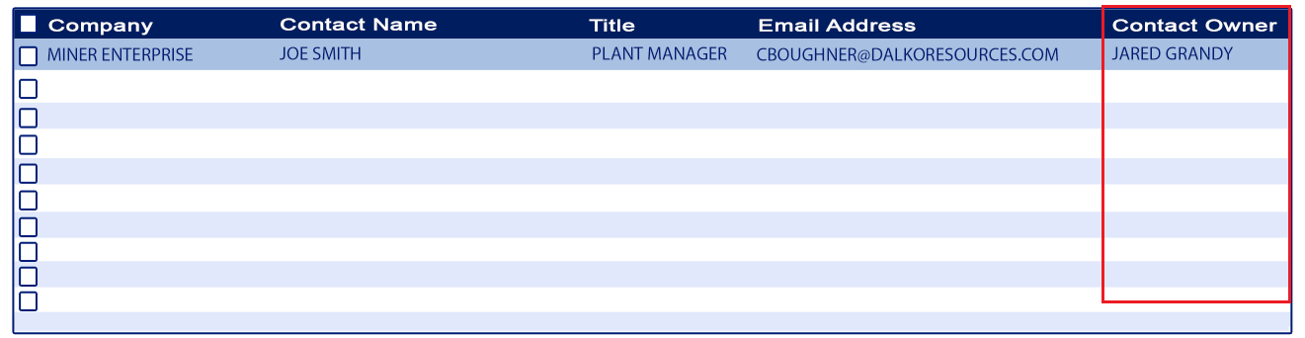
Function:
-displays the full name of the contact owner
-informational

Details:
-comes from the Contact: Contact Owner field
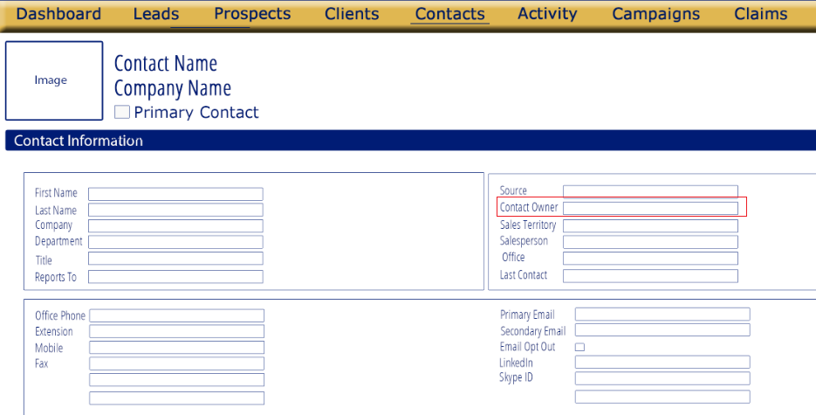

Validation:
-

OK button
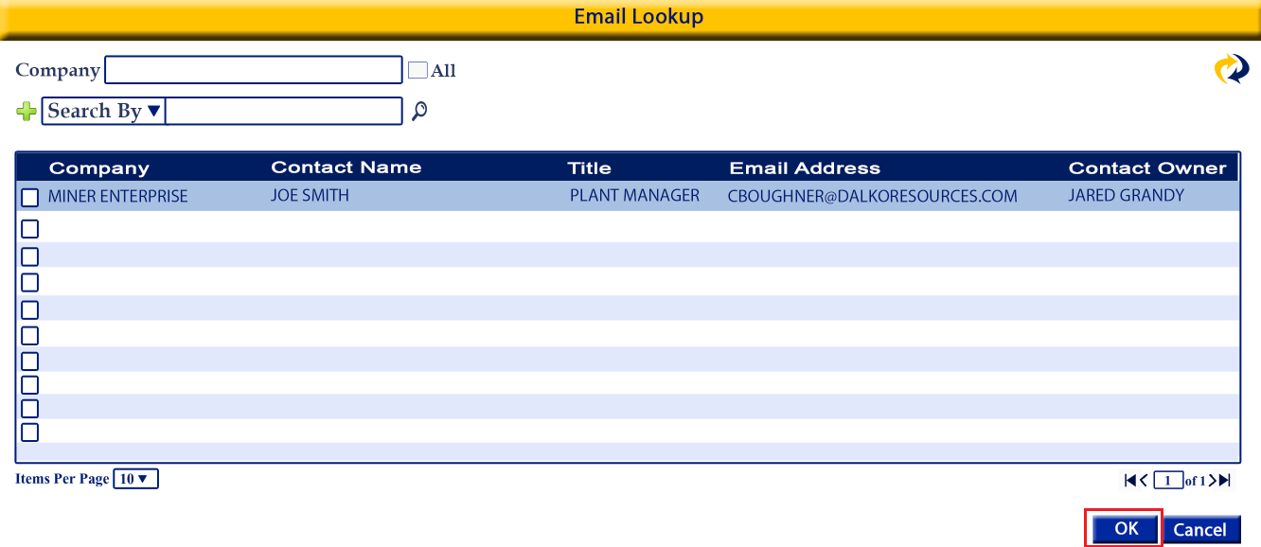
Function:
- adds the selected email addresses to the email input field of the New Email screen based on the button used to open the Email Lookup widow (To, Bcc, Cc)
Details
-button
-hover text: “Add email address(s)”
- adds the selected email addresses to the email input field of the New Email screen based on the button used to open the Email Lookup widow (To, Bcc, Cc)

Validation
-at least one email address must be selected
Message: Please select a contact email

Cancel
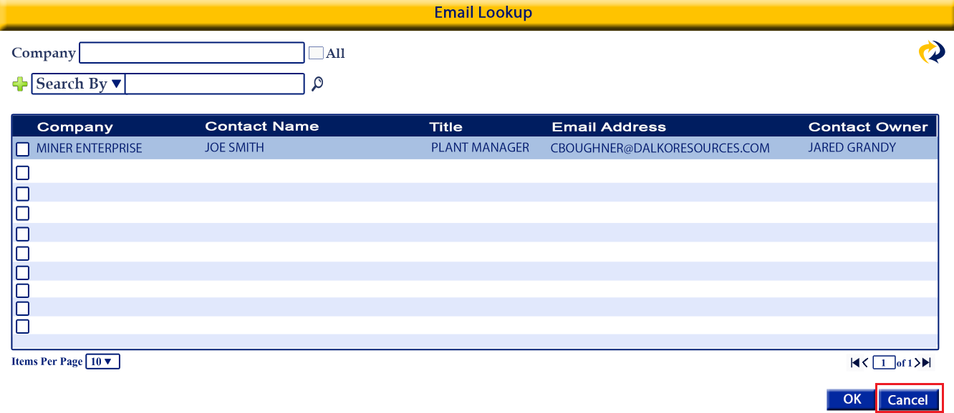
Function:
-closes the Email Lookup window without adding an email to the New Email screen

Details:
-button
- closes the Email Lookup window without adding an email to the New Email screen and returns the user to the New Email screen

Validation:
-

